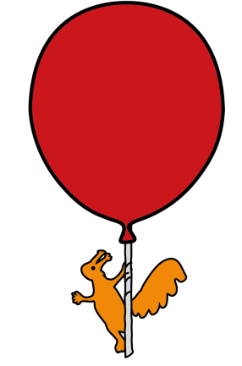
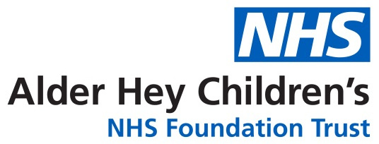

Community Speech and Language Therapy

Helping your child make friendships

Information for parents/carers and settings

- Before your child meets up with their friend, have a think about what is going to happen. You could draw a cartoon strip or write a simple story together. This is good for helping your child to prepare and understand new situations with other children.

- Discuss what a friend is:
  - Friends stay and play with each other
  - Friends like to ask each other questions to find out what they like
  - Friends look at each other and listen to what they are saying
  - Friends say nice things to each other

- Use pictures, photos, drawings or written reminders of things your child may want to say. You can stick these up at home or in school
Can I play with you?

Did you have a nice weekend?

Hello

- Help your child feel comfortable; visit places where they can be around other children such as play areas, youth centres, sports clubs etc.

- Activities with a sense of ‘working together’ are great for encouraging talking. (Make a snack, make a den, tower, make a scene for an action movie/play).

- Create tasks or games to encourage your child to play and talk to their new friend. Some children may benefit from a little bit of support from you for example, “why don’t you build a house out of the Lego” or “why don’t you show your friend your new board game” Allow your child time to get to know their new friends but step in if your child needs help to get things moving.

- Games with rules (such as monopoly, connect 4, board games, bingo, catch or hide and seek) can provide lots of opportunity to practise turn taking in a more structured but fun way (you may need to step in to talk about winning and losing!).

Childrensslt@alderhey.nhs.uk

Sefton: 0151 282 4973 Liverpool: 0151 295 3990

Speech and language therapy - Alder Hey Children's Hospital Trust
(click this link or type into search engine)

This leaflet only gives general information. You must always discuss the individual treatment of your child with the appropriate member of staff. Do not rely on this leaflet alone for information about your child’s treatment.
This information can be made available in other languages and formats if requested.

Alder Hey Children’s NHS Foundation Trust
Alder Hey
Eaton Road
Liverpool
L12 2AP
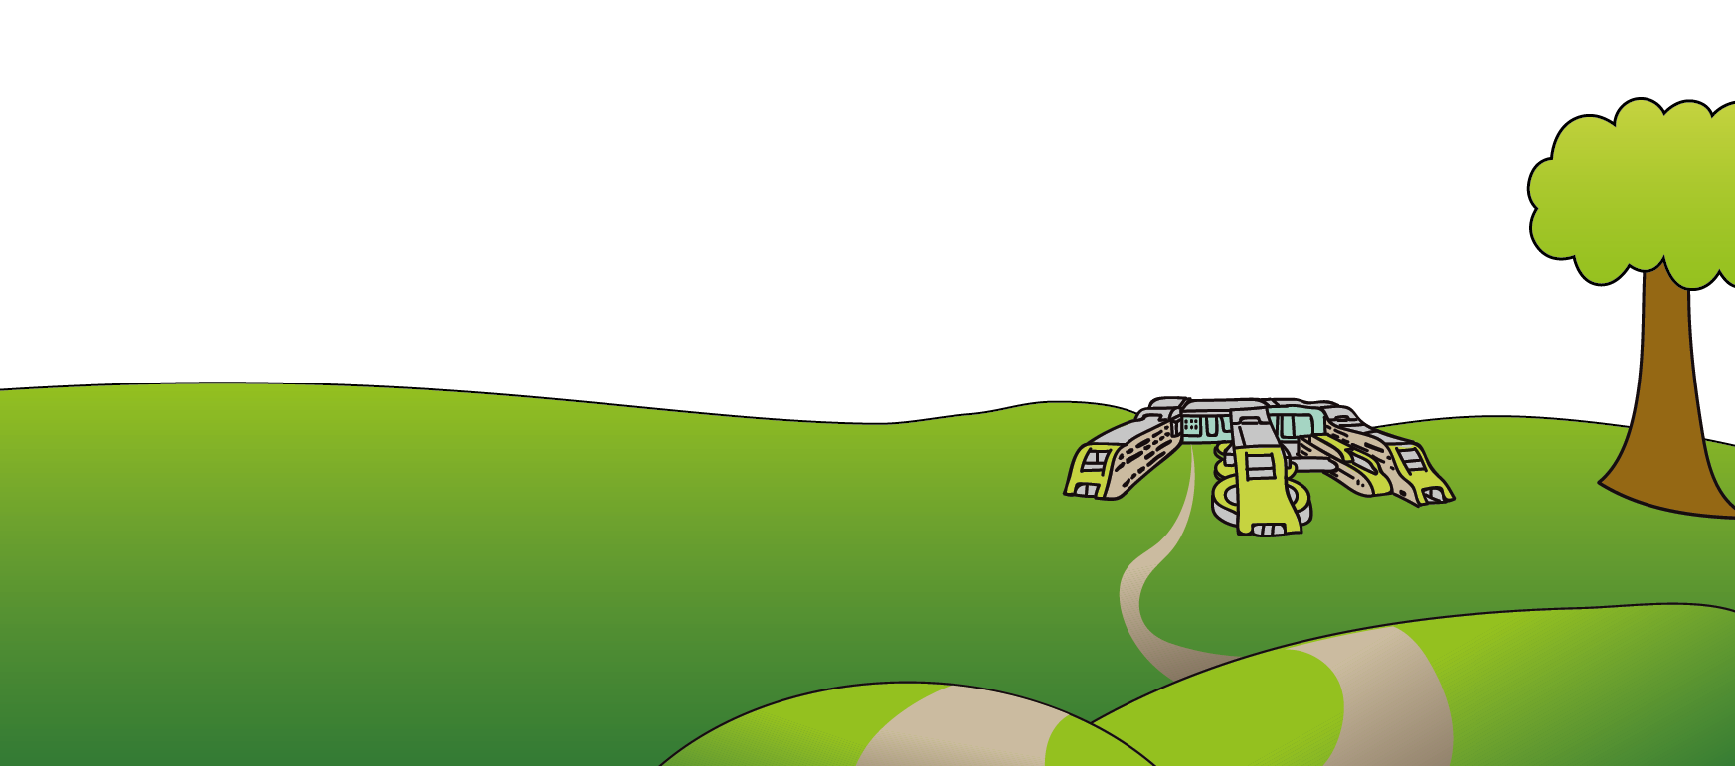
Tel: 0151 228 4811
www.alderhey.nhs.uk

© Alder Hey Review Date: January 2028 PIAG: 0094

