


Integrated Children’s Community Nursing Team

Caring for a child with Henoch Schӧnlein Purpura (HSP)

Information for parents and carers

What is Henoch Schӧnlein Purpura?

Henoch Schӧnlein Purpura (usually known as HSP) is an unusual disease, the exact cause is not known. It sometimes occurs after viral infection and is rare in adults. It is not an infectious condition. The disease causes inflammation of small blood vessels in the body. In the skin a bruising type rash is shown, most commonly on the legs, buttocks or forearms. It can also cause stomach pain and sore swollen joints. If the disease affects the kidneys it can cause blood to appear in the urine.

In most cases the disease settles down in about two to three weeks and apart from rest and pain relief, no specific treatment is required. A very small number of children may develop kidney problems, so testing your child’s urine for blood is very important. If your child is feeling well and not complaining of any joint or stomach pain then there is no reason why they should not continue their usual activities.

Management of Henoch Schӧnlein Purpura

- The Integrated Children’s Community Nursing Team may check your child’s blood pressure and check their urine using a dipstix.

- Your child may complain of mild / moderate pain in their head, abdomen or joints. Paracetamol and/or Ibruprofen will help to make your child comfortable. Appropriate doses of pain relief will be prescribed and discussed with you before you take your child home.

When you should contact the Integrated Children’s Community Nursing Team


You can contact the nursing team with any concerns you may have but you must contact us if your child develops any of the following;

- Visible blood in their urine
- Very black stools (poo) or blood in the stools
- Difficulty in passing urine
- Puffy appearance of their face, hands or feet
- Severe stomach pain
- Severe pain or swelling in their joints

This leaflet only gives general information. You must always discuss the individual treatment of your child with the appropriate member of staff. Do not rely on this leaflet alone for information about your child’s treatment.
This information can be made available in other languages and formats if requested.
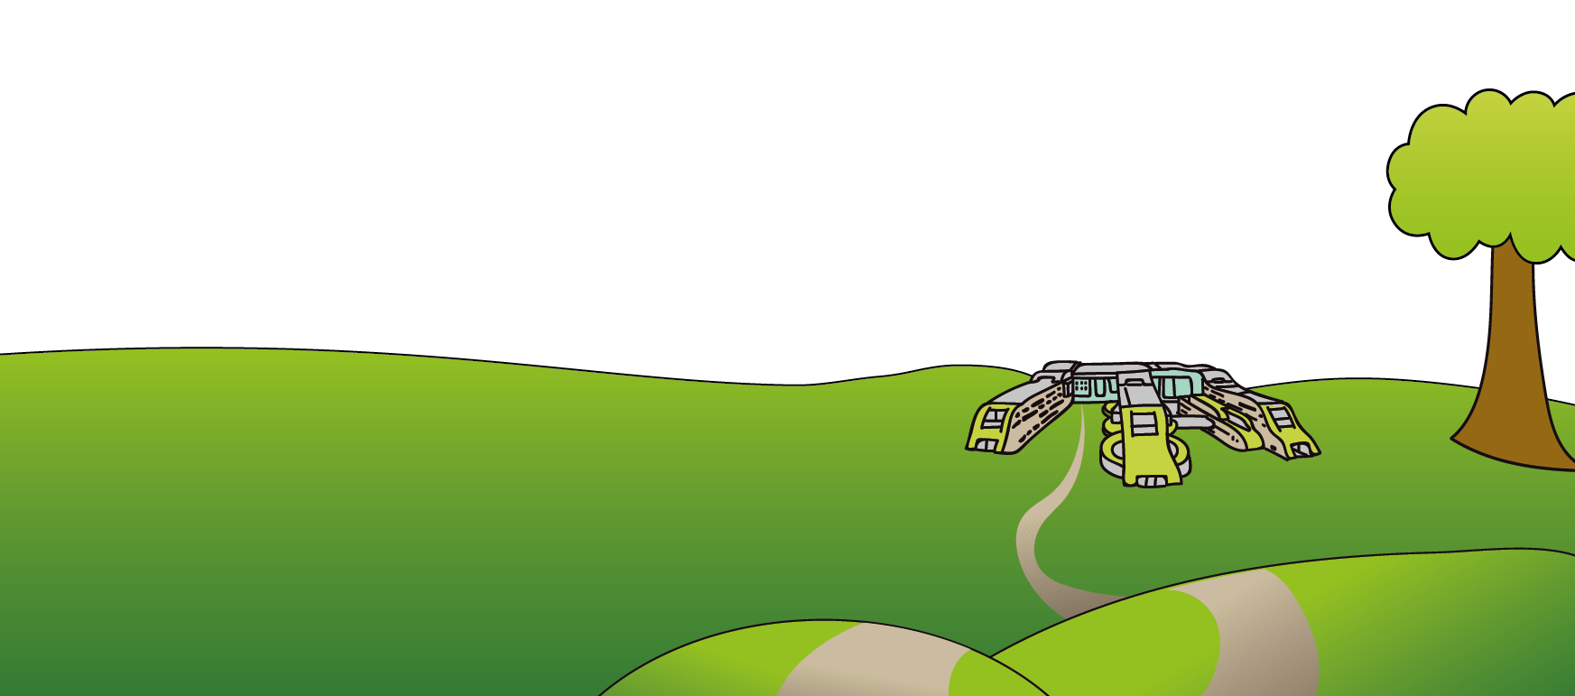
Alder Hey Children’s NHS Foundation Trust
Eaton Road
Liverpool
L12 2AP
Tel: 0151 228 4811
www.alderhey.nhs.uk
© Alder Hey Review Date: March 2028 PIAG: 2

