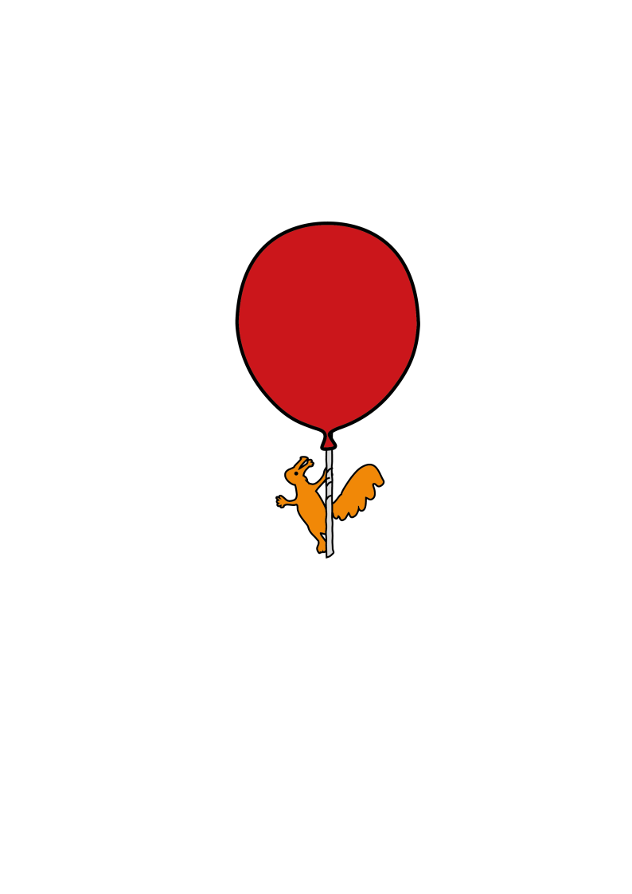

Integrated Children’s Community Nursing Team

**High Temperature**

Information for parents and carers

**Introduction**

This leaflet aims to provide you with information about what to do if your child has a high temperature and they are receiving care from the Integrated Children’s Community Nursing Team. Body temperature can vary but it is usually below 37.2°c. A high temperature is the body’s normal response to infection.

**It is important that you:**

* **keep** a regular check on their temperature with their own thermometer
* **keep** your child cool take off any of their excess clothing. Do not wrap your child in blankets
* **make sure** your child has plenty to drink to stop them becoming dehydrated. They can have hot or cold drinks
* 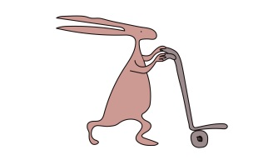**give** paracetamol every 4 – 6 hours (no more than 4 doses in 24 hours)
* **give** ibuprofen every 6-8 hours (no more than 3 doses in 24 hours)
* If your child is asthmatic and uses a brown inhaler please let us know before you give them Ibuprofen.
* Please follow advice for dosage on the paracetamol and ibuprofen medicine bottles
* **store** all medicines in a safe place and out of reach of children
* **make sure** the room temperature is warm and well ventilated and not cold
* **do not** put your child in a bath of cold water
* **do not** put a fan directly onto your child as this will cause the temperature to drop too quickly.

**What to look out for when checking your child’s condition**

* if your child’s temperature is above 38°c, give the medicine prescribed as explained by the children’s community nurse
* if your child’s temperature does not come down to below 38°c, 45 minutes after paracetamol or ibuprofen contact the children’s community nurse
* your child becomes irritable
* your child becomes very pale or mottled with cold hands and feet
* your child starts to vomit
* your child is refusing all drinks and has not passed urine for over 4 hours during the day

**If your child has any of the above symptoms since they were last seen by the children’s community nurse you must contact us immediately.**

**If your child:**

* develops a rash that does not disappear when pressed with a glass (glass test)
* is difficult to wake up or they are very floppy or unresponsive
* has a convulsion/fit.

**Ring 999 and ask for an ambulance**

If your child has a convulsion or fit whilst you are waiting for an ambulance

* place your child on their side on the floor somewhere safe
* do not try to hold your child during a convulsion or fit
* do not try to put your fingers or any object into your child’s mouth
* stay with your child until the convulsion or fit stops

If your child is taken to the Emergency Department, please tell the staff that your child is part of the Integrated Children’s Community Nursing Team.

This leaflet only gives general information. You must always discuss the individual treatment of your child with the appropriate member of staff. Do not rely on this leaflet alone for information about your child’s treatment.

This information can be made available in other languages and formats if requested.

Alder Hey Children’s NHS Foundation Trust

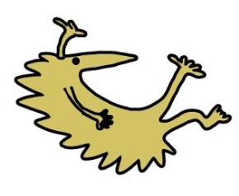Alder Hey

Eaton Road

Liverpool

L12 2AP

Tel: 0151 228 4811

[www.alderhey.nhs.uk](http://www.alderhey.nhs.uk)

**© Alder Hey Review Date: April 2028 PIAG: 011**