********

**Ear, Nose & Throat Department**

**Frequently Asked Questions**

**About Care After Baby’s Frenotomy (Tongue Tie Division)**

**Information for parents and carers**

**Q:** **What will the wound be like?** There will be a diamond shaped wound under the tongue, This should heal well by itself .over 7-14 days. The wound should be initially pink, then be white.   
It is important to thoroughly sterilise any feeding equipment/dummies to prevent infection.   
If the wound becomes red, inflamed, or if baby develops a high temperature, refuses to feed, is very sleepy or irritable please contact your GP.   
  
**Q:** **What about the bleeding?** Your practitioner will check your baby’s wound and ensure   
bleeding has stopped. It is advised to give your baby a feed before you leave the clinic.   
Your baby may swallow some blood, from this you may notice some blood if baby vomits or some blackness in baby’s nappy .   
  
**Q:** **Will the wound start to bleed again?** This is rare but if it does happen - first calm your baby, if this does not help , apply pressure to wound with a finger and gauze or muslin cloth .   
If bleeding persists please take your baby to your nearest A&E dept.   
  
**Your baby’s behaviour**: Babies react differently to the frenotomy, some babies may be sleepy -others may wish to feed a lot and be a little fussy with feeding for a couple of days.   
Keeping your baby calm - lots of cuddles - skin to skin, frequent breastfeeds, bathing, baby   
massage.   
   
**Q:** **Will my baby need pain relief?** For babies over 8 weeks infant paracetamol can be used   
according to manufacturer's instruction. For babies under 8 weeks, speak with your GP .

**On-going support:**  
**Infant Feeding Team at Liverpool Women’s**

(babies under 6 weeks ) - 0151 702 4293  
  
**Breastfeeding Support**

**Liverpool Bambis**

0151 702 4411 / 0151 233 6874  
  
**Sefton Breastfeeding Support**

0151 291 8010

**Knowsley’s Breastfeeding Support**

****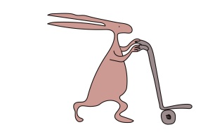0151 244 3269

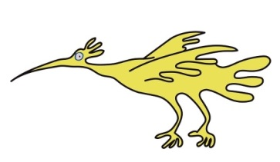

This leaflet only gives general information. You must always discuss the individual treatment of your child with the appropriate member of staff. Do not rely on this leaflet alone for information about your child’s treatment.

This information can be made available in other languages and formats if requested.

Alder Hey Children’s NHS Foundation Trust

Alder Hey

Eaton Road

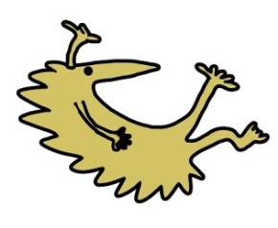Liverpool

L12 2AP



Tel: 0151 228 4811

[www.alderhey.nhs.uk](http://www.alderhey.nhs.uk)

**© Alder Hey Review Date: June 2027 PIAG: 273**