Radiation Safety
(A Note for Parents)
A Fluoroscopy Procedure does involve a dose of radiation.
There is no upper limit for the amount of radiation required to undertake any of these procedures, as the benefits of the procedure outweigh the risks of the radiation dose received.
Every patient of child bearing age undergoing Fluoroscopy procedures will be asked the date of their last period.
For some procedures a Pregnancy test prior to the procedure may also be required to be undertaken.
This is to avoid any unnecessary radiation dose being given to a developing foetus.
Please do not take offence, as this is Trust policy.



If you have any queries, please feel free to contact us on: 0151 252 5332.

This leaflet only gives general information. You must always discuss the individual examinations of your child with the appropriate member of staff. Do not rely on this leaflet alone for information about your child’s examinations.
This information can be made available in other languages and formats if requested.

Alder Hey Children’s NHS Foundation Trust
Alder Hey
Eaton Road
Liverpool
L12 2AP

Tel: 0151 228 4811
www.alderhey.nhs.uk

© Alder Hey
Review Date: September 2027 PIAG: 438



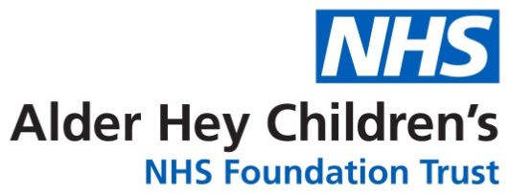

Radiology
Department

Fluoroscopy



Information for patients,
parents and carers

Here is some information about your screening procedure

The team consists of:
Radiologist
Radiographer
Play therapist (if required)
Specialist team nurses (if required)
Training Radiologists and Radiographer’s may be present for teaching purposes.



There are many different types of Paediatric Fluoroscopy procedures.
Here listed are a few of the most common procedures:
Micturating cystogram (MCUG) - This looks at the filling and emptying of the bladder (N.B. You will be given additional information regarding antibiotics for this test.)
Barium Studies - These look at the stomach and intestines to ensure that they are positioned and function correctly.
Linograms - To ensure that central lines are working correctly.
Gastro-Jejunal Tube Changes - When a tube is changed, we need to check it is positioned correctly.
Phonetics (Speech Therapy) - This looks at the swallowing and speech mechanism of structures in the throat.



All of these procedures we perform in our specialist Fluoroscopy room situated in radiology.
Radiographers perform special dynamic (moving) x-ray pictures in our Fluoroscopy room to assist the Radiologist or Nurse Specialist.

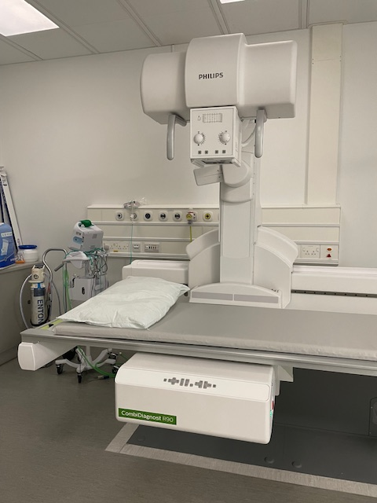
This is a photo of the Fluoroscopy room that the radiographer’s use to make the moving pictures for the Radiologist.

