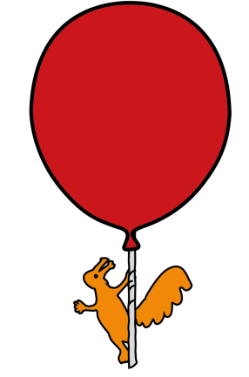
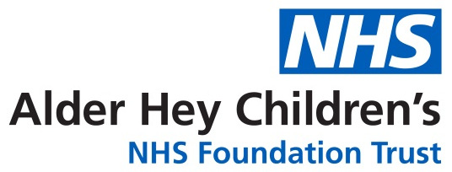

Accident & Emergency Department
Fever
Information for parents and carers

Introduction

This leaflet aims to give you some information about fever, how a simple fever can be managed at home and when a medical opinion should be sought.

What is a normal temperature?

A normal temperature is about 37°C when taken orally (by mouth). Temperatures taken rectally (by rectum) usually run 1°C higher than those taken orally.

What is a fever?

A fever is a body temperature which is higher than normal, (usually more than 38°C). This is a natural response and helps the body to fight against infections.

When should I try to lower my child's temperature?

Fevers are a sign that the body is fighting an infection. The main reason to treat your child is to make him or her feel better. When your child is irritable or cranky, you may want to give him or her some medicine.

Simple fevers can be managed at home by:
- removing layers of clothing;
- encouraging your child to drink cool drinks and/or continue breast feeding;
- giving medication - paracetamol (Calpol) and/or ibuprofen (Brufen / Nurofen);
- nursing your child in a cot rather than in arms.
If you take these measures you may make your child more comfortable.

Medication – always follow instructions on the packet or bottle

- Alternating ibuprofen and paracetamol can help provide symptom relief for longer.
- Ibuprofen:
  - Use cautiously if your child is not drinking or passing urine well;
  - Do not give more than 3 times in 24 hours.
  - Ibuprofen should not be given to children with chickenpox. This is because some studies suggested that there may be an association with more severe skin reactions if ibuprofen is used for chickenpox.
- Paracetamol:
  - Do not give more than 4 times in 24 hours.

Why not use aspirin to lower my child's fever?

In rare cases aspirin can cause Reye's syndrome in children who have flu or chickenpox. Reye's syndrome is a serious illness that can lead to death. It may be hard to tell if your child has one of these infections, so it's best not to use aspirin.

When should I get a medical opinion?

If you are very concerned about your child or they have any of the below features call 999 or attend the Emergency Department:

• A stiff neck
• A rash that does not fade when you press a glass on it (See below ‘Meningitis Glass Test’)
• Are bothered by light
• A fit (febrile seizure) for the first time (they cannot stop shaking)
• Unusually cold hands and feet
• Blue, pale or blotchy skin, lips or tongue
• Weak, high-pitched cry that's not like their normal cry
• Drowsy and hard to wake
• Extremely agitated (does not stop crying) or is confused
• Finding it hard to breathe and sucking their stomach in under their ribs
• Not responding like they normally do, or is not interested in feeding or normal activities

The meningitis glass test
Press the side of a clear glass firmly against the skin, spots/rash may fade at first, keep checking. Fever with spots/rash that do not fade under pressure is a medical emergency.
On dark skin, the spots/rash can be more difficult to see, check lighter areas such as the palms of the hands, soles of the feet, inside the eyelids and the roof of the mouth.

Further Help and Advice
Can be obtained from NHS 111, your GP or local pharmacist. .
REFERENCES:
https://alderhey.nhs.uk/symptom-checker/fever-high-temperature
https://www.meningitisnow.org/meningitis-explained/signs-and-symptoms/glass-test/?gclid=CJWh-aLL8s0CFcE_GwodT4ALcg#the-meningitis-glass-test
https://patient.info/skin-conditions/viral-rashes/chickenpox-in-children

This leaflet only gives general information. You must always discuss the individual treatment of your child with the appropriate member of staff. Do not rely on this leaflet alone for information about your child’s treatment.
This information can be made available in other languages and formats if requested.

Alder Hey Children’s NHS Foundation Trust
Alder Hey
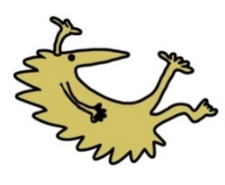
Eaton Road
Liverpool
L12 2AP

Tel: 0151 228 4811
www.alderhey.nhs.uk

© Alder Hey Review Date: June 2027 PIAG: 64

