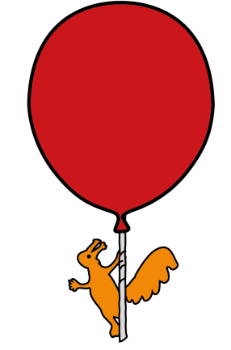
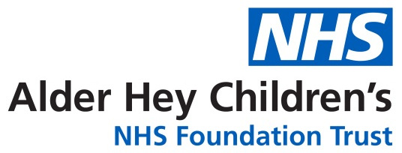

Children and Young People’s Diabetes Service
Insulin Pump Therapy
Hypoglycaemia

Information for patients, parents and carers

What is Hypoglycaemia?
Hypoglycaemia means a low blood glucose level; sometimes it is called a hypo. In someone without diabetes the body is able to keep the blood glucose levels within very narrow targets by constantly changing the amount of insulin that is produced. In Type 1 Diabetes this is much harder to do. Hypoglycaemia happens when blood glucose levels go too low usually when there is a mis match between insulin, food and activity levels. A low blood glucose level in a child or young person with diabetes is 3.9mmol/L or below.

What may cause hypoglycaemia?
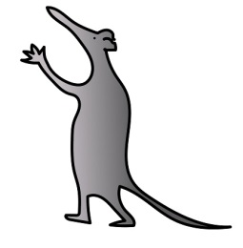
- Too much insulin being delivered this could be a basal rate that is too high or a bolus that was too much for the amount of carbohydrate eaten.
- Insulin at the wrong time
- Fasting
- Physical activity and exercise
- Hot or cold temperatures
- Stress or Illness
- Alcohol

The body does not like the blood glucose level to drop too low, so it will produce warning signals that mean the blood glucose level may be falling too low.
Symptoms are divided into 2 types; symptoms caused by the body trying to raise the blood glucose level and symptoms caused by the effect of the low blood glucose level on the brain.
Not everybody will have the same symptoms, it is important to check the blood glucose level if you suspect a hypo.
A hypo may be mild and easily treated, moderate which needs some help or severe. A severe hypo usually needs treatment with glucagon, medical help or hospital.
Signs and Symptoms of a Hypo
Mild or early |  | Moderate | Severe
Pale  Hunger  Shaky  Wobbly legs  Sweating | Tired or sleepy  Headache  Trembling  Tingling  Faint or dizzy | Blurred vision  Aggressive  Moody or irritable  Slurred speech  Confused  Strange behaviour | Fainting  Fitting  Loss of consciousness
Often it is possible to explain why a hypo has happened, but sometimes they may happen unexpectedly. The symptoms of a hypo may be any one or a combination of the above. It is important to treat a hypo immediately. Untreated hypos can lead to loss of consciousness or fitting.
What to use to treat a mild or moderate hypo
A hypo is treated by giving extra fast acting carbohydrate to bring the blood glucose level up. The amount of treatment needed depends on your age and size, as well as how active you are and when you last had any insulin.

Age | Amount of  carbohydrate | Examples
Under 1 year | 2-3g | 50ml fruit juice, ¼ tube Glucogel, 4g Polycal powder mixed with 20ml water
1-5years | 5g | 1-2 glucose tablets (check the label), 60ml Lucozade, 1 jelly baby, 2 fruit pastilles, 100ml fruit juice, ½ tube Glucogel
5-10 years | 10g | 3-4 glucose tablets (check the labels), 120ml Lucozade, 2-3 jelly babies, 4 fruit pastilles, 200ml fruit juice, 1 Glucogel
10-18years | 15g | 4-5 glucose tablets (check the label), 180ml Lucozade, 4-5 jelly babies, 6 fruit pastilles, 300ml fruit juice, 1 ½ tubes Glucogel

Chocolate is not recommended as a hypo treatment as it is broken down to glucose slowly.
If fruit juice is used a double dose may be needed as natural sugars are absorbed more slowly.

Long acting carbohydrate is not recommended in addition to fast acting rescue treatment. Sometimes a snack may be needed. No more than 20g of carbohydrate should be taken. Consider an extra snack if
- Hypo is just before or after exercise
- Too much insulin is the cause of the hypo
- Alcohol is the cause of the hypo
- If your child has had a hypo in the last 24hours or you are worried.

How to manage hypoglycaemia
How to treat a mild or moderate hypo
- Check the blood glucose level and give the hypo treatment.

- Wait 10-15 minutes and recheck blood glucose level. If the blood glucose level is below 5.6mmol/L repeat steps 1 and 2 until blood glucose level is greater than 5.6mmol/L.

If the blood glucose level is 5.6mmol/L or more no further action unless:
- You are about to sport/physical activity – have an extra 15-20g carbohydrate snack before activity.

- You are concerned the blood glucose level may drop again because the hypo was caused by too much insulin or alcohol. If you have treated 2 or more hypos already consider using a temporary basal rate decrease or suspending the insulin delivery until glucose is within range and hypo is resolved.

How to treat a severe hypo
If the child is unconscious, having a fit or is unable to take anything by mouth follow the steps below:

Do not give anything by mouth – this can cause choking
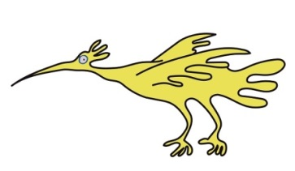
- Place your child in the recovery position, away from danger
- Check the time
- Give the glucagon injection
- ½ dose for under 8 years (0.5mg)
- Full dose for over 8 years (1mg)
- Check the blood glucose
- Disconnect or suspend the pump
If you are not able to give the glucagon injection call 999 for an ambulance
Stay with the child, if there is no sign of recovery after 10 minutes or if they are not fully recovered after 30 minutes call 999 for an ambulance.

When fully awake follow the steps 1 and 2 (on page 2)
Reconnect/resume the pump once the blood glucose level is above 5.6mmol/L.

A severe hypo can cause vomiting. If this happens after the hypo treatment is given wait a few minutes and then repeat the fast acting carbohydrate.
A severe hypo will leave you feeling tired and unwell. Always recheck the blood glucose before falling asleep and eat a long acting carbohydrate snack.
Check the blood glucose level every 30minutes for 2-3hours after a severe hypo.

Hypos at night
A hypo at night is treated in the same way as you would in the day. A hypo at night may cause a child to be agitated and call out as if they are having a bad dream. It is possible for a child/young person to sleep through a hypo. This is common after exercise in the afternoon or evening, after a hypo in the day or when alcohol has been consumed.

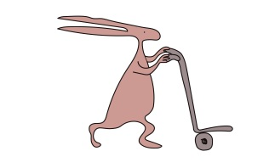
A hypo at night may cause
- Frequent nightmares
- Feeling sick, with a headache in the morning
- Blood glucose of less than 4mmol/l before breakfast
- Blood glucose above 14mmol/L in the morning.
- No symptoms at all

If you suspect a night hypo and do not use a glucose sensor, you should check blood glucose levels between midnight and 3am. If you do use a glucose sensor and are getting low alarms overnight, changes may need to be made to your insulin doses. These can be discussed with the diabetes team if required.

Preventing and treating Hypoglycaemia Checklist
- Everyone who looks after a child with diabetes needs to be able to recognise and treat a hypo
- Always carry some hypo treatment for example Lucozade Energy drink or glucose tablets
- Hypos can happen quickly at any time, treat them quickly
- If possible check the blood glucose before treating the hypo
- Think about why the hypo might have happened
- If you use Glucagon or Glucogel, always make sure you replace it.
- Check that your Glucagon and Glucogel are in date
- Always carry or wear some diabetes identity
- Calculate your carbohydrate and insulin doses as carefully as possible
- Use different ICRs (insulin to carb ratios) at different times of day if needed
- Check your ICR if hypos happen within 4 hours of a meal bolus
- Avoid only using normal or standard boluses for large meals, low GI meals or high and fat protein meals.
- Use correction doses carefully, use a bolus advisor or calculator whenever possible and remember that fast acting insulin works for 2-5hours in the body.
- Treat any high blood glucose levels after hypos with caution. A high blood glucose level 2-4hours after a hypo may not need a correction dose.
- Adjust your insulin doses for planned exercise.
- Never give a bolus for alcohol unless you know how it affects the blood glucose levels
- Check that your basal rates are correct every 6-12weeks

Hypo Treatment Flowchart

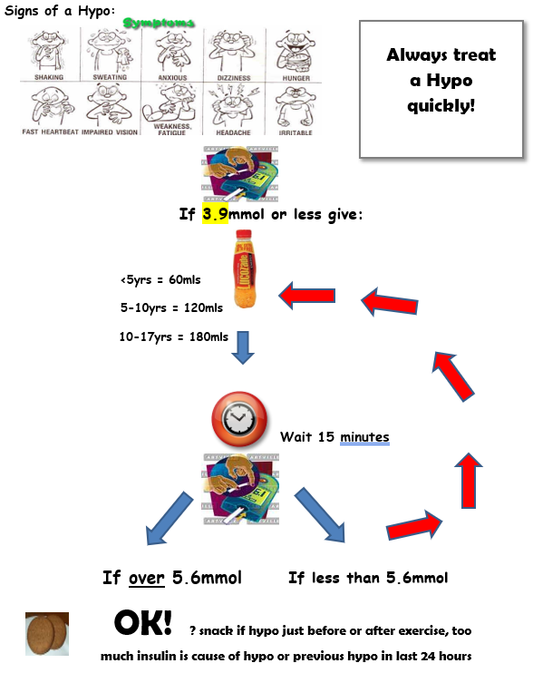

Who to contact for further help or advice
If you need urgent advice about diabetes management Monday – Friday 8am – 6pm, call 0151 252 5766.

For out of hours advice call the hospital switchboard on 0151 228 4811 and ask for ‘Diabetes nurse on call’.

For non-urgent advice contact your diabetes nurse on the usual numbers or email diabetes@alderhey.nhs.uk

Website: https://alderhey.nhs.uk/parents-and-patients/services/diabetes
Meet the team, useful guidelines, research and publications, helpful advice and video guides.

Download the Digibete app, the video platform to share videos and educational resources about Type 1 Diabetes. The content is to support children, young people and their families to self manage their own diabtetes by extending the reach of their clinical teams online using the clinic code - AEBDR
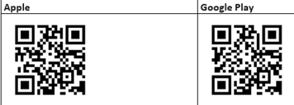

This leaflet only gives general information. You must always discuss the individual treatment of your child with the appropriate member of staff. Do not rely on this leaflet alone for information about your child’s treatment.
This information can be made available in other languages and formats if requested.

Alder Hey Children’s NHS Foundation Trust
Alder Hey
Eaton Road
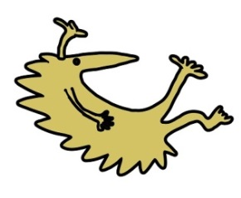
Liverpool
L12 2AP

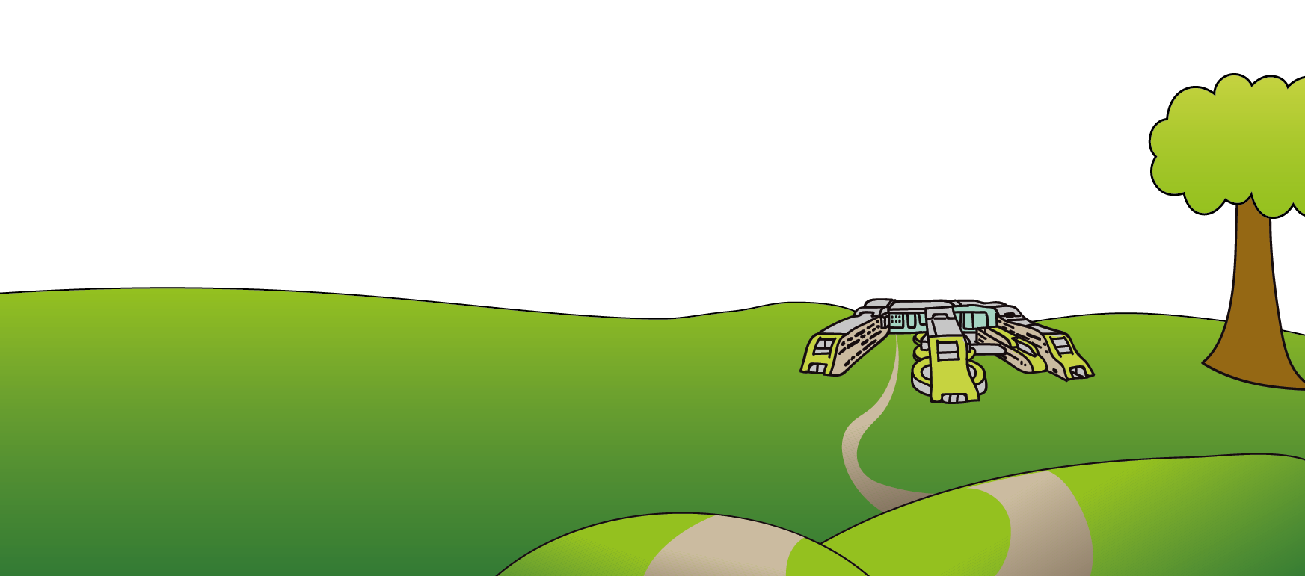
Tel: 0151 228 4811
www.alderhey.nhs.uk

© Alder Hey Review Date: August 2027 PIAG: 111

