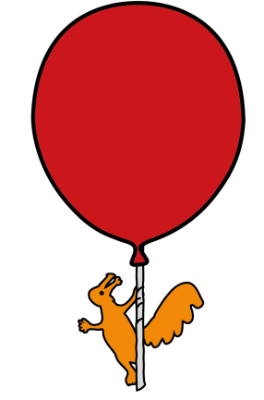
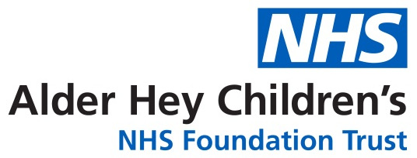

Cardiac Department

Cyanotic Spells (Blue Spells) in Tetralogy of Fallot

Information for parents and carers



What is Tetralogy of Fallot?

Tetralogy of Fallot (TOF) is a combination of four problems affecting the heart.
These consist of:

- Pulmonary stenosis - a narrowing of the pulmonary valve, the area below the valve, or the pulmonary artery which carries blood from the heart to the lungs.

- Ventricular septal defect - VSD: a hole between the two bottom chambers (the ventricles)of the heart.

- Overriding aorta - the aorta, the large artery that takes blood to the body is on top of both ventricles instead of just the left ventricle as in the normal heart.

- Right ventricle hypertrophy - the right ventricle becomes thicker and more muscular than normal as a result of the heart working harder to pump the blood through the narrow pulmonary valve.

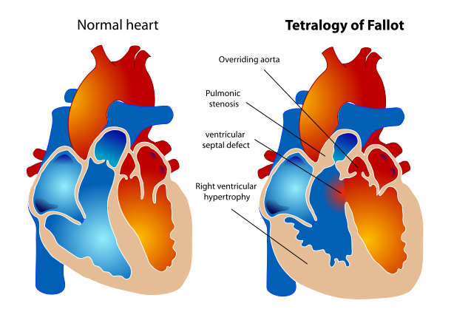

What is Cyanotic spelling?

Some children with TOF may be cyanosed, appear blue - often around the lips, mouth and nail beds. Sometimes they may look pale/grey rather than blue. Depending on the colour of your skin some babies’ lips may appear ‘black’.

This is because the blood being pumped around your child’s body doesn’t contain as much oxygen as it should.

Children with TOF may have a period where they become irritable with uncontrolled crying, have rapid and deep breathing and become very blue or pale /grey and floppy. This is called a hypercyanotic episode or ‘spell’.

During a spell, blood flow to the lungs is severely decreased.

Common factors contributing to a spell:

- Pain - treat causes of pain appropriately using comfort measures and/or medication as necessary.
- Crying
- Feeding
- Having bowels open/ wind
- Dehydration - reduced feeding / vomiting. Ensure adequate fluid intake, observe for signs of dehydration such as sunken fontanelle (soft spot on the skull), dry mouth and skin and fewer wet nappies. If your baby shows any of these signs it is very important to have a low threshold for going into hospital as your baby may need a drip for fluids.
- Fever - treat any high temperatures by removing excess clothing and layers and give paracetamol as directed.

Seek immediate medical advice if you have any concerns about your child’s health. This may be at your open access at your local hospital or nearest A&E.

What to do if your child is spelling

- Try to remain calm.

- Bring your baby’s knees up to their chest and hold them firmly in place. You can also do this by holding your baby over your shoulder. This increases the pressure going around the body and forces blood flow to the lungs. Try to comfort and settle your baby.



- Call an ambulance to take your baby to hospital (often they will give oxygen along with further cyanotic spell management which might include IV cannula / fluid / medications)


- Always tell your cardiologist / nurse specialist if it is the first time your baby has a spell or if the frequency of spells increases. Telephone: 0151 252 5291.
This leaflet only gives general information. You must always discuss the individual treatment of your child with the appropriate member of staff. Do not rely on this leaflet alone for information about your child’s treatment. This information can be made available in other languages and formats if requested.
Alder Hey Children’s NHS Foundation Trust
Eaton Road
Liverpool
L12 2AP
Tel: 0151 228 4811
www.alderhey.nhs.uk

© Alder Hey Review Date: July 2028 PIAG: 214

