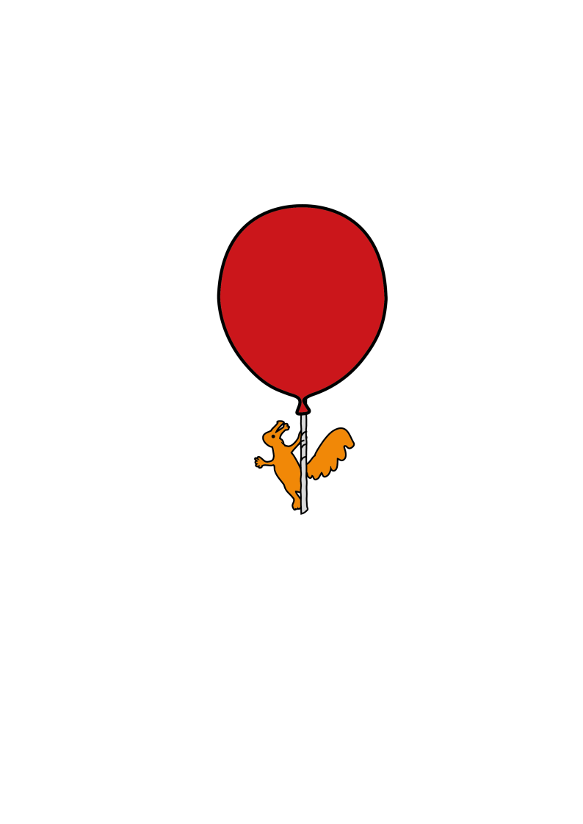

Orthopaedic Physiotherapy

**Crutches guidance for patients who are non-weight bearing (NWB)**

**Safety**

****Before you use your crutches you should:

* Check that the ferrells (rubber bits on the bottom of the crutches) are not too worn and have been fully pushed on.
* Check that the buttons are clicked in properly and fully through the holes on both sides of the crutches each time
* Check there are no loose nuts or bolts

**Mobilising NWB**

* Stand up from your chair pushing through your arms with all of your weight going through your unaffected leg and your affected leg off the floor
* Put your arms into your crutches and stand until you have your balance
* Bring your crutches in front of you. Imagine a line in between your crutches and push through your arms to hop your unaffected leg to it (do not hop past your crutches)
* 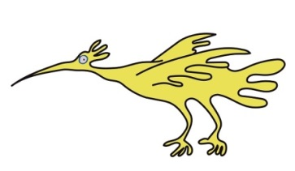When sitting down, make sure you can feel the chair with the back of your legs and take your arms out of your crutches to reach back for the arms of the chair. Lower yourself down keeping your affected leg off the floor.

**Stairs**

Going up

* Put one hand on the bannister with your crutch in the other hand
* Keep your crutch on the floor and push through your arms on your crutches and the bannister to bring your unaffected leg up onto the step, keeping your affected leg bent if able or hitch up through your hip so your toes don’t catch on the step. (Make sure your whole foot is on the step)

Coming Down

* Bring yourself close to the top of the stairs, with one hand on the bannister, and the other in your crutch
* Put your crutch down onto the step below
* 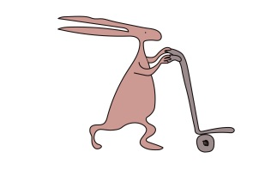Keep your affected leg out in front of you so you don’t catch your toes and push through your arms on the crutch and the bannister to slowly lower yourself down using your unaffected leg onto the same step as your crutch

ALL CRUTCHES ARE TO BE RETURNED TO THE HOSPITAL IN GOOD CONDITION WHEN THEY ARE NO LONGER NEEDED SO WE CAN CONTINUE TO PROVIDE THEM FOR ALL CHILDREN WHO NEED THEM.   
THANK YOU.

This leaflet only gives general information. You must always discuss your individual treatment with the appropriate member of staff. Do not rely on this leaflet alone for information about your treatment.

This information can be made available in other languages and formats if requested.

Alder Hey Children’s NHS Foundation Trust

Alder Hey

Eaton Road

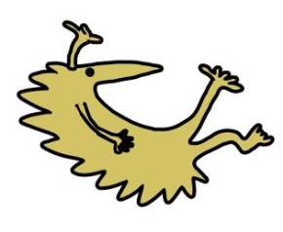Liverpool

L12 2AP



Tel: 0151 228 4811

[www.alderhey.nhs.uk](http://www.alderhey.nhs.uk)

**© Alder Hey Review Date: July 2028 PIAG:384**