Peer Support
Peer support can be really helpful when you and your baby are learning what to do. Here are the details of local peer support who can help you.

Liverpool Community Bambis – 0151 233 6874 or 07545200318
Seton Feel Good Factory – 0151 291 8010
Knowsley Bosom Buddies – 0151 244 3269

When should I bring my baby back to hospital?
You will be supported by your community midwife or health visitor but if you are concerned that your baby is unwell, eg having less wet and dirty nappies, irritable, lethargic, reduced feeding, then bring them back to the emergency department.
This leaflet only gives general information. You must always discuss the individual treatment of your child with the appropriate member of staff. Do not rely on this leaflet alone for information about your child’s treatment.This information can be made available in other languages and formats if requested
Alder Hey Children’s NHS Foundation Trust
Eaton Road
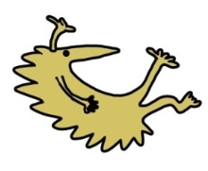
Liverpool
L12 2AP

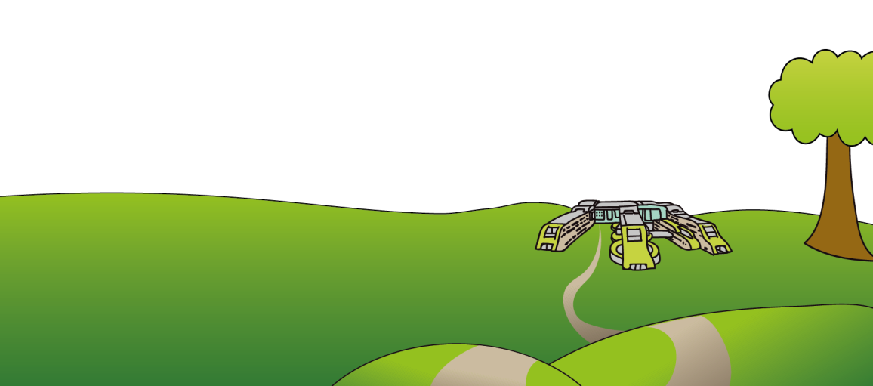
Tel: 0151 228 4811
www.alderhey.nhs.uk

© Alder Hey Review Date: December 2027 PIAG: 502



Department – Infant Feeding

Plan A Newborn Weight Loss

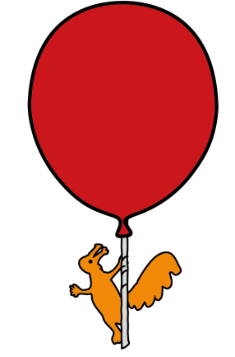

Information for patients,
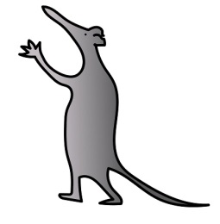
parents and carers

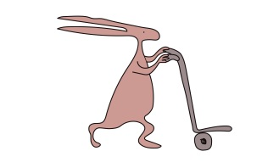

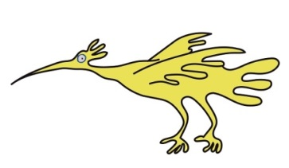

Introduction
This leaflet aims to give you general information about weight loss in the first few days of life and provide you with some support and guidance on how to help your baby gain weight.

Why has my baby lost weight?

It is normal for healthy newborn babies to lose weight after birth and then regain it within a couple of weeks. Sometimes they lose a bit more than we would like and your midwife/GP has referred you to us to check everything is ok. This may be worrying for you, but we are here to support you and your baby and get you back home as soon as possible.

This is an individualised plan for you and your baby.
You are doing an amazing job of breast feeding your baby and we at Alder Hey want to support you.

Whilst in hospital the clinicians will have taken a thorough history and examined your baby to ensure they are safe to be discharged home. Depending on their percentage weight loss different advice will be given as follows…

Baby ……………………………. weighs …………..KG
So has lost around 8-10% of their birth weight

We are happy for you to go home but would like you to do the following things to help make sure your baby doesn’t lose any more weight.
• Contact your midwife/health visitor and arrange a visit for a follow up weight and review in 48 hours
• Ensure your baby breastfeeds effectively at least 8 times in 24 hours
• You may need to ‘switch’ feed if your baby is sleepy (change breasts frequently during the feed to wake baby up) but ideally feed fully from one breast before offering the second
• Consider doing breast compressions to help transfer your milk to your baby – (see QR code)
• Try to avoid dummy use as this can interfere with feeding cues
• Enjoy lots of skin to skin contact and cuddles!


Breast compressions Positioning and attachment

