


Integrated Children’s Community Nursing Team

Care of a child with Gastroenteritis

Information for parents and carers

Introduction

Please read this leaflet and follow all the advice given. Do not hesitate to contact the nurse at any time for any concerns you may have, that is what we are here for.

Whilst your child is under the care of the Integrated Children’s Community Nursing Team, it is important to:

- Give your child enough fluid to prevent them becoming dehydrated.
- Record the fluids your child has taken and the amount of urine they have passed.
- Record any vomiting by your child.

Signs to look out for when checking on your child’s condition:

- Vomiting increases either in the amount or the number of times your child vomits.
- Your child is vomiting everything they have drunk
- If the amount of times diarrhoea increases, or becomes very watery.
- You notice blood in your child's stools.
- Your child refuses to drink anything for four hours during the day.

If your child has the above symptoms and have become worse since they were last seen by the nurse you must contact us immediately.

When your child passes urine it is important to asses it, although this can be difficult to see when they have diarrhoea.

Please monitor the following:


For children out of nappies

- If your child has not passed urine for four - six hours during the day
or
- Your child has not passed urine overnight and has still not passed urine two hours after waking.

For children still in nappies

- If your child does not have a wet nappy for four -six hours during the day.
or
- If the nappy is completely dry overnight and still dry two hours after waking in the morning.

If your child has any worsening of the above symptoms since they were last seen by the nurse you must contact the team immediately.

If your child does vomit allow him/her to settle for about half an hour. After this try him/her with a drink.

Please note: the key to stop the vomiting is giving small amounts frequently rather
than a whole glass or bottle of fluid at once.

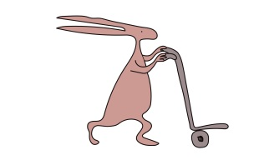
It would help us in your child’s care if you could write some information

- What time your child had a drink or food and how much he/she has taken.
- When your child passes urine or has their nappy changed.
- The time and the amount of any vomiting
- If you child has a high temperature, what the temperature was and the time and dose of any medications you have given.

Please note: even after vomiting has stopped diarrhoea may persist for a longer period. If your child is well and drinking adequate amounts they will not need to be visited at home until the diarrhoea stops.

Date & Time | Type of feed | Amount and frequency your child should be fed today

This leaflet only gives general information. You must always discuss the individual treatment of your child with the appropriate member of staff. Do not rely on this leaflet alone for information about your child’s treatment. This information can be made available in other languages and formats if requested.
Alder Hey Children’s NHS Foundation Trust
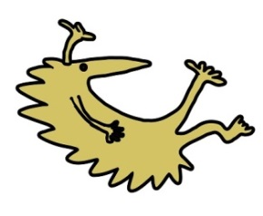
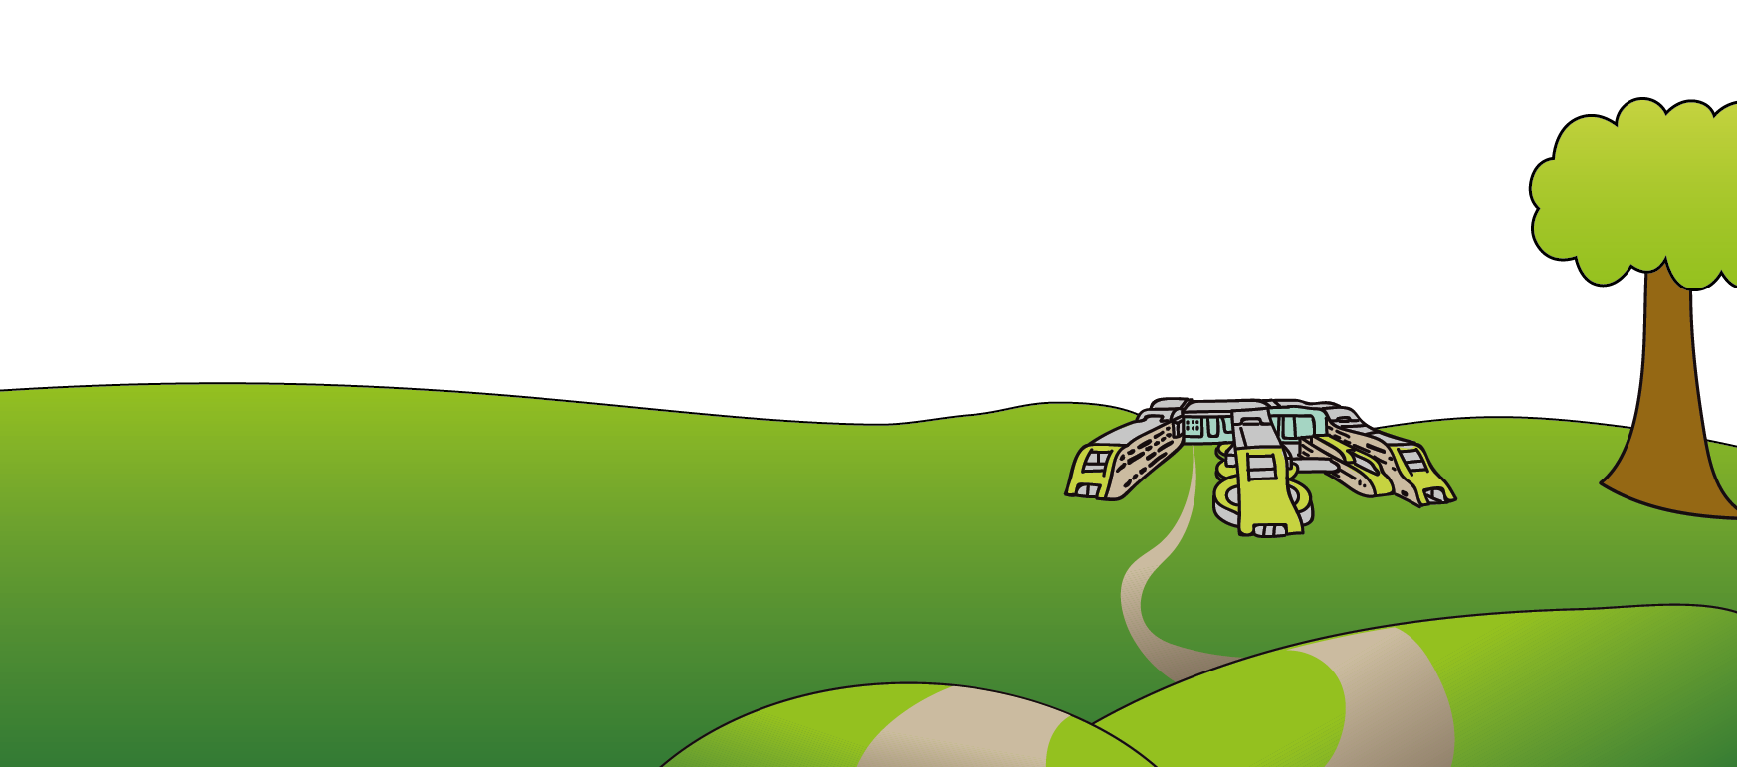
Alder Hey
Eaton Road
Liverpool
L12 2AP

Tel: 0151 228 4811
www.alderhey.nhs.uk

© Alder Hey Review Date: March 2028 PIAG: 058

