
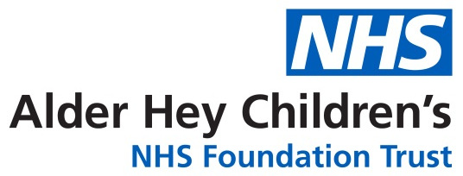

Cardiac Surgery Information leaflet

A guide for parents and carers

This information booklet has been designed to answer questions you may have about your child’s upcoming cardiac surgery.

Cardiac surgery on babies and children has been carried out in Liverpool since the 1950’s, first at Myrtle Street children’s hospital in the city centre, and then from the early 1990’s at the Alder Hey site.

We have four surgeons at Alder Hey who are highly experienced in paediatric cardiac surgery. They are Ram Dhannapuneni, Tommaso Generali, Atillio Lotto and Ramesh Kutty.
There are many heart conditions requiring different treatments. The medical and surgical team will have discussed your child’s condition and will decide when the time is right for an operation. Your child’s surgery will be placed into a priority list based on urgency. Some children need surgery within days or weeks whereas others can wait 6-12 months. It is important that you continue to attend your clinic appointments whilst awaiting a date for surgery.
This booklet had been devised by the cardiac nurse specialist team at Alder Hey. We are a team of 11 specialist nurses here to support you from antenatal diagnosis to transition to adults.

Admission For Cardiac Surgery

Emergency Admission

These are mostly new-born infants admitted directly from the local maternity hospital- some parents will have been seen antenatally and aware of their child’s heart condition. These infants may be on ward 1C or on the Critical Care Unit. Families under our antenatal team may be offered a virtual tour prior to birth.

Elective Admission

These children are having planned surgery and are generally well at home but on the surgical waiting list. Once listed for surgery the following process will happen:

Pre assessment

You will be asked to attend a pre assessment session either face to face in our cardiology clinic (2.2) or virtually via video appointment. This will be with one of our cardiac nurse specialists. If
face to face we will take some pre-operative swabs for MRSA and Staphlococcus Aureus, check a blood group (if not already known) and do some baseline observations, height and weight. There will be an opportunity to visit ward 1C and Critical Care during this appointment. The purpose of this appointment whether virtual or face to face is to identify any issues we need to sort such as dental issues and whether play therapy or psychology support is required. We will also discuss your understanding of the planned operation and go through a departmental consent discussing potential risks and complications.

Pre- Admission

Once a date is confirmed for surgery you will be invited to our pre-admission clinic in clinic 2.2. This occurs the Thursday before your surgery. During this appointment you will be seen by several members of the team. You will seen by a cardiac nurse specialist, an anaesthetist, a physiotherapist (if your child is over 5) and one of our dentists. Depending on day of surgery you may also complete surgical consent with a member of the surgical team.This clinic can last several hours so be prepared with snacks and activities. During this appointment your child will have a chest x-ray, echocardiogram and 12 lead ECG (unless they have had one recently). If your child has had surgery before they may require a Doppler ultrasound of their groins/ neck to assess their blood vessels for patency. We will complete further height, weight and baseline observations and do pre-operative swabs if not already done. The cardiac nurse specialist will discuss admission and nil by mouth guidance. She will also examine your child to assess fitness for surgery.
You will be required to bring your child the day before surgery for pre-operative bloods. If you are travelling a long distance we can sort accommodation for you the night before surgery. Currently if you surgery is on a Monday or Friday we will complete pre op bloods either in clinic or in phlebotomy.

Pre op wash

As you know we complete pre-operative swabs. During pre-admission we will give you the appropriate Octenisan wash/wipes for prior to surgery. We will give you either a 5 day treatment which involves an antiseptic wash and some nasal ointment, or some antiseptic wipes to use the night before and morning of surgery. By using these treatment’s we can reduce the risk of post operative wound infection. There is an alternative wash if you child suffers from Eczema.

Day of surgery

You will be asked to come to ward 1C on the morning of surgery at 07:30 am. There you will meet some of the ward team and will see your allocated anaesthetist Post surgery you child will be on the Critical Care unit. We ask that during surgery you stay on the hospital premises and are contactable.
We can give you an estimation of how long the operation may be, for most surgery it is 4-6 hours. However with some complex surgery it can be longer. Once surgery is completed you will be contacted.
The first time you see you child on the Intensive care or High dependency unit the bedside nurse will explain all the equipment and what is happening. The surgeon will come and see you to discuss the surgical outcome.

Anaesthesia Information

In order to carry out cardiac surgery your child will have to have a general anaesthetic. This ensures your child is safe, pain free and unaware of the surgery. This following information written by our cardiac anaesthetists, aims to explain what to expect before, during and after the operation.
Pre-operative anaesthetic visit
You will meet a consultant anaesthetist before your child’s operation; this may be at the Pre-assessment Clinic or on the ward. The anaesthetist is a specialised doctor who assesses your child’s fitness for surgery and looks after them while they have their operation.
The anaesthetist will ask about your child’s medical history, heart condition, previous operations, regular medication, family history and allergies.
They will talk to you about fasting times on the day of surgery, choice of anaesthesia, pain relief and how they are going to sleep.
The anaesthetist will also explain other necessary procedures (such as breathing tubes, monitoring lines), blood transfusion, nerve blocks for pain relief and they will go through the relevant risks involved.
This is usually a good time to talk about previous experiences, ask questions and address any concerns you or your child may have.
Anaesthesia is a complex medical treatment and there are risks. Often these cannot be separated from the risks of the surgery itself. You should have received another leaflet explaining the risks of anaesthesia. This is a leaflet we aim to send to everyone, whether they are having heart surgery or more minor surgery. Children with heart disease are a special group of patients and special forms of treatment are often used. We strongly encourage you to ask questions and discuss any concerns you or your child may have when you see the anaesthetist before surgery.
Food and drink on the day of surgery
Any patient having surgery under general anaesthesia must have an empty stomach, this is to avoid any food or drink coming to the back of the child’s throat and into their lungs which can potentially lead to serious complications.
- All children can drink clear fluids (e.g. water or diluted juice) until they are called for theatre.
- All infants less than 1 year of age can have breast milk up to 3 hours before surgery.
- All infants less than 1 year of age can have formula milk or cow milk up to 4 hours before surgery.
- All patients can have solid food up to 6 hours before surgery.
Whilst we take efforts to avoid children being kept without food or drink for longer than required, it is often not possible to know exactly the time we will start. Some children and infants will, unfortunately, be kept without food or milk for longer than these times.
Pre-medication “Pre-med”
Some children can feel anxious about coming to theatre, they may benefit from taking a “pre-med”- this is a drug given to the child shortly before coming to theatre. The medicine is usually in liquid form and should make your child feel more relaxed but can also make them drowsy or sleepy so they don’t remember coming to theatre. It is important to remember that everyone reacts a little differently to the same medication.
The anaesthetic room
You may accompany your child along with the ward nurse to the anaesthetic room. This is where your child will go to sleep. The anaesthetic room is connected to the operating room.
Your child will be connected to monitors then they will be sent off to sleep - either by injecting medicine through a cannula in the back of the hand or foot or by breathing anaesthetic gas through a plastic mask- your anaesthetist will have discussed this with you during the pre-operative visit. After your child is anaesthetised you will be taken back to the ward and the anaesthetist will continue preparing them for the operation:
- A breathing tube is passed down the nose or mouth and connected to a breathing machine (ventilator) during the operation and possibly afterwards.
- A cannula is placed in an artery (arterial line) - usually in an arm or in a groin. This is used to monitor heart rate, blood pressure and take blood samples.
- A long cannula is placed in a large vein (central line) - usually in the neck or groin. This is used to give medication, monitor heart function and take blood samples. It is often secured in place with a stitch.
- A thin flexible tube (catheter) is passed into the bladder to measure urine produced by the kidneys.
- If considered necessary, the anaesthetist will give your child a local anaesthetic nerve block to help with pain relief.
- If necessary, a TOE (trans-oesophageal ECHO) probe will be passed into the mouth down to the oesophagus to allow us to see what is happening inside the heart.
- Special stickers are placed on the forehead to monitor oxygen in the blood going to the child’s brain.
Once everything is ready, the child is moved into the operating room.
During the operation
The anaesthetist continues to give medicines to keep your child asleep and to monitor the patient’s vital organ functions. They may administer medication to support the body during the operation. Many patients going to theatre for heart surgery will be put temporarily on a heart-lung bypass machine; this machine takes over the job of the heart and lungs while the heart is being operated on. Many children will require transfusion of blood, platelets or other blood products during heart surgery to help treat bleeding. You should receive an information pack about blood transfusion before the operation. If you have any concerns or questions about this you should ask the anaesthetist. During the surgery there is a possibility of some skin marking in pressure areas due to the prolonged nature of the surgery and difficulties monitoring sites whilst under drapes.
After the operation
Your child will be taken to a special ward were we can monitor them more closely and provide further treatment. This may be the Paediatric Intensive Care Unit (PICU) or the High Dependency Unit (HDU), which we also call the Post-Operative Care Unit (POCU).Many patients are ready to be woken up at the end of surgery and before returning to PICU or HDU, however, it is also likely that the first time you see your child in PICU they will be asleep and connected to a ventilator. Whether your child is kept asleep longer or woken up at the end of surgery will depend on many factors, especially their condition at the end of surgery. We can often give you an idea as to whether they will be more awake or how long we might keep them asleep when we speak to you before the operation, but often this is uncertain.
Providing good pain relief after surgery is important. The Pain Team doctors and nurses will visit your child in the days after surgery. After the operation your child will be connected to a drip providing continuous pain relief, this is usually needed for 2-3 days but every child is different. There are many reasons why a child may be upset after a major operation and in younger children, or children less able to communicate, knowing why can be difficult. You know your child best, with your help the doctors and nurses can find the best way to manage your child’s pain.

CardioPulmonary Bypass
What is Cardiopulmonary bypass?
It is a heart lung machine which provides patients with cardiac and lung support while bypassing the heart and lungs. It artificially adds oxygen to the blood, pumps/circulates the blood through both the cardiopulmonary circuit and the patient and removes excess carbon dioxide from the blood. It allows the surgeon to perform the operation on the heart whilst it is not pumping blood.
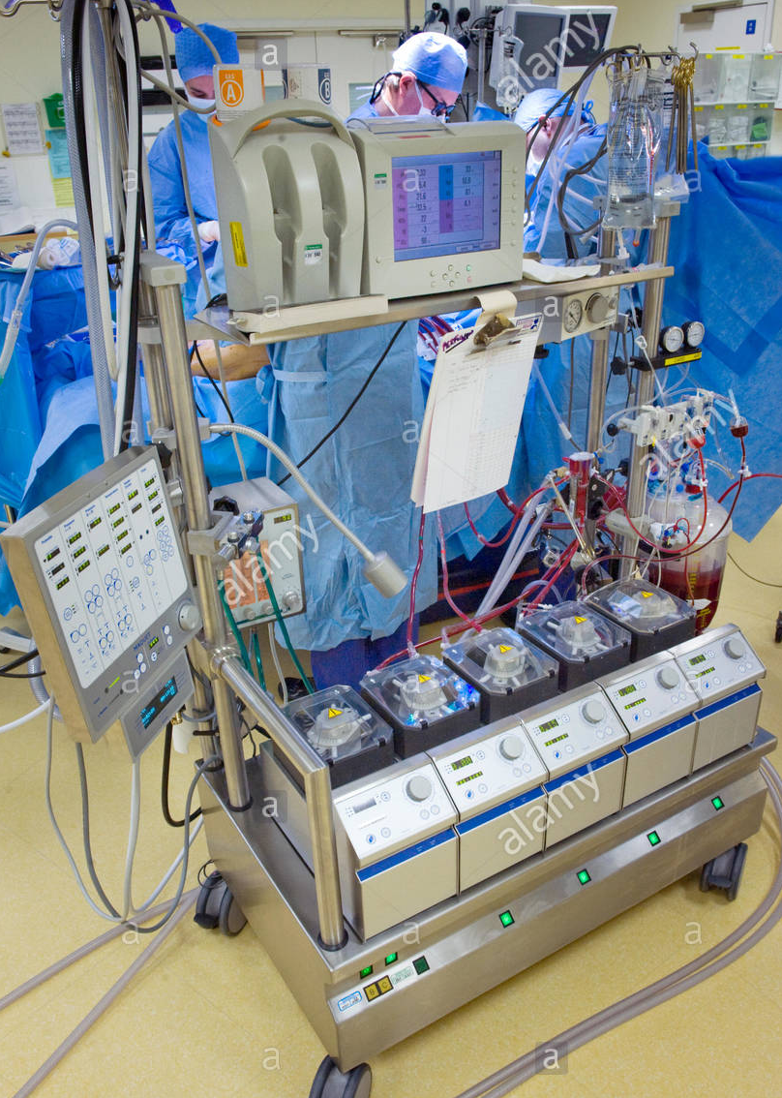
How does it work?
The surgeon inserts cannulas (small tubes) into the patient’s main veins, the Inferior Vena Cava and the Superior Vena Cava, and arteries (the Aorta).
The blood flowing through the main veins (IVC and SVC) is taken to the bypass machine before it reaches the heart. The blood then travels through the bypass machine via a pump and is cooled or warmed, and then picks up oxygen as it passes through an oxygenator (artificial lung) and is pumped into the other tube sited in the aorta. This ensures all vital organs are adequately perfused and oxygenated. It is the responsibility of the perfusionist to manage the bypass machine throughout the operation.
Prior to going on to bypass the machine and the patient are given a drug called heparin. This drug thins the blood and prevents normal clotting mechanisms from occurring and therefore clots from forming in the circuit. At the end of the procedure a further drug called protamine is given to reverse the effects of heparin.
If the surgeon is required to work inside the heart it may be necessary to actually stop the heart from beating. In order to do this a cold solution called cardioplegia will be infused into the heart. The high potassium and cold temperature stops the heart from beating, protecting it from lack of blood supply for a period of time allowing the surgeon to perform the repair work inside the heart.
When the surgery is complete the heart often requires a small electrical jolt to start It beating again. On occasion the heart may require temporary pacing wires to help with beating as it recovers.
Will my child need cardiopulmonary bypass?
Not all children requiring heart surgery need to go onto bypass. Your cardiologist or cardiac nurse specialists will inform you of this. The following surgeries do not require the use of bypass:
Pulmonary Artery banding
Coarctation of the Aorta
Patent Ductus Arteriosus ligation
BT shunt (sometimes bypass may be required for this but not always)
Risks and complications of bypass
- Air bubbles in the blood – both air and clots can break loose and travel to another part of the body. This can lead to an event such as a stroke or seizures. This is however a rare neurological event.
- Bleeding after the operation- as previously mentioned we have to thin the blood to stop the blood from clotting and reverse this with the use of another drug. This may lead to some bleeding. The bypass machine also damages some parts of the blood that help form clots. It is therefore common after surgery, especially with those children who have a long operation time to have some bleeding. This is monitored via chest drains. We will replace any clotting factors and give blood transfusions as required once back on the intensive care unit. In some cases where bleeding is excessive the patient may have to return to theatre to stop the bleeding.
- Blood transfusion- despite careful screening, a blood transfusion can sometimes result in a reaction, usually very mild. We use the smallest volume of blood we can to restrict exposure to blood products.
- Activation of a systemic inflammatory response- being on an artificial machine the body often activates the body to release chemicals and cells that cause inflammation. This leads to the body to swell and for lungs to become ‘wet’. Diuretics will be given post surgery to reduce the fluid. You child may also develop a temperature post op due to this.

Risks and complications of surgery

All surgery, however minor, carries risk of complications and death. These risks are related to the anaesthetic, bypass and the surgery itself. Whilst in most patients the risks are low, it is never possible to guarantee a risk free operation. Complications can occur during the operation or in the early post operative period. Risks can depend on the following factors:
Age of the child Condition of the child prior to surgery
Nature of the heart defect Previous heart surgery Additional medical conditions.
The cardiac nurse specialists will carry out the Lilac consent at your pre assessment appointment. This is an informed consent which will give you percentages of risk from mortality to post op complications.
The surgeon will access the heart via a sternotomy incision at the front of the chest or via a thoracotomy from the side of the chest. Sometimes the chest may be left open and covered with a see through dressing called a silastic membrane. Your child will be heavily sedated and paralysed if this is the case. The chest will be closed by the surgical team within a day or so of the operation.
Complications
- Bleeding
- Infection – your child will require a short course of antibiotics post operatively. We look out for infection daily with bloods tests, swabs and regular microbiologist review.
- Fluid collection- due to the inflammatory response post bypass fluid sometimes collects around the lungs. This sometimes requires a chest drain insertion. Your child may appear more swollen than usual but this will improve. Some surgery such as Fontan completion may require a prolonged period with chest drains.
- Heart failure- post surgery the heart function may be decreased and may require support. We can give intravenous medication called inotropes to support the heart whilst it is adjusting to its new anatomy.
- Kidney Failure- sometimes whilst on bypass some organs and tissues get a little less blood flow than normal resulting in some reduction in kidney function. Although infrequent if this does happen we can support the kidneys through peritoneal dialysis or in some cases haemofiltration
- Brain damage- As previously mentioned there is a small risk of air or clot embolism which can lead to stroke or seizures.
- Intestinal damage- this is more common in new-born infants. There is increased risk of NEC (necrotising enterocolitis) and ileus. Your child will be fed as soon as possible post op in most cases via nasogastric tube at a reduced volume. Due to drugs and surgery the gut takes some time to absorb feed again and even to pass a stool. In new-borns who are unable to feed we can commence an intravenous feed called TPN.
- Nerve damage- sometimes surgery can damage the phrenic nerve which controls the diaphragm. In younger infants this can lead to difficulties weaning from the ventilator. A small procedure can be done to correct this. Laryngeal nerve damage can also occur, this is rare and causes a permanent hoarseness.
- Arrythmia- due to where the surgeon is operating the electrical activity within the heart can be temporarily damaged/inflamed requiring temporary or in rarer cases permanent pacing.
- Intraventricular Haemorrhage – this can occur in preterm infants / new-borns. Due to the heparinisation from bypass there is risk of bleeding into the ventricles of the brain. After birth a preterm baby’s brain is exposed to changes in blood flow and oxygen levels. This may cause vessels to break and bleed.
- Extracorporeal Membrane Oxygenation (ECMO)- In some more complex cases sometimes the heart and lungs need time to recover from the surgery. ECMO can provide this support. The ECMO machine is similar to the heart/lung machines used during bypass. We have a specialist team of nurses on ICU who can nurse your child whilst on ECMO.

What happens after surgery?
Whilst in theatre we would ask you to remain on the hospital grounds or over at Mc house. There is a waiting area between 1C and Critical Care where you can wait. There is a small kitchen to make a drink and a breastfeeding room if required.
After the operation nursing staff will accompany you onto the unit. We understand this can be a scary, stressful time and we are here to support you. Your child will have a lot of monitoring initially and will be nursed 1:1. Whilst on Intensive care your child will be cared for by the medical team led by consultant intensivists.
We advise regular food and drink breaks and encourage you to get your rest overnight. You cannot sleep at the bedside and there can only be two visitors at a time. The staff on Critical Care are there to look after you as well as your child so feel free to discuss any concerns with your nurse. We do not allow young siblings to visit on Intensive Care. There is also a protected handover time between 7 and 730 am/pm where you cannot visit.
When well enough your child will step down to 1C or occasionally via the high dependency unit. The length of time required on ICU varies from child to child, we advise taking each day as it comes.

Useful Information

Accommodation

Ronald Mcdonald house is our hospital accommodation. Whilst on Critical care you will be able to stay in MC house. This is run by an independent charity and is free of charge. They ask for a £25 deposit at the start of your stay. Here there are kitchen and laundry facilities to use. Each room can sleep up to 4 people.

Parking

We have a multistorey car park at Alder Hey which is within walking distance of MC house. The car park is £8 per day. However once an inpatient if you visit the concierge desk you can obtain a parking pass. This requires a £5 cash deposit. If you have a blue badge parking is free.

Breastfeeding

We have a dedicated breastfeeding / expressing room by the entrance of critical care. There are also several baby change facilities around the hospital.

Food and drink

Whilst on the ward you child’s food will be provided by the ward chef. For parents there are several outlets within the hospital. We have Treetops restaurant, baguette company, costa coffee and a WHsmith on site. Close to the hospital there is a Sainsbury’s supermarket which is within walking distance.

Spiritual Care

The spiritual care department is centred on the sanctuary which is located in the lower floor of the “tree house” accessed from level 2. As well as space for worship there is a quiet room where families can reflect or pray in peace. Prayer mats and screens are also provided. We can contact a member of the team, whatever faith, for a prayer or for even a baptism.

Other information

On site we have a cash machine and free Wifi. We ask whilst on the ward or critical care you keep your phone on silent. There is a park nearby and lots of outside areas around the site. We do offer an interpreter seRvice for all nationalities. There is also now a Family Wellbeing Hub based in the atrium. This team is available to discuss financial support, PALS, legal issues, housing and any other issues you may face when your child is in hospital.

Play therapy

Prior to surgery we can refer children who we think are appropriate for some play therapy. This is very useful in children to prepare them for surgery and overcome fears. We have a cardiac play specialist who can help and support our children through.

Psychology

We recognise both children and their families may benefit from some psychological support either prior to or during you child’s hospital stay. We can refer a parent or child to our service prior to surgery. We then have psychologist’s on site who cover critical care and ward 1C to meet your needs.

Dental team

We recognise children who have heart defects are more at risk of decay and in rarer cases endocarditis. We therefore highly promote attending your dentist 6 monthly. Prior to surgery our dental team will assess your child’s teeth. They also may send them for a dental x-ray. If there is evidence of decay then your child may need some dental extractions prior to surgery. This will lead to surgery cancellation.


Final thought

We are aware all this information can be very overwhelming and it is normal to feel that way, always remember “ it’s ok to ask questions”.

Important contact numbers and organisations you may find helpful

Cardiac Nurse Specialists Alder Hey – 0151-252-5291
Ward 1C ( Cardiology) – 0151- 252-5418
Cardiac Nurse Specialists Manchester – 0161-701-0664/0665/0931
Surgical Secretaries Alder Hey – 0151-282-4515

Alder Hey website – www.alderhey.co.uk
Twitter @heartcentreAld1

Children’s Heart Association- 01706-213632
Website – www.heartchild.info

British Heart Foundation – 020-7935-0185
Website – www.bhf.org.uk

Children’s Heart Federation- 08088085000
Website – www.childrens-heart-fed.org.uk
Email- chf@dircon.co.uk

Little Hearts Matter ( for children with single ventricle anatomy)
0121-455-8982
Website – www.lhm.org.uk
Email- info@lhm.org.uk

Max Appeal ( for children affected by Di-George syndrome)- 01384-821-227
Email- maxappeal@cableinet.co.uk

Somerville Foundation- 01473-252007
Website- www.thesf.org.uk

Congenital Cardiac Audit Database (CCAD)- We submit all our operation data to this NHS database. Our surgical results can be viewed at www.ccad.org.uk/congenital. The information is held by the NHS and used to audit the quality and outcome of treatment.

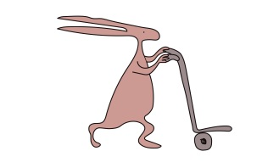



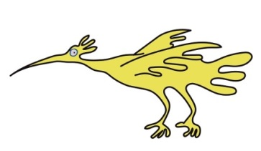
This leaflet only gives general information. You must always discuss the individual treatment of your child with the appropriate member of staff. Do not rely on this leaflet alone for information about your child’s treatment.
This information can be made available in other languages and formats if requested.

Alder Hey Children’s NHS Foundation Trust
Alder Hey
Eaton Road
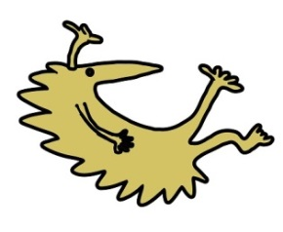
Liverpool
L12 2AP

Tel: 0151 228 4811
www.alderhey.nhs.uk

© Alder Hey Review Date: June 2028 PIAG: 408

