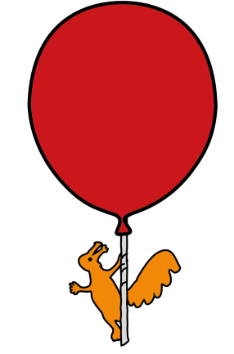
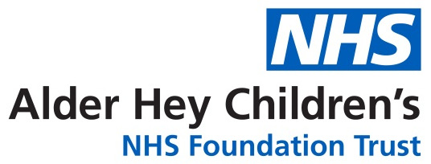

Respiratory Department

Bronchoscopy and Lavage for Children attending

for day case bronchoscopy

Information for young people, parents and carers

Introduction
Please take time to read this leaflet. It was written with input from children and parents who have experienced a bronchoscopy and lavage. They believe there is less stress when you understand what will happen.

Why do I need a bronchoscopy and lavage?
Your doctor has advised you should have a bronchoscopy and lavage because you have a problem with your chest. By having a bronchoscopy and lavage, there is a good chance we will find a reason for your chest problem. Knowing what is causing the problem will help us choose the best treatment for you.
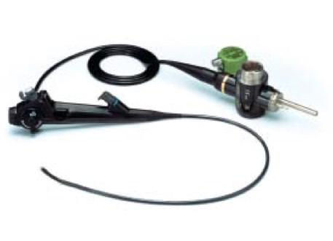

Picture of a Bronchoscope

What is a Bronchoscopy?
A Bronchoscopy is how a doctor looks inside your airways.

This is done by looking at your airways using a bronchoscope while you are having a deep sleep that we call a general anaesthetic.

A bronchoscope is soft, flexible and thinner than
a pencil. It fits easily inside your mouth and airways.
The bronchoscope has a bright light at the end to light up your airways and a camera. The image that is seen by the camera is shown on a television screen.

We usually make a digital video recording of the bronchoscopy so that we can review what we have seen during the bronchoscopy. We can show this to you as well, if that is helpful. We store the recording securely. Sometimes we used the video recording for teaching doctors and students.

What are the benefits of me having a bronchoscopy?
By having a bronchoscopy and lavage there is a good chance the doctors will find a reason for your chest problem. Understanding what is wrong will help the doctors to treat your chest problem correctly.

How is the bronchoscopy done?
When you arrive at hospital, you will meet nurses and doctors who will be looking after you.
The doctor who will do the bronchoscopy will speak to you and your parents and will examine you.
You will also meet the doctor who is your anaesthetist. You may be sent for a chest X-ray.
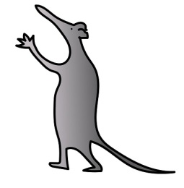
The bronchoscopy will be done while you are having a deep sleep. You will not know
it is happening and you will not remember it. To make you sleep the anaesthetist will
give you sleep medicine that we call a general anaesthetic.

You might need a small plastic line put into the back of your hand so that anaesthetic medicine can be given into a vein.

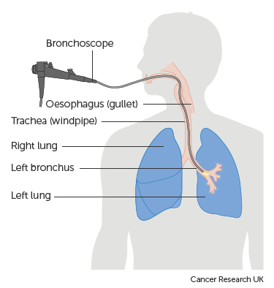
Diagram of bronchoscopy

Diagram of bronchoscopy

If you need a line you will have some “magic” numbing cream on the back of your hands. This will stop it hurting when the line is being put in. You might feel a little scratch.

Once you are sleeping, the back of your mouth will be sprayed to make it numb. The bronchoscope is then passed through your mouth and into your airway. The doctor can then look around your airways.

What is Lavage?
Lavage really means washing. This is how we find infection and abnormal cells in your airways. Some salt water is
squirted down the bronchoscope into your airways.

The salt water is then sucked out along with some cells and any bacteria or virus. The information this part of the procedure gives us is usually helpful. The results help us decide on the treatment you may need.

What do I need to do to prepare for the Bronchoscopy?

THIS IS IMPORTANT
- If you are on asthma inhalers or oral asthma medicines, you must continue to take these as normal.

- If you are on oral or nebulised (inhaled) antibiotics, please stop these 48 hours before the bronchoscopy.

Can I eat or drink before the Bronchoscopy?
You must not eat anything 6 hours before your bronchoscopy.
This is very important because if you do eat close to the operation, you may be sick (vomit) during the anaesthetic and this is dangerous. You are allowed to sip small amounts of water or clear juice up to 0730AM on the morning of the bronchoscopy.

If your child is under 12 months and is breastfeeding, our advice is to finish the last breastfeed before 05.30 AM (3 hours before the procedure)

If your child is under 12 months and is bottle-fed, we advise finishing the last bottlefeed before 04.30 AM (4 hours before the procedure).

Our hospital staff may give children a small drink of water or clear juice before their bronchoscopy.

Will the medical team do anything else?
While you are asleep, we have a good opportunity to take any blood tests that might be required, and because you are asleep you won’t feel any pain.

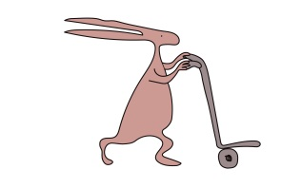
If we see signs of infection in your lungs you will need treatment with antibiotics. You may need antibiotics given into a vein for a couple of weeks. A long line can be placed in your arm vein while you are still asleep.
The long line lasts much longer than the small line (cannula) that is put in the back of your hand.

It is normal to take blood for tests if we put a line in or plan to give antibiotics.

Will bronchoscopy and lavage hurt me?
No. Most young people and children have no problems with bronchoscopy. Tell us if you feel unwell, are sore or uncomfortable and we will try to help.
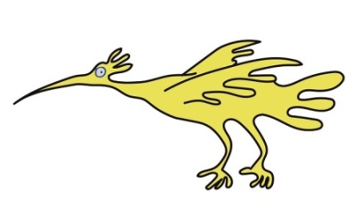

What are the risks of me having a bronchoscopy?
Bronchoscopy is usually a safe and straightforward procedure.

Are there any alternatives to this procedure?
No.

What will happen if I decide not to have a bronchoscopy?
You may still need treatment for your chest condition, but we will be making decisions without all the information that we would like to have. This could mean we don’t make the correct decision and it may take longer to make you better.

How long will I be hospital?
A bronchoscopy is usually done as a day case and most patients are able to go home on the same day. However, some patients will be asked to come into hospital the day before for tests and some may have to stay in hospital after the procedure.

Your own plan should have been agreed with you before you come to hospital.
Sometimes we have to change this plan according to what we find during the bronchoscopy.

Please bring an overnight bag just in case you need to stay overnight.

How long will the bronchoscopy take?
The bronchoscopy and lavage will take about 10 minutes. You will be asleep for about an hour while we do the bronchoscopy, lavage and insert a long line, if a long line is needed.

What should I expect afterwards?
After the bronchoscopy you will be taken to the recovery area you will wake up.
You must not eat or drink for one hour after the bronchoscopy, as your throat will still be numb. You may feel sleepy for the rest of the day.

Can I bring my teddy or favourite toy to theatre with me?
Yes, of course you can. You can ask for a name label for your teddy so we know who they belong to. Please make sure we know where teddy is so we can take special care of teddy too.

When will I get the results?
After you wake up, the doctor who did the bronchoscopy will usually come and tell you and your parents or carers what was seen. Some results from the lavage will be known in three days but it can take up to two weeks for all the results to be known.

You will usually be asked to come to a clinic appointment with your usual respiratory doctor to discuss the results.

Discharge information: Are there after effects?
Some children will cough for a couple of hours after the procedure.

Don’t worry if your voice sounds hoarse. This often happens and your voice will usually be back to normal by the next day.

A few children have an uncomfortable or sore throat. If you feel sore you can ask for some paracetamol.

Sometimes children get a temperature or fever soon after bronchoscopy. If you have a temperature and feel uncomfortable you can have some paracetamol.

Important note to parents and carers: Please seek medical attention from your local doctor if you are concerned that your child is becoming unwell.

Getting back to normal:
You can carry on with all your normal activities the day after your bronchoscopy. We expect school age children will be fit to attend school next day but they can be excused contact sports on that day!
Long lines can get pulled out by accident. Don’t worry to much if this happens – it is not an emergency. If the line gets pulled out, and there is any bleeding, just apply firm pressure with a clean tissue or handkerchief for three minutes. Please call your community nurse team to let them know that the line has come out and they will give you advice about what to do next.

Who do I contact if I need more information?
Don’t be afraid to ask questions.

If you have any questions, please call the Respiratory Unit on 0151 252 5777.
Or you can ask to speak to the doctors on the day of your bronchoscopy.

We are keen to hear about your experience of our service.
If you have a moment please give us feed back at www.mychildsbronchoscopy.com
That website has more information for you.

This leaflet only gives general information. You must always discuss your treatment with the appropriate member of staff. Do not rely on this leaflet alone for information about your treatment.

This information can be made available in other languages and formats if requested.

Alder Hey Children’s NHS Foundation Trust
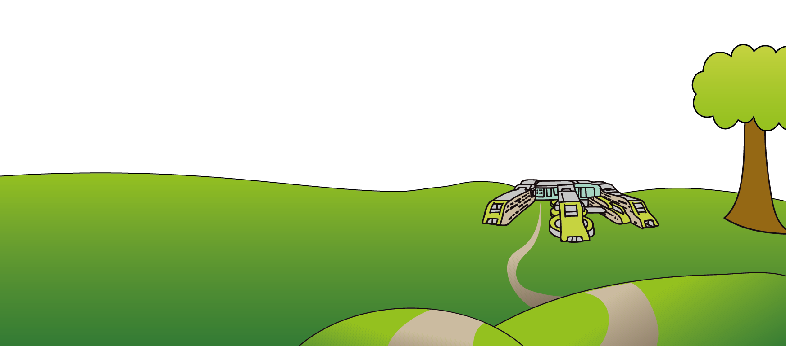
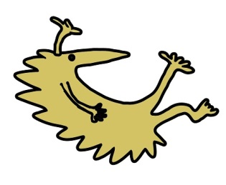
Alder Hey
Eaton Road
Liverpool
L12 2AP

Tel: 0151 228 4811
www.alderhey.nhs.uk

© Alder Hey Review Date: May 2028 PIAG:20

