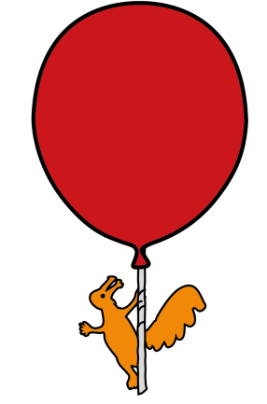
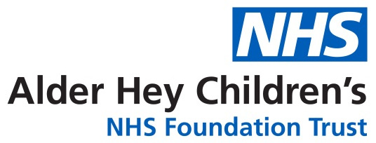

Outpatient Department

Phlebotomy (Blood tests)

Information for patients,parents and carers

Introduction:
This leaflet aims to provide you with information about the Phlebotomy Clinic and what to expect when you and your baby/child/young person attends for their appointment.
How to book a blood test appointment:
The Phlebotomy service is available by appointment only, which can be booked via the telephone line on 0151 282 4589 (Line open from 09:00 to 17:00 Monday to Friday, excluding Bank Holidays).
Phlebotomy appointments are available from 08:30 to 17:45 for appointments requested by your GP, and from 08:15 to 17:00 for Alder Hey Phlebotomy requests.
If you need to cancel your Phlebotomy appointment, please call 0151 282 4589 (Line open from 09:00 to 17:00 from Monday to Friday excluding Bank Holidays) or visit https://www.alderhey.nhs.uk/visiting/outpatient-appointments/change-cancel/, alternatively you will be able to cancel via the text reminder.
Please inform us if your child or young person has a diagnosis of autism, has a learning disability, is needle-phobic or has a mental health condition that requires reasonable adjustments on their visit to the department i.e. quieter space to wait in, longer appointment time etc.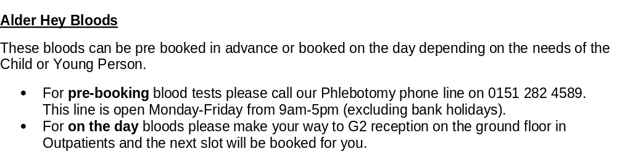Why do Children and Young People need a blood test?

Children and Young People may need to have a blood test because they have been feeling unwell. The blood test will help us find out why. Blood tests can also be used to monitor existing conditions, treatments and medications. If you are not sure why the blood tests are needed, please ask the doctor or nurse who has requested them.

Numbing cream (Magic Cream) and Cold Spray.

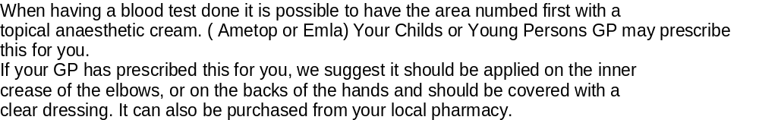

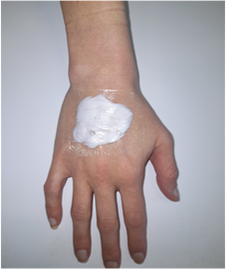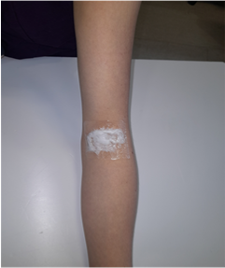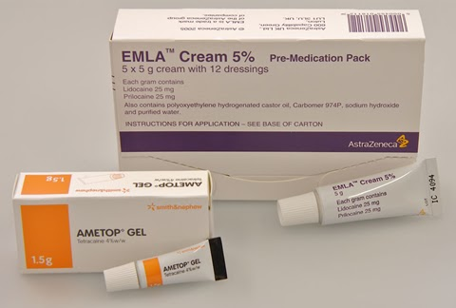
Back of Hands
Crook of Elbows
Ametop must be stored in the fridge. Emla Cream must be stored in a cupboard.

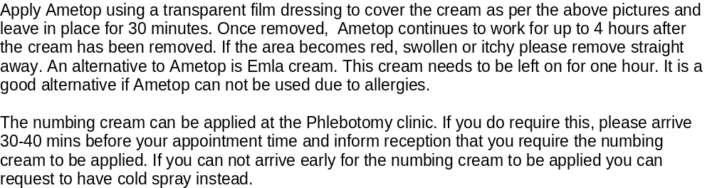
Cold spray is applied and works instantly, the phlebotomist will spray this on the arm or hand, it does feel very cold, but it doesn’t hurt. Please note if a Child or Young Person has very small veins, or is known to have difficult access we would recommend the numbing cream rather than the cold spray. The nurse can review this with you on the day.

Please inform staff if your Child or Young Person has any allergies prior to using Ametop, Emla or the cold spray.

Buzzy Bee

The Buzzy® device can be used to reduce or block pain from needle procedures such as blood tests. This can be used with or without numbing cream and cold spray. It can also be used with the wings frozen or without wings.

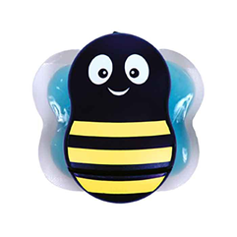
Preparation advice.

Having a blood test can be quite unsettling for your Child or Young Person. It is always a good idea to prepare your child before having one done. Talk to your child before hand explain what might happen, tell them it will be over with quickly, be honest with them and give them lots of reassurance.

Parents are strongly encouraged to stay and help their child during the procedure, your child may want to sit on your lap or cuddle you whilst having their blood test done. Distracting your child during the procedure will help take their minds off what is happening, we encourage you to bring along their favourite toy, teddy, book or electronic device that may help them to do this. Other top tips includes keeping arms and hands warm prior to the appointment, particular in winter as this will help with the blood test. Please encourage your Child or Young Person to drink plenty of fluids prior to their appointment as this will help the phlebotomist to find a vein. If your child is for fasting bloods they can be given water but no food, milk or chewing gum.

We have a number of resources for use to help prepare your child or young person for coming into hospital and having a blood test which you may find useful. Please look at these resources and decide if they are useful for you and your child/young person.

- We have a story board which can be found on the following page of this leaflet
- There is a workbooklet called “Terrys trip to Alder Hey” that you can work through with your child.
- There is also a animation available to watch.

All these resources can be found on the Alder Hey web site.

Health Play Specialist

The Trust has a Health Play Team, made up of Health Play Specialists and Play Leaders. A Health Play Specialist uses therapeutic play, tools and strategies to prepare and distract children and young people during medical procedures. If your child/young person requires support for their blood test, please let a member of the Outpatient Team know and we can contact the Play Team.

What will happen during the appointment?

On arrival please book into either G2 reception or Catkin reception (depending on where your blood test is). You will be called into the room by one of the phlebotomists who will introduce themselves and explain all about what will happen during the procedure.

The phlebotomist will review the blood requests and will discuss with you the most suitable way to collect the blood sample. There are two different ways we can collect blood from Children and Young people:

- From the vein with a very small butterfly needle or
- Finger/heel prick.

How we collect the blood sample will depend on the volume of blood and specific blood tests that are required. We can have this discussion with you and give all the information you require during your appointment.

What should I expect to happen once my Child or Young Person has had this procedure?

It is quite common for some localised bruising to occur after a blood test, this will normally go away in 3-5 days, however if it does not improve, is swollen or painful then please contact the clinic or seek medical advice.

Once the blood samples have been taken they are sent to the laboratory for testing. How long the test results take to come back can vary, some can be completed within a few days but other more complex tests can take a few weeks. Once completed the results will be sent directly to the doctor who requested them, this is usually a consultant within the hospital or your Childs or Young Person’s GP. The doctor will usually inform you of the results by letter, occassionally by telephone or at your child’s next appointment. Please be aware that your Child or Young Person’s results can only be given to you by the doctor involved in your Childs or Young Person’s care.

For more information, including our Phlebotomy Animation, please visit our website:

https://www.alderhey.nhs.uk/services/phlebotomy/

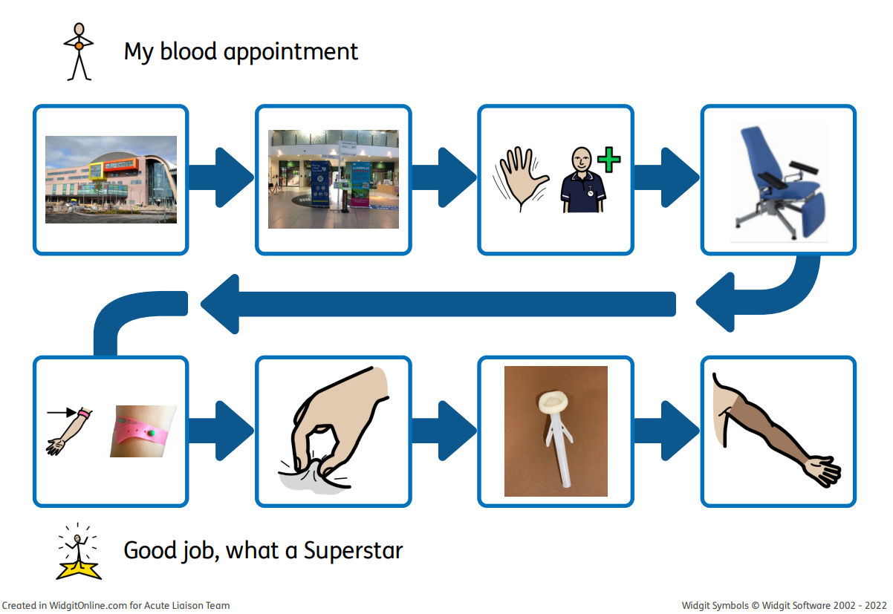
Social Story
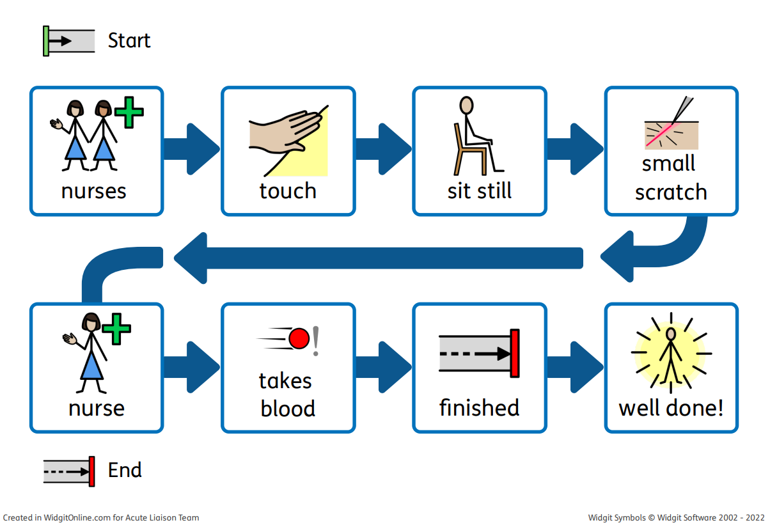

This leaflet only gives general information. You must always discuss the individual treatment of your child with the appropriate member of staff. Do not rely on this leaflet alone for information about your child’s treatment.
This information can be made available in other languages and formats if requested.

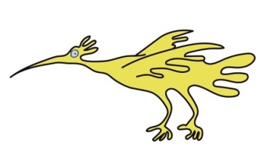
Alder Hey Children’s NHS Foundation Trust
Alder Hey
Eaton Road
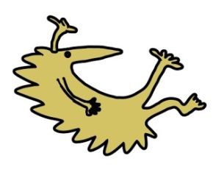
Liverpool
L12 2AP
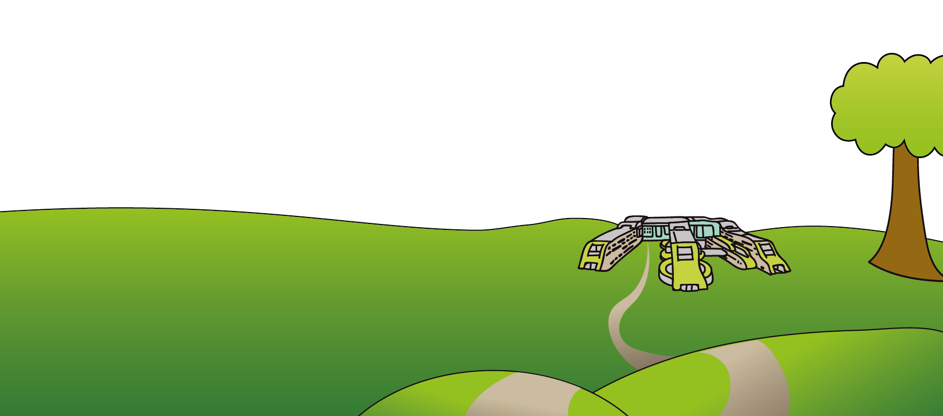
Tel: 0151 228 4811
www.alderhey.nhs.uk

© Alder Hey Review date: August 2029 PIAG: 478

