Department of Orthopaedics and Trauma

Achilles Tenotomy in Clinic

Information for Parents and Carers

Introduction

This leaflet has been produced to give you some information about the Achilles tenotomy procedure to improve the position of your baby’s foot before they go into boots and bars.

Why does my child need an Achilles Tenotomy?

The Achilles tendon is the tendon that runs down the back of the ankle. After your child’s foot/feet have been manipulated in casts, the final step is to cut the tendon to improve the foot position to stop it pointing downwards. This allows the tendon to lengthen and fit better into the boots and bars.

What does the procedure involve?

Your child will have their plaster removed when they arrive to outpatients by one of our plaster technicians. They will then have some numbing cream (Ametop) applied to the back of their ankles around where the cut will be. This takes around 30 minutes to work so you will then be asked to wait in the waiting area.

When the numbing cream has worked, we will bring you and your child into the clinic room. We will ask you to feed your baby once the procedure starts. An injection of local anaesthetic will be infiltrated into the skin where the numbing cream previously was and a small blade will be used to cut the tendon. After the procedure, a dressing will be applied and the final Ponseti plaster put on. This will stay on for a further 3 weeks.

We will ask you to wait in the department for 30 minutes after the final cast has been done to make sure baby is settled and there are no immediate concerns.

Will it hurt?

The Ametop works well and can be used on its own for the procedure. However, we inject a small amount of local anaesthetic to make sure that your baby is completely comfortable. Nationally, this is well accepted method of numbing the skin to allow release of the tendon and recommended by the UK Clubfoot Consensus Group.
How can I prepare for it?

We ask for you to feed your baby first thing in the morning (bottle or breast feed) around
08:00 and then keep them starved for the procedure, which is in the afternoon.
As your baby will be hungry, when they are fed during the tenotomy, it automatically
soothes them and keeps them settled throughout.
What are the benefits?

Professor Ponseti’s original work said that 80-95% of patients require an Achilles tenotomy to fully correct the foot. By cutting the tendon, the heel position improves and it is the final step of a casting process.

What are the risks?

The risks are small. There is a risk of bleeding at the site where the cut has been made. This is usually solved by applying pressure to the area for 2-3 mins. Occasionally the tendon may need to be cut twice if it does not completely release during the first time.

At a later date, if the foot starts pointing downwards, the Achilles tenotomy may need to be done a second time. If this happens, the second procedure will be under general anaesthetic in theatre.

What should a parent or carer look out for once the child goes home?

The final Ponseti cast is similar to the previous casts that have been applied, and the same precautions should be taken. The foot is in an overcorrected position to get the best shape of the foot. If there is any blood coming through the cast, please contact us either by email/ contacting the plaster room.

Who should a parent or carer contact for further information or if they are worried?

Contact the Plaster Room between 9am to 5pm on Monday to Friday. Their direct telephone number is: 0151 252 5754. For any problems / issues with Boots and Bar contact the Orthotics Team on 0151 252 5318.
Otherwise, attend the Accident and Emergency Department for any emergency and the on-call Orthopaedic Team will be happy to see your child.

What will happen in the next appointment after the tenotomy?

At the next appointment, your baby will be seen by the Ponseti team and a member of the orthotic team. We will remove the cast and the first boots and bars will be fitted. Please bring a thin pair of socks with you for the baby so we can show you how to put the boots and bar on. It is good for both parents to attend this appointment so they can both learn how to fit the boots and bar.

Other sources of help and information
STEPS is a voluntary organisation which support the care of children with lower limb abnormalities. STEPS Helpline: Tel: 0871 717 0044 www.steps-charity.org.uk.

UK Clubfoot Consensus Group (UKCCG): www.clubfootuk.net
Other web sites:
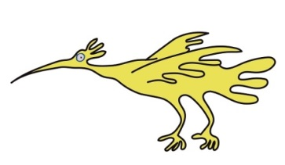
www.ponseti.org.uk
www.vh.org/pediatric/patient/orthopaedics/clubfeet/index.html.

This leaflet only gives general information. You must always discuss the individual treatment of your child with the appropriate member of staff. Do not rely on this leaflet alone for information about your child’s treatment.
This information can be made available in other languages and formats if requested.

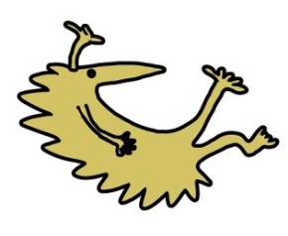
Alder Hey Children’s NHS Foundation Trust
Alder Hey
Eaton Road
Liverpool
L12 2AP
Tel: 0151 228 4811
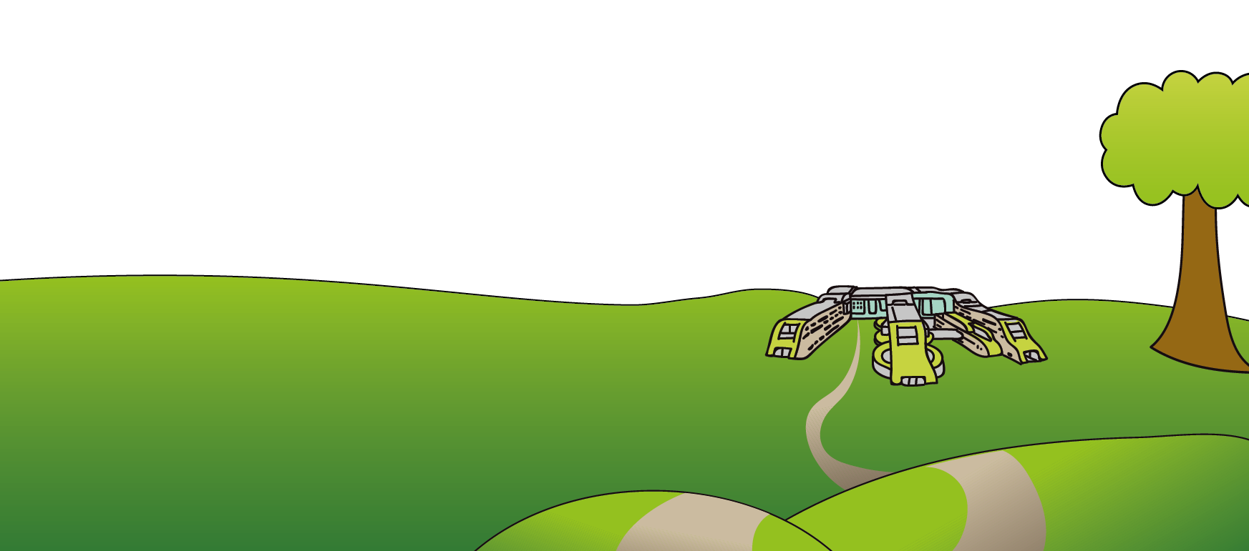
www.alderhey.nhs.uk

© Alder Hey Review Date: August 2026 PIAG: 477

