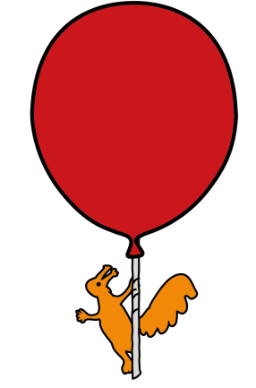


Department of Pharmacy

Levomepromazine

Information for patients, parents and carers

This leaflet has been written for parents and carers about how to use this medicine in children. Our information sometimes differs from that provided by the medicine’s manufacturer, because their information is usually aimed at adult patients. Please read this leaflet carefully. Keep it somewhere safe so that you can read it again.

Why is it important for my child to take this medicine?
Levomepromazine is usually used as an anti-sickness medication and is given to prevent or stop episodes of nausea and vomiting. Levomepromazine is licensed for other uses in adult practice.

What preparations of levomepromazine are available?
Levomepromazine is available as a 25mg tablet, which can be halved or quartered for smaller doses, and as a 5mg/1mL oral solution.

The oral solution has a 3 month expiry date, once opened. If the pharmacy department have opened or packed-down this solution into a smaller bottle, they will specify the expiry date. If you receive a full, unopened bottle, you must write the expiry date on the label when you open the bottle for the first time.

How much levomepromazine should I give and when should I giveit?
Your prescriber will decide how much levomepromazine your child will need. The dose of levomepromazine varies according to your child’s body weight. The dose will be stated on the pharmacy label.

How should I give it?
The oral solution should be given using a marked enteral syringe. The bottle should always have a bung, to allow you to accurately measure the dose (this may be placed in the bottle by the dispensing pharmacy team, or provided for you to place into the bottle when you open it). The oral solution may be given by mouth, or down a feeding tube if your child has one.

The tablets (which can be quartered or halved if necessary) can be swallowed with water, or crushed and added to a spoonful of soft food (such as yoghurt) or dispersed in water or fruit cordial.

When should the medicine start working?
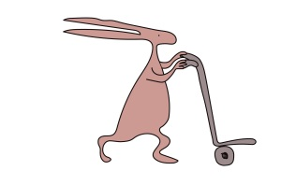
The effects of levomepromazine should be felt within a couple of hours.

What if my child is sick (vomits)?
Do not give another dose, but continue when the next dose is due.

What if I forget to give it?
If you forget to give your child a dose, give the next dose as usual. Do not give a double dose to make up for a forgotten dose.

What if I give too much?
If you accidently take too much, you should immediately call your child’s team at Alder Hey for advice.

Are there any possible side effects?
Like all medicines, levomepromazine can cause side effects, although not everyone gets them. Some commonly reported side effects are:
- Drowsiness
- Dry mouth and a feeling of weakness
- Low or high blood pressure or feeling dizzy upon sitting or standing up
- Alteration of the heart rhythm
- Constipation, nausea and vomiting

There may, sometimes, be other side-effects that are not listed above. If you notice anything unusual and are concerned, contact your doctor. You can report any suspected side-effects to a UK safety scheme at http://yellowcard.mhra.gov.uk.

Tell your doctor right away if your child has any of the following:
- symptoms of infection (which may include fever, mouth and gum inflammation, swollen tonsils, or flu-like symptoms)
- high fever with muscle stiffness

Can other medicines be given at the same time as levomepromazine?
You should always tell your pharmacist, nurse or doctor if your child is on any other medication, including over the counter medicines and herbal medications, as they may affect how levomepromazine works. Your pharmacist will review any other medications your child may be on to make sure levomepromazine can be used safely and effectively.

Is there anything else I need to know about this medicine?
Anyone who is taking levomepromazine should avoid alcohol, driving, and operating machinery.

Where should I keep this medicine?
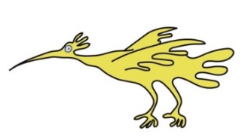
- Store in the original container in a cool dry place and out of direct sunlight. This medication doe not require refrigeration.
- Keep this medicine out of the sight and reach of children.
- Do not use this medicine after the expiry date stated on the label or carton.

If you have received this medicine in its original manufacturers packaging, discard 3 months after first opening.
- Do not throw away any medicines via wastewater or household waste. Ask your pharmacist how to throw away medicines you no longer use. These measures will help protect the environment.

General advice about medicines
- Only give this medicine to the person it has been prescribed for.Never give it to anyone else, even if their condition appears to be the same, as this could do harm.
- If you think someone else may have taken the medicine by accident, contact their doctor straight away.
- Make sure that you always have enough medicine, try to avoid running out by requesting it from the hospital in advance.
- Make sure that the medicine you have at home has not reached the ‘best before’ or ‘use by’ date on the packaging. Be aware that levomepromazine oral suspension may have a short expiry date. Return unwanted medicines to your pharmacist to dispose of.
- Please remember to bring all medication with you at each hospital visit.
- This leaflet should be read with any manufacturers’ patient information. If there is one available. You must always discuss individual treatment with the appropriate member of staff
How do I get further supplies of levomepromazine?
If you think you will run out of medication before your next appointment you will need to contact the hospital for another prescription. Please ensure you allow adequate time for this (two weeks, where possible).
If you have any problems, please contact the Pharmacy Department (see below for details)

Use of unlicensed medication in your child
This may be because there is not a licensed medicine for the illness your child has. Most medicines that are prescribed for a child will have a licence for use in adults. If a doctor believes a medicine is safe and effective for use in children, they may continue to prescribe it for a child. Your doctor will only suggest using a medicine for your child if they think that it is the best thing to help your child.
This leaflet only gives general information. You must always discuss the individual treatment of your child with the appropriate member of staff. Do not rely on this leaflet alone for information about your child’s treatment.
This information can be made available in other languages and formats if requested.

Oncology department (Ward 3B)  Alder Hey Children’s NHS Foundation Trust  Eaton Road  Liverpool  L12 2AP  Tel: (0151) 252 5212 | Outpatients Pharmacy Department  Alder Hey Children’s NHS Foundation Trust  Eaton Road  Liverpool  L12 2AP  Tel.: (0151) 282 4494
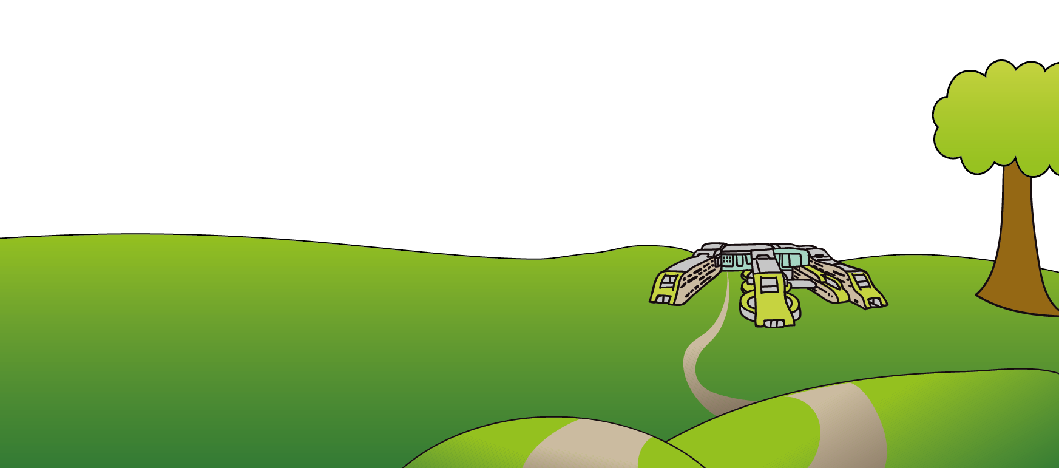

Tel: 0151 228 4811
www.alderhey.nhs.uk

© Alder Hey Review Date: July 2027 PIAG: M30

