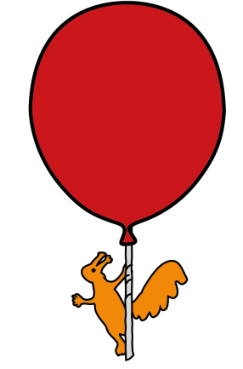
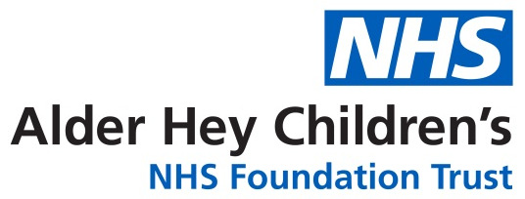

Department of General Paediatrics and Neurology
Migraine in children
Information for patients, parents and carers

Introduction

This leaflet aims to give you information about migraines and the available treatments.

What is a migraine?

Migraines are the most common type of headache in young children. It affects about 1 in 10 children of school age.$¹$ A variety of symptoms may accompany the headache which can have a huge impact on the child’s life at school and home. It is important that you know and understand how to manage migraines well.

What causes a migraine?

Migraines usually run in families and often a family member would have suffered them as well. We don't fully understand why migraines happen. It is thought that something may trigger a change in activity of some brain chemicals to set off a migraine attack.

What are the symptoms of a migraine?

Most children have a pounding or throbbing headache, which worsens as the day goes on. The headache may be on one side of their head.

Symptoms that may accompany migraine are:

  - Looking pale
  - Feeling sick and may be sick
  - Feeling those normal light causes discomfort
  - Feeling that normal noises sound loud and uncomfortable
  - Visual problems (blurred vision, unusual patterns of lines or circles/dots in black and white)
  - Unpleasant taste
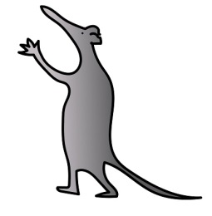
  - Sensitivity to smell
  - Sweating
  - Feeling clumsy
  - Numbness in the arms or legs
  - Difficulty in speaking or understanding

All of these symptoms do not always occur and can vary from one child to another with some children having worse symptoms. Some children have symptoms before that help predict an attack of migraine (aura). They may have a craving for some foods e.g. sweets, be hyperactive or feel excessively tired, yawning, experience mood changes.

Some children have ‘tummy pains’ without headaches. They may also have the listed symptoms accompanying a migraine – and this is recognized as a type of migraine as well.
How are migraines diagnosed?

There are no specific tests to diagnose migraine. Diagnosis is based on doctors reviewing the symptoms and examining the child. Keeping an accurate record of the child’s symptoms in a headache diary helps doctors decide about the diagnosis and management.
Scans of the head do not help in the diagnosis of migraine.

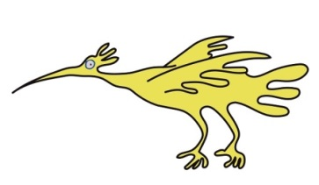
A Headache diary is useful to record:

- the frequency, duration and severity of headaches,
- any triggers or precipitating factors
- and to monitor the effectiveness of headache interventions

How is migraine treated?

Although migraines cannot be cured, they can be effectively managed in most cases. Migraine in children often responds to conservative management with trigger avoidance and simple analgesia

Self-help:

Do:
Drink plenty of water
Get plenty of rest in dark quiet place
Take regular breaks
Try to relax – Stress can make headaches worse
Take Paracetamol or Ibuprofen
Do not:
Do not skip meals (even if you might not feel like eating anything)
Do not strain your eyes for a long time – For example, by looking at a screen for long times, take breaks

Treatment of acute attack

The best treatment for most attacks is rest and sleep. Most children find relief by lying still in a dark quiet room. Many local therapies like applying cold packs to the head or massage to head, neck and temples also help. Drinking plenty of water at the start of the headache makes the child feel better.
It would be appropriate to treat with a painkiller (usually paracetamol and/or ibuprofen) in doses directed by the doctor. Frequent use of analgesics needs to be avoided to prevent medication overuse headache.

Alternatively, there are medications called ‘triptans’ that could be tried in selected cases. These would be recommended by your doctor in selected cases.

For some children, nausea and vomiting are the most distressing aspects of migraine and an anti-sickness medicine like prochlorperazine and domperidone can be useful.

Opioids should not be used to treat migraine headaches.

Lifestyle advice and identification for triggers

Headaches can be triggered by a variety of lifestyle factors, and these can be very individual. Identification and avoidance of these triggers, and lifestyle changes can help in preventing and reducing the headaches. The ones listed below are commonly recognised triggers and may be relevant to your child’s headaches. Please record any identifiable triggers in the headache diary.

1. Eating: It is important to eat regularly and avoid skipping meals. Ensure meals include protein, carbohydrates, fruits, and vegetables. Many dietary factors can trigger migraine headaches. For example; coffee, chocolate, cheese, tea, baked beans, tomatoes including ketchup, fizzy drinks/cola, citrus fruit/juices (oranges, lemon, lime). Some food additives may also act as triggers (monosodium glutamate found in Chinese takeaways).

ALL these foods do not need to be avoided, if a food is suspected to trigger migraine a period of exclusion can be trialed to see if this helps to reduce migraine episodes. These foods only must be kept out of the diet if you think that food triggers a migraine and avoidance helps.

2. Drinking: Dehydration can be a trigger for headaches, ensure adequate intake of fluids, and drink plenty in hot weather and when exercising.

3. Exercise: Regular exercise is an important part of a healthy lifestyle and is associated with less frequency of headaches. Too much exercise or inconsistent patterns of exercise may trigger headaches.

4. Hormones changes and periods can be linked with migraines. Combined oral contraceptive pills are not recommended in migraine with aura.²

5. Computer/TV screens can worsen headaches. Children should take regular and frequent breaks away from screens.

6. Sleep: oversleeping or sleep deprivation can trigger migraines. Maintain regular sleeping hours and routines as well as avoiding a morning lie-in.

7. Be aware of the effects of drugs, alcohol, and smoking on health. There is evidence that these may increase the risk for more frequent migraine attacks.

8. Stress: Stress, fatigue and anxiety are the most common triggers of headaches. Identify stress and seek advice and help for anxiety and stress management.

9. Managing exams and studies: anticipate and plan children’s studies to reduce stress and disruption to routines such as sleep, rest, and food.

10. Avoid medication overuse: taking regular painkillers like paracetamol, ibuprofen, Migraleve, etc. (more than 2 days per week) can cause a dull daily headache (medication overuse headache), which is difficult to treat and does not respond to any medications. The only way to stop medication overuse headache is to stop taking these regularly.

What happens to migraines as the children grow older?

Migraine may never be completely remitted. Most boys find that migraines tend to improve around puberty. In contrast, girls tend to get worsening migraines due to hormonal changes during teenage years.

Most children will be able to identify lifestyle changes that worsen their headaches as they grow older and adopt strategies to avoid anything that worsens the headaches.

Preventative medications

If, despite following the lifestyle measures and avoiding excessive use of painkillers, migraines continue, then preventative medication can be taken to reduce the frequency and severity of headaches. It is unlikely to cure migraine completely, however, it may reduce the number and severity of attacks. It is useful for you to keep a headache diary to monitor how well a medicine is working.

The medicine should be taken regularly for at least two – three months to note if there is an improvement. If the medicine is not beneficial after four months, it should be gradually discontinued, and another option should be discussed.

None of the preventative medicines are without side effects. Sometimes, these medicines may cause a temporary worsening of the headaches. It may take 1-3 months for maximum benefit to be noticed. Therefore, if it does not seem to work at first, do persevere for a while before giving up.

After six months or more of good control, a trial period without preventative medication being taken is recommended. This is to establish if there is an on-going need for the medication.

The commonly used groups of preventative medicines are:
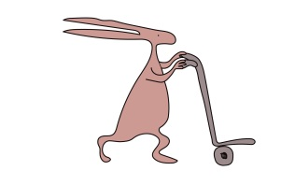
□ Propranolol (not suitable for children with asthma)
□ Pizotifen
□ Amitriptyline
□ Topiramate- Topiramate can seriously harm a baby when taken during pregnancy. Prior to initiation for girls of childbearing potential we need to ensure that they are using highly effective contraception (like contraceptive injection, intrauterine coil, or intrauterine system) and are aware of the risks from use of topiramate. You can ask for further information from your doctor.
Non-pharmacological therapies ³
Can be used as an adjunct or alternative to pharmacological therapy depending on the specific clinical situation and the person’s preference, including:
  - Behavioural interventions (such as relaxation techniques [for example, mindfulness or meditation] or cognitive behavioural therapy).
  - Riboflavin (vitamin B2) 50-400 mg/day — may be effective in reducing migraine frequency and intensity for some people

Where can I get further information?

The ‘Migraine Trust’ has a website www.migraine.org.uk and www.migrainetrust.org which has lots of helpful and age-appropriate information for 7-12 years and teens about headaches and migraines. You could also download leaflets about lifestyle changes, medication overuse headache and a headache diary from this website.

Please note: We do not monitor the content of third-party websites. Any link provided is solely for your convenience. WE do not accept any responsibility for any third-party website.

References:
- https://patient.info/brain-nerves/migraine-leaflet
- https://cks.nice.org.uk/topics/migraine/management/adults/#information-self-care-advice
- https://cks.nice.org.uk/topics/migraine/management/adults/#choice-of-preventive-treatment

This leaflet only gives general information. You must always discuss the individual treatment of your child with the appropriate member of staff. Do not rely on this leaflet alone for information about your child’s treatment.
This information can be made available in other languages and formats if requested.

Alder Hey Children’s NHS Foundation Trust
Alder Hey
Eaton Road
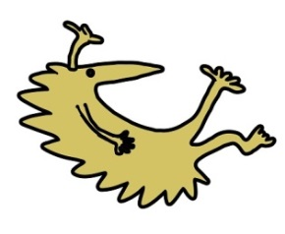
Liverpool
L12 2AP

Tel: 0151 228 4811
www.alderhey.nhs.uk

© Alder Hey Review Date: February 2028 PIAG: 35
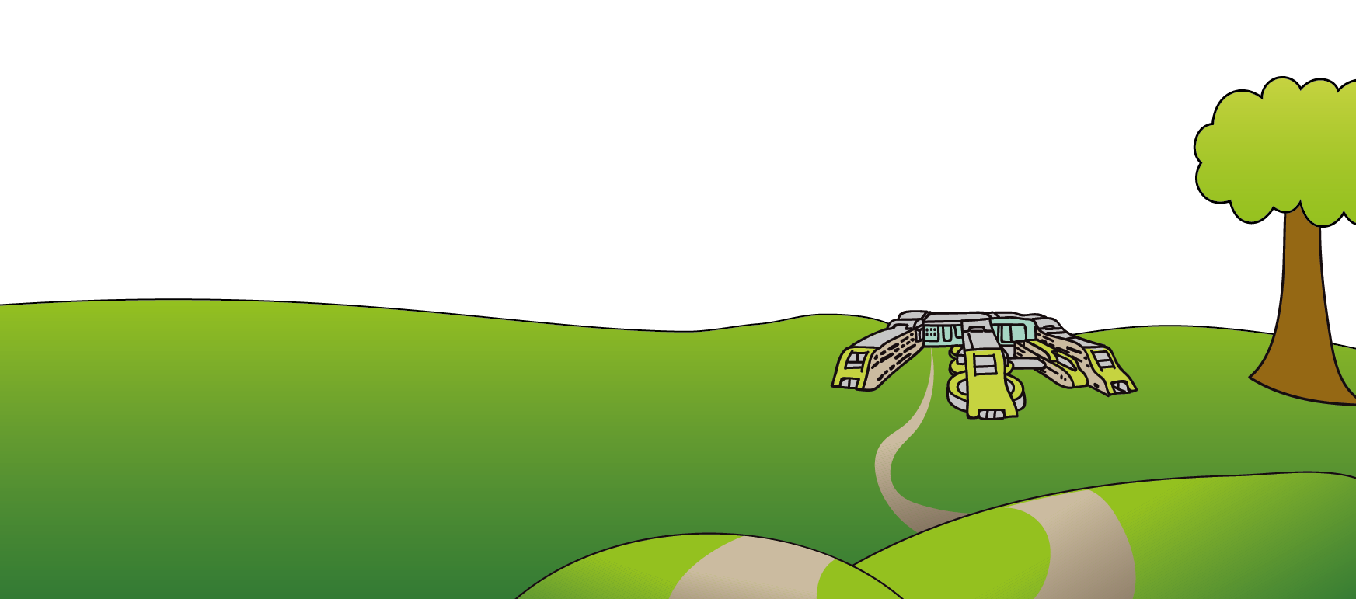

D  A  T  E | Headache Duration |  | Headache severity |  |  |  | Associated Symptoms  (please tick P ) |  |  |  |  |  | Medications Used  (Name and dose) | Relief  (please tick P) |  |  | Triggers  Activities/Foods  School /Sleep / Stress video screens etc.
D  A  T  E | More than 4 hours | Less than 4  hours | Stops  & lies down | Decrease  normal activity | Continue normal activities | Clear days | AP | N | V | PT | PN | WPA | Medications Used  (Name and dose) | No | Yes | Good
1
2
3
4
5
6
7
8
9
10
11
12
13
14
15
16
17
18
19
20
21
22
23
24
25
26
27
28
29
30
31
Key: AP: Abdominal Pain N: Nausea V: Vomiting PT: Sensitivity to light (Photophobia)
PN: Sensitivity to sound (Phonophobia) WPA: Worsen with Physical Activity

Instructions for completing your headache diary
Please complete diary for full calendar month, for each day please tick the box that indicates:
- how long (duration) your headache lasted for
- how it affected you (severity)
- associated symptoms other than the headache
- Also important to document clear days – when there is no headache,
- If medicine was taken please record what it was and how much taken on that day. Please tick the box to indicate if the medicine worked (relief). Please write anything you think may have caused the migraine (triggers).
- Please note as much information as possible
Please record the:

Number of visits to your GP (doctor) for headache .........

Number of hospital visits for headache .........
Number of school days missed because of migraine .........

© Alder Hey Review Date: February 2028 PIAG: 35
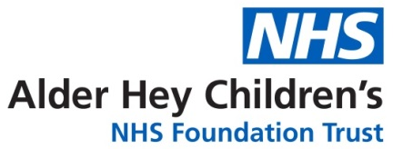

My Monthly Headache Diary

Name ...…………………………………

Month ……………………………………

Year ...…………………………………..

