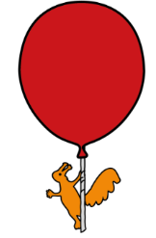

Looking after your Child’s Teeth

General Information about tooth brushing
- Teeth should be brushed twice a day: Once first thing in the morning and again in the evening before bed

- After brushing teeth, spit don’t rinse

- Babies aged 0-2 years old Use a smear of fluoride toothpaste (minimum 1000ppm*)

- Children aged 3 years + old Use a pea size amount of fluoride toothpaste, minimum of 1450ppm* (adult toothpaste).

- Adults should supervise tooth brushing until their child can brush effectively alone.

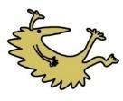

Diet information
- Drink Plain water or milk

- Eat sugar-free snacks only.

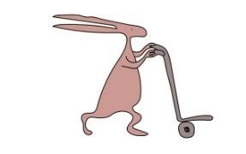
- Do be aware of hidden sugars in food.

For more information on how to look after your teeth please see watch our videos;



Taking care of your teeth

Save your teeth from sugar
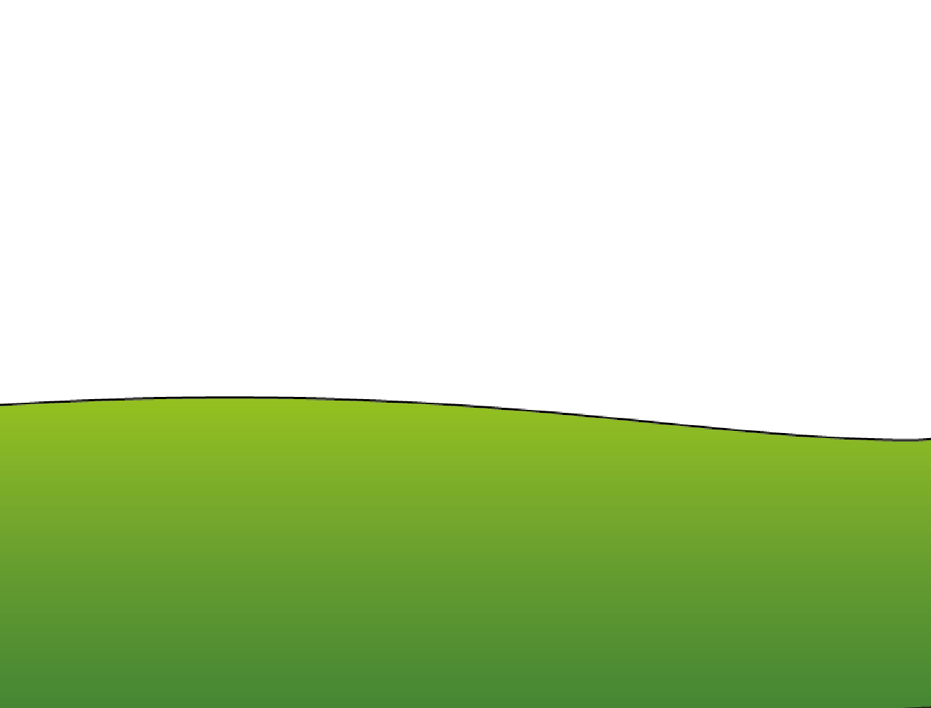
2

Tel: 0151 228 4811

www.alderhey.nhs.u
k

© Alder Hey

Review Date
:

-

202
9
-
0
2
-
18

PIAG
:

460

This information can be made available in
other languages and formats if requested

Alder Hey Children’s NHS Foundation Trust
Alder Hey
Eaton Road
Liverpool
L12 2AP

