

***‘Inspired by Children’***

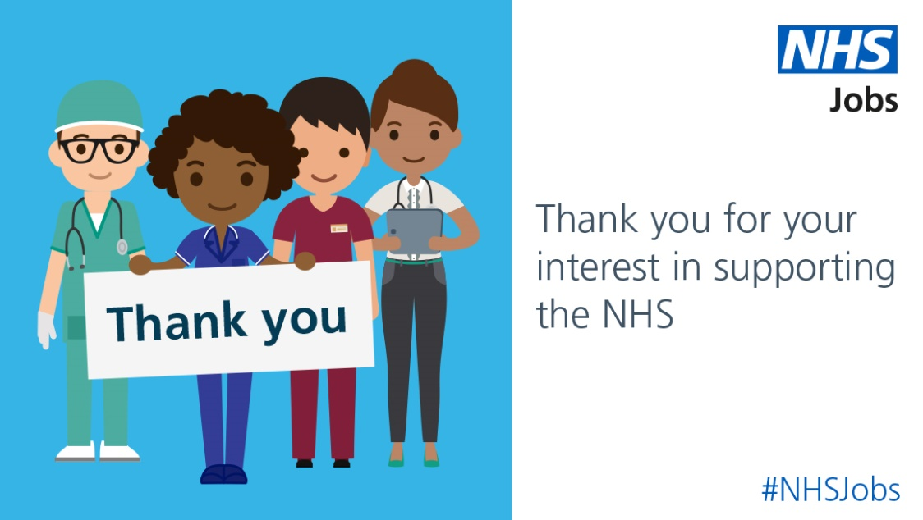**How to apply for an NHS job**

Helping to recruit the future NHS workforce

**User guide content:**

**SECTION 1:** About the NHS and its ‘Values’ Page 2.

**SECTION 2:** Alder Hey Children’s NHS Foundation Trust Page 2.

**SECTION 3:** NHS recruitment *(it’s all about skills, potential & values)* Page 3.

**SECTION 4:** The ‘NHS Jobs’ website Page 3.

**SECTION 5:** The application process & your ‘Supporting Information’ Page 4.

**SECTION 6:** The ‘Interview’ Page 4.

**SECTION 1:** **About the NHS and its ‘Values’**

**In the UK, we have all used the NHS at some point. But what exactly is the NHS?**

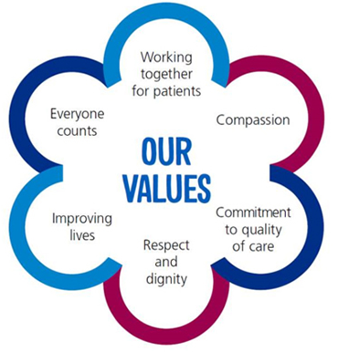The NHS is the term used in the UK to describe the collective publicly funded

**The NHS ‘Values’ are:**

healthcare systems of the United Kingdom. It’s made up of a wide range of different organisations with different roles, responsibilities and specialities. These organisations provide a variety of services and support to patients and carers. Examples include GP services, GP Out of Hours, Acute Hospitals including Emergency Departments and Cancer Care, Mental Health Services and Social Care.

**SECTION 2:** **Alder Hey Children’s NHS Foundation Trust**

Alder Hey Children’s Hospital cares for over 330,000 children, young people and their families every year.

***‘Inspired by Children’***

As one of Europe’s biggest and busiest children’s hospitals, we treat everything from common illnesses to highly complex and specialist conditions.

In 2015 we opened a state-of-the-art hospital alongside a brand new research, innovation and education centre. Alder Hey in the Park and the Institute in the Park bring together excellent care, technology and design to provide the best possible healing environment for children and their families.

In addition to our main hospital site, we offer paediatric services at a number of community sites and hold local clinics across Merseyside, Cumbria, Shropshire, Wales and the Isle of Man. We also provide specialist inpatient care for children with complex mental health needs at our Alder Park Building in North Liverpool.

We know that a children’s hospital is different and that our job is more than just treating an illness. To us, every child is an individual. As well as giving them the very best care, we set out to make them feel happy, safe and confident as they play, learn and grow.

At Alder Hey we are here to look after a child and their family and that includes mums, dads, brothers and sisters.

Alder Hey has a thriving research portfolio and leads research into children’s medicines, infection, inflammation and oncology. We are becoming recognised as one of the world’s leaders in children’s healthcare and research. We contribute to public health, lead cutting-edge research and teach the next generation of children’s specialists.

For over 100 years, Alder Hey has been providing innovative high quality care for children and young people. We continue to drive innovation in paediatric healthcare within our Innovation Hub. The Innovation Hub is a dedicated space where clinicians and industries can come together to create new products and technologies.

**SECTION 3:** **NHS recruitment *(it’s all about skills, potential & values)***

Values Based Recruitment (VBR) is about seeking to recruit staff with values that are the same as the organisation. It is used in the NHS to ensure that the NHS has the right workforce, with the right skills, in the right numbers, with the right values, to support effective team working and deliver excellent patient care and experience.

The NHS wants to recruit like-minded people which is why what you put in your ‘Supporting Information’ is very important.

**SECTION 4: The ‘NHS Jobs’ website**

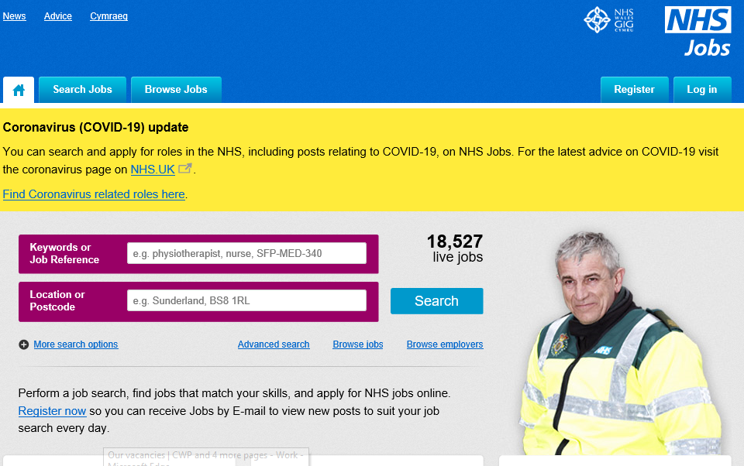

**Jobs can be found on NHS Jobs and the Trust’s website**

Click on the hyperlink below to firstly register or login:

<https://www.jobs.nhs.uk/>

You can search for jobs and set up notifications of new jobs being advertised

Ensure that you use a professional email address when registering or applying for jobs

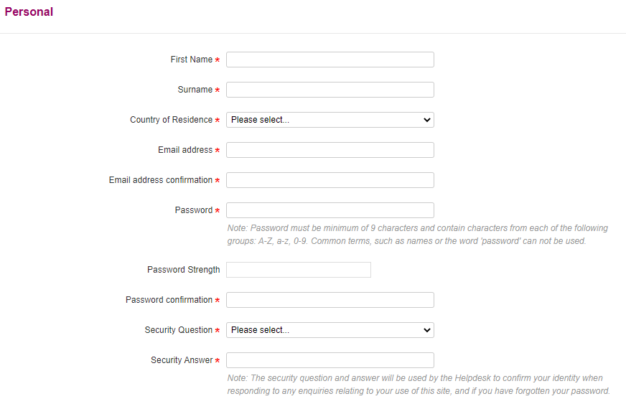

Register your personal details:

* **First Name**
* **Surname**
* **Country of Residence**
* **Email address**
* **Email address confirmation**
* **Password**
* **Password confirmation**
* **Security Question**
* **Security Answer**

**SECTION 5:** **The application process & your ‘Supporting Information’**

For first time applicants there is a lot to complete but once you have done this it can be saved for next time if required.

**The sections to complete are:**

* This is your time to shine!
* Think back to the NHS values
* Research your employer and their **‘Values’**

**Personal information**

**Qualifications**



**Employment history**

* Don’t assume that the employer will know your skills and experience from your employment history
* Go through the Job Description and the Personal Specification and escribe how you can do the job
* Sell yourself and your skills
* Proofread and review your spelling and grammar

**Referees**

**Supporting Information** * *see below*

**Monitoring Information**

The ‘Supporting Information’ section is key. You need to sell yourself to show how you meet all the criteria in the job description and personal specification documents. You need to demonstrate that not only do you have the skills for the job, but also share the Trust’s values.

**SECTION 6:** **The ‘Interview’**

* Values based interview
* 45 minutes to 1 hour, a least 2 interviewers
* Prepare, prepare, prepare
* Talk about yourself
* Why do you want the job?
* Think about questions that might be asked. “Tell me about a time when…” ***scenario questions***
* It’s a two-way process – what would you like to ask?

You can also access support with interview guidance by clicking on the hyperlink:

<https://www.jobs.nhs.uk/advice/be_my_interviewer.html>

**What to do next……**

* If you have any questions please email [recruitment@alderhey.nhs.uk](mailto:recruitment@alderhey.nhs.uk)
* In addition to the NHS Jobs site, Alder Hey specific vacancies can also be found on our website:

<https://alderhey.nhs.uk/join-us/work-here/current-vacancies>

**‘Good Luck’ with your application!**