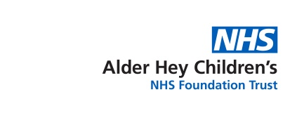

**A Parent’s/Carer’s**

**Guide to**

**Apprenticeships**

Helping your child to search and apply for Apprenticeships



**Contents:**

* A quick guide to Apprenticeships PAGE 3
* A quick guide to T-Levels PAGE 4
* A quick guide to Traineeships PAGE 5
* Apprenticeships in Health and Social Care PAGE 6
* Apprentice perspective: Life as an Apprentice at Alder Hey PAGE 7
* How to search and apply for Healthcare Apprenticeships PAGE 8
* How to search and apply for other Apprenticeships PAGES 9 & 10
* Apprentices with a learning difficulty or disability PAGE 11

* References and useful links PAGE 12

**A quick guide to Apprenticeships:**

**What is an Apprenticeship?**

An Apprenticeship is a real job where your child will learn, gain experience and get paid. They’re an employee with a contract of employment and holiday leave.

By the end of an Apprenticeship, your child will have the right skills and knowledge needed for their chosen career. It can take normally between 1 and 4 years to complete an Apprenticeship or sometimes longer depending on which one they choose. It’s funded from contributions made by the government and their employer.

**How does my child become an Apprentice?**

To become an Apprentice in England, you must:

* **Be 16 or over**
* **Not already be in full-time education**
* **Live in England**

You can start an Apprenticeship whether you’re starting your career, want a job change or you’re upskilling in your current job.



**What will my child do as an Apprentice?**

**As an Apprentice they’ll:**

* Learn and train for a specific job
* Get paid and receive holiday pay
* Get hands-on experience in a real job
* Study for up to 6 hours of their working hours *(6 hours for FTE, pro-rata for PTE* ) – usually at a college, university or with a training provider or at their place of work
* Complete assessments during and at the end of their Apprenticeship
* Be on a career pathway with lots of future potential!

**What will my child achieve at the end of their Apprenticeship?**

Each Apprenticeship has a level and an equivalent education level and your child will achieve this at the end of their Apprenticeship. For example, if they complete a Level 3 Apprenticeship, they’ll achieve the equivalent of an A-Level. Depending on the Apprenticeship Standard, they will also typically achieve Maths and English Functional Skills qualifications as part of their Apprenticeship if they started it without these or without GCSE’s in Maths and English, normally at grades 4 – 9.

**A quick guide to T-Levels:**

T Levels are new courses which follow GCSEs and are equivalent to 3 A levels. These two year courses, which launched in September 2020, have been developed in collaboration with employers and businesses so that the content meets the needs of industry and prepares students for work, further training or study.

T Levels offer students a mixture of classroom learning and ‘on the job’ experience during an industry placement of at least 315 hours (approximately 45 days).

For the following further information relating to T Levels, please visit the GOV.UK website or click on the links below:

[When they will start](https://www.gov.uk/government/publications/introduction-of-t-levels/introduction-of-t-levels#when-they-will-start)

[How T Levels will work with other qualifications](https://www.gov.uk/government/publications/introduction-of-t-levels/introduction-of-t-levels#how-t-levels-will-work-with-other-qualifications)

[How T Levels have been developed](https://www.gov.uk/government/publications/introduction-of-t-levels/introduction-of-t-levels#how-t-levels-have-been-developed)

[Structure of a T Level](https://www.gov.uk/government/publications/introduction-of-t-levels/introduction-of-t-levels#structure-of-a-t-level)

[Industry placements](https://www.gov.uk/government/publications/introduction-of-t-levels/introduction-of-t-levels#industry-placements)

[Grading and certification](https://www.gov.uk/government/publications/introduction-of-t-levels/introduction-of-t-levels#grading-and-certification)

[UCAS tariff points](https://www.gov.uk/government/publications/introduction-of-t-levels/introduction-of-t-levels#ucas-tariff-points)

[Timeline](https://www.gov.uk/government/publications/introduction-of-t-levels/introduction-of-t-levels#timeline)

[Find out more](https://www.gov.uk/government/publications/introduction-of-t-levels/introduction-of-t-levels#find-out-more)

Or you can visit the HASO (Healthcare Apprenticeship Standards Online) website for further information on T-Levels within the health sector:

<https://haso.skillsforhealth.org.uk/t-levels/>

**In time, students will be able to take a T Level in the following subject areas:**

* Accounting
* Agriculture, land management and production
* Animal care and management
* Building services engineering for construction *(available now)*
* Catering
* Craft and design
* Design and development for engineering and manufacturing
* Design, surveying and planning for construction *(available now)*
* Digital business services *(available now)*
* Digital production, design and development *(available now)*
* Digital support and services *(available now)*
* Education and childcare *(available now)*
* Engineering, manufacturing, processing and control
* Finance
* Hair, beauty and aesthetics
* Health *(available now)*
* Healthcare science *(available now)*
* Legal
* Maintenance, installation and repair for engineering and manufacturing
* Management and administration
* Media, broadcast and production
* Onsite construction *(available now)*
* Science *(available now)*



**A quick guide to Traineeships:**

**How Traineeships work:**

Traineeships are a great option for young people aged between 16 and 24 (or 25 for individuals with an Education and Health Care Plan), who don’t have the skills or experience to take on a job or Apprenticeship. Traineeships act as a skills development programme, where your child can complete an unpaid work placement alongside a training course. They can last from 6 weeks up to 1 year (although most last up to 6 months) and are designed to help prepare your child for work or an Apprenticeship. If your child already has some work experience, they may be ready for an Apprenticeship.

**Who can apply for a Traineeship?**

**You child can apply for a Traineeship if they are:**

* Eligible to work in England
* Have little or no work experience but are motivated to work
* Aged 16 to 24, or 25 with an Education, Health and Care (EHC) Plan
* Qualified up to level 3

**The core elements of a Traineeship include:**

* Completion of a quality work placement of at least 70 hours with a local employer
* Training to ensure the trainee is equipped with the skills needed to succeed in the placement
* English, Maths and digital support (where required)
* CV and application support
* An exit interview at the end of the placement which provides written feedback about the trainees performance

The training provider will arrange a work placement with an employer, usually a minimum of 70 hours. The employer and training provider then work together to create an individual plan for the trainee, providing additional work preparation prior to the placement.

Along with recognition of your child’s learning, there will be support to link them with job opportunities.

**They may get:**

* Expenses for transport and meals from their employer
* Financial support for travel, childcare or a disability from their training provider
* Support from their local Jobcentre Plus if they are eligible for work benefits

*For the following further information relating to Traineeships, please visit the GOV.UK website or you can visit the HASO (Healthcare Apprenticeship Standards Online) website for further information on Traineeships within the health sector:*

[Traineeships - HASO (skillsforhealth.org.uk)](https://haso.skillsforhealth.org.uk/traineeships/)

**Apprenticeships in Health and Social Care**

There are **over 150 clinical and non-clinical** apprenticeships available in healthcare. Apprenticeships in Healthcare range from level 2 to 7 and can take time anytime between 12 and 58 months to complete.

**The NHS has so much to offer, did you know that you could do Apprenticeships in all of these things?**

**Clinical Apprenticeships:**

**Non-clinical Apprenticeships:**

Healthcare Support Worker

Nursing Associate

Physiotherapist

Advanced Clinical Practitioner

Registered Nurse

Diagnostic Radiographer

Social Worker

Pharmacy Technician

Healthcare Science Practitioner

Health Play Specialist

Digital User Experience (UX) Professional

Assistant Accountant

Operations Departmental Manager

HR Consultant

Chartered Manager

Digital Marketer

Senior Leader

Business Administrator

Team Leader/Supervisor

Associate Project Manager

Visit the HASO (Healthcare Apprenticeship Standards Online) website for a full list of Healthcare Apprenticeship Standards available:

<https://haso.skillsforhealth.org.uk/standards/>

*Apprenticeships are a great steppingstone into the NHS and your child may start an Apprenticeship in one area and then progress to another one within their Healthcare career!*

**Apprentice perspective: Life as an Apprentice at Alder Hey**

We are introducing you to one of our **Registered Nurse Apprentices** here at Alder Hey Children’s NHS Foundation Trust

**How did you get your Apprenticeship?**

I was starting to research universities to apply to for Children and Young Person’s Nursing when I found information about Apprenticeships. Once I had done some reading I knew that this was the best course for me and started looking at NHS Jobs daily.

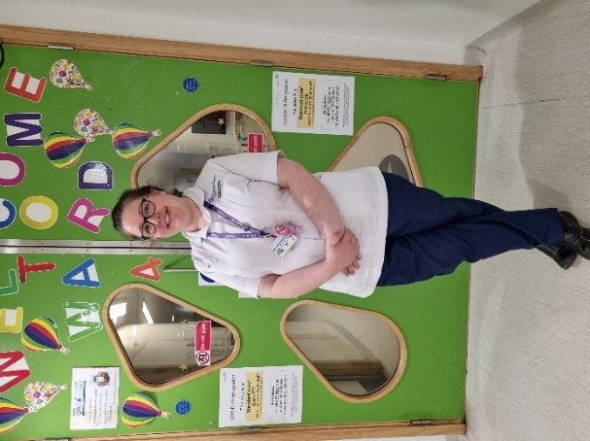

**What do you hope to do next?**

Apart from passing my degree, I always thought that I would love to be a Neonatal Nurse. However, in the short time that I have been an Apprentice, I find working with children with complex needs so rewarding and I find myself drawn towards that area.

**Do you have any tips for future Apprentices?**

I would say read up on common childhood conditions, keep trying and go for it! For me this is the best of both worlds in which to work towards my degree. If you get the opportunity then grab it with both hands!

Meet one of our Apprentices

**What has been the best part?**

The best part is getting to learn at Alder Hey, the support that we get is great and the opportunities for learning are amazing!

**What has been the hardest part?**

The hardest part for myself is returning to learning after a big gap and juggling shift patterns and home life while still trying to ensure that I have some downtime for myself.

**What is the study model like and what types of things have you been doing in your off-the-job learning?**

We have 2 full days on placement each week and a university study day. Our placements are about 12 weeks long and this is great as I feel we can really get to know the ward, what conditions they treat and our assessors get to know us as a student and what we are capable of.

**How to search and apply for Healthcare Apprenticeships:**

**Does my child need any qualifications to become an Apprentice?**

**How does my child apply to become an Apprentice with the NHS?**

Apprenticeship opportunities with the NHS are advertised through NHS Jobs:

<https://www.jobs.nhs.uk/>

**How does my child apply to become an Apprentice with Alder Hey?**

Any current Apprenticeship opportunities with Alder Hey are advertised through NHS Jobs.

Please visit our guide on **‘How to apply for NHS jobs’** for further support. This can be found on our website using the following link:

<https://alderhey.nhs.uk/healthier-future/education/alder-hey-academy/schools-and-colleges>

*\*Please be advised that your child can only complete an Apprenticeship if they don’t already hold equivalent qualifications at the same level of the Apprenticeship as they must be able to gain* ***significant new knowledge, skills and behaviours*** *(KSB’s) as part of their Apprenticeship training.*

**Depending on the level and the subject, some Apprenticeships may:**

* Require previous qualifications such and English and Maths GCSE’s or Functional Skills
* Require other previous qualifications, e.g. to apply for the Registered Nurse Degree Apprenticeship, in addition to English and Maths, you must evidence at least 112 UCAS points achieved through A-Levels, Access to Higher Education with Distinction (in Healthcare) or a BTEC Level 3 National Diploma

**How to search for other Apprenticeships:**

**How does my child identify an Apprenticeship subject that may be relevant for them?**

On the Institute for Apprenticeships website you can search for an Apprenticeship Standard by title, keyword or route(s) to find what you are looking for. There are currently over 700 Apprenticeship Standards available:

<https://www.instituteforapprenticeships.org/apprenticeship-standards/>?

**Example 1:**

My daughter is doing A-Levels in Maths, Physics and Geography and is interested in doing a Degree in Geology, Geography or Earth Sciences at University. Are there any relevant Apprenticeship subjects that she can do at degree level?

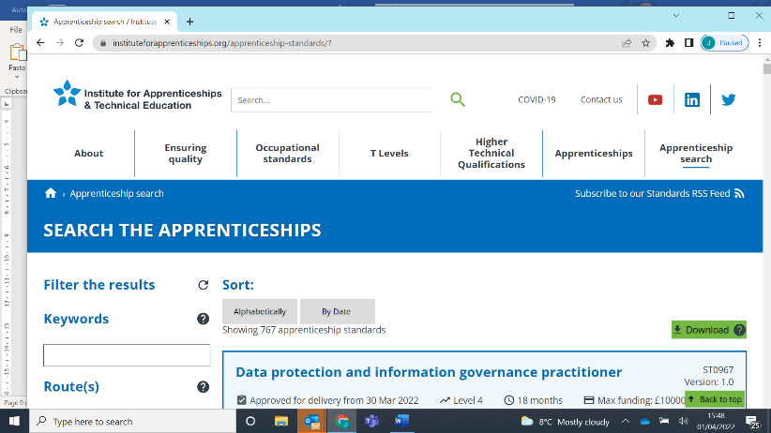Yes, if you click on the **‘Apprenticeship search’** tab on the Institute for Apprenticeships homepage, this will allow you to **‘SEARCH THE APPRENTICESHIPS’**.

The link below will take you directly to this page:

<https://www.instituteforapprenticeships.org/apprenticeship-standards/>?

On the left hand side of the page as shown below, there is a list of route(s) where you can explore and filter relevant Apprenticeship Standards by selecting the route(s) and then the Standards within that route that best fit your daughter’s A-Level subjects. Suggested routes include:

* Engineering and manufacturing
* 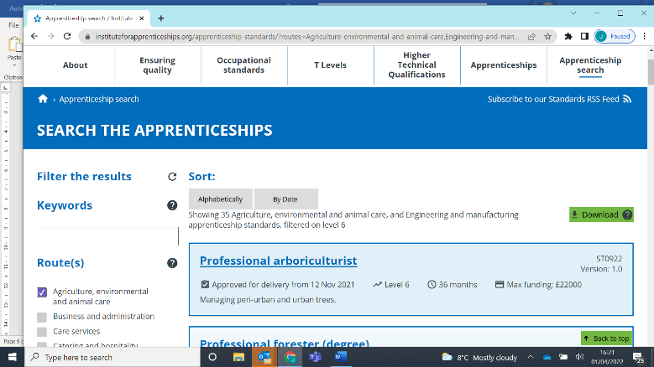Agricultural, environmental and animal care

Within these routes, the following Apprenticeship Standards may be relevant:

* Civil Engineer (Degree)
* Ecologist (Degree)
* Environmental Practitioner (Degree)

**Example 2:**

My son is interested in a career Pharmacy and has just left school with 5 GCSEs which include Maths and English Language at Grade 4. Can he do an Apprenticeship in this subject area?

Yes, if there are currently any vacancies with the NHS then he can search for these by registering for an account with NHS Jobs or visiting the government website:

<https://www.jobs.nhs.uk/>

<https://www.gov.uk/apply-apprenticeship>

**How to apply for other Apprenticeships:**

Other Apprenticeship opportunities are advertised on the government website:

<https://www.gov.uk/apply-apprenticeship>

You can search and apply for an Apprenticeship in England by:

Using the search tab and following criteria:

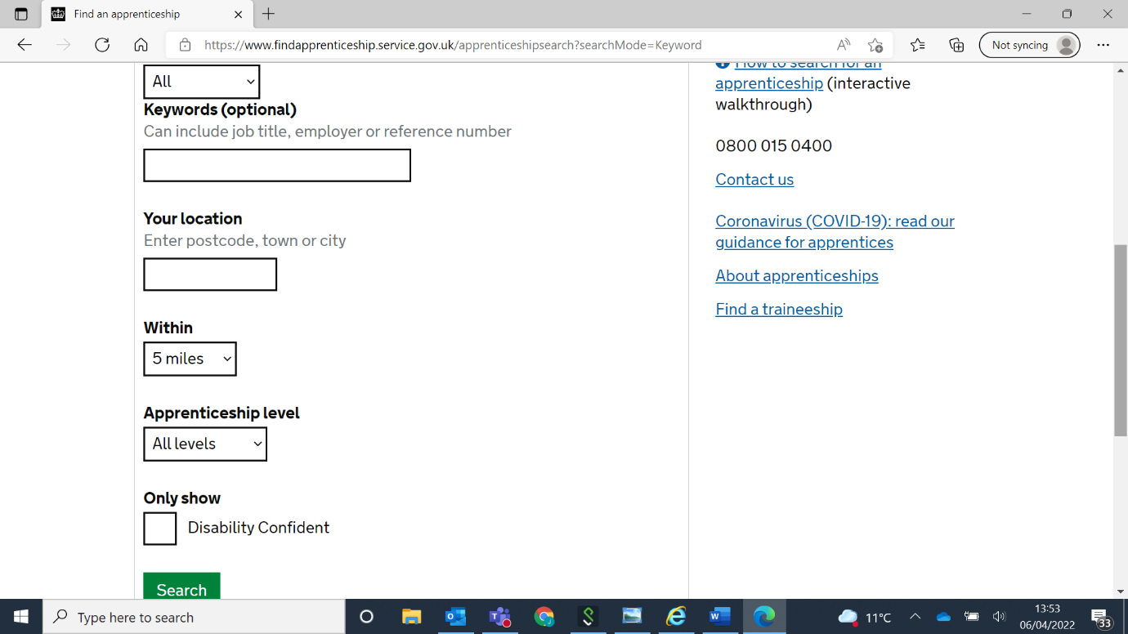

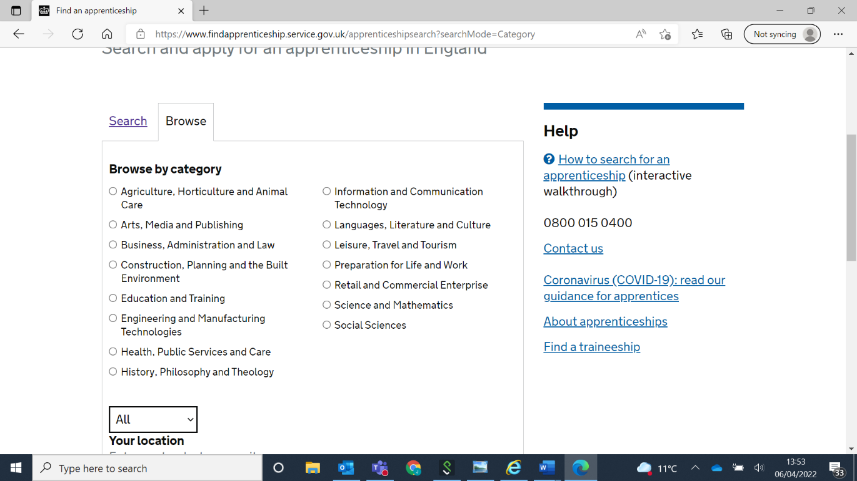Or by browsing by category:

**Apprentices with a learning difficulty or disability:**

For Apprentices who need access to Learning Support, Apprenticeship providers are committed to supporting them and helping them achieve the best results, setting them up for a successful career.

Learning support, from Government, is available to Apprenticeship Training Providers to meet the costs of putting in place a reasonable adjustment, as set out in **section 20 of the Equality Act 2010**, for Apprentices with a learning difficulty or disability where this affects their ability to continue and complete their Apprenticeship.

Apprenticeship Training Providers will provide learning support for apprentices with learning difficulties or disabilities as defined in section **15ZA(6) of the Education Act 1996 (as amended by section 41 of the Apprenticeships, Skills, Children and Learning Act 2009)**.

This includes diagnosis of a learning difficulty or disability but has been identified by the Apprenticeship Training Provider as a learning need.

This includes diagnosis of a learning difficulty or disability but has been identified by the Apprenticeship Training Provider as a learning need.

**Additional learning support can be used to:**

* give different learners extra 1:1 time with tutors
* cover the costs of assistive software
* implement reasonable adjustments for exams and assessments such as an Apprentice receiving extra time or having a scriber or reader with them

Learning support cannot be used to deal with everyday difficulties that are not directly associated with an Apprenticeship. If an Apprentice needs help at work they may be able to get help from Access to Work.

**References and useful links:**

**National Careers Service:** <https://nationalcareers.service.gov.uk/>

**UCAS** have provided us with a calculator where you just click on the drop down menu and find your child’s qualifications and how many tariff points they may be worth. Please be advised that this doesn’t include GCSE’s and not all level 3 qualifications:

<https://www.ucas.com/ucas/tariff-calculator>

*https://www.apprenticeships.gov.uk/apprentices/becoming-apprentice*

*https://www.gov.uk/government/publications/introduction-of-t-levels/introduction-of-t-levels*

*<https://assets.ctfassets.net/8kbr1n52z8s2/k9DXxk7lDEfoxanEPzvVE/79bd1a56b8d185628789f5468ccb71e2/PDF-a-guide-to-traineeships.pdf>*

[*https://haso.skillsforhealth.org.uk/wp-content/uploads/2021/02/2021.02.01-Applying-for-an-apprenticeship.pdf*](https://haso.skillsforhealth.org.uk/wp-content/uploads/2021/02/2021.02.01-Applying-for-an-apprenticeship.pdf)