After the scan
You are free to go straight home after your scan unless you have any other appointments to attend. The Radiologist (x-ray doctor) will report the scans in time for your next appointment in clinic. If you do not have a follow up appointment with your child’s Consultant you will need to contact their secretary to arrange one within the next few weeks.

The liquid that your child has been given to drink will pass through their system very quickly and may cause diarrhoea. We advise you to stay near to toilet facilities for a couple of hours after the scan and drink fluids to help flush the liquid through the digestive system.

Contact details
If you have any other questions, concerns or feel that your child will not be able to co-operate with this examination please feel free to contact us on 0151 252 2042.

Thank you.

This leaflet only gives general information. You must always discuss the individual treatment of your child with the appropriate member of staff. Do not rely on this leaflet alone for information about your child’s treatment.
This information can be made available in other languages and formats if requested.

Alder Hey Children’s NHS Foundation Trust
Alder Hey
Eaton Road
Liverpool
L12 2AP

Tel: 0151 228 4811
www.alderhey.nhs.uk

© Alder Hey
Review Date: April 2024 PIAG: 238

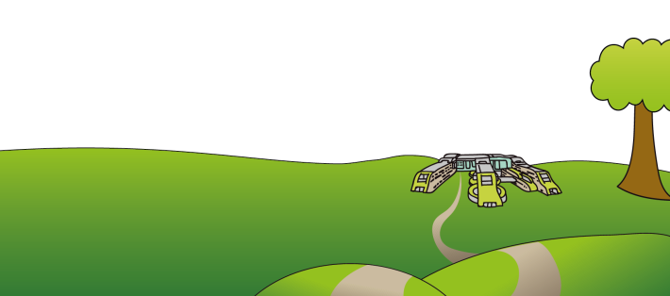

Radiology Department
Your child’s Small Bowel
MRI Scan

Information for parents
and carers

Your Child’s Small Bowel MRI Scan

Introduction
Small bowel MRI is a specialised MRI scan that is used to examine the small bowel for any problems; it is particularly helpful in patients with Crohn’s disease.

An MRI (magnetic resonance imaging) scan uses a strong magnetic field to take pictures of your child’s body. You are welcome to stay with your child for the scan. You will need to fill out a metal safety checklist for yourself and your child before entering the scan room. The radiographer will discuss the safety checklist with you and ask you to leave all metal/electronic belongings in a locker. The scan is very noisy so anyone in the room must wear ear defenders, we have an entertainment system and your child can watch a DVD while they have their scan done.

When you receive your appointment
If you cannot attend for your appointment please ring 0151 252 2042 as soon as possible to cancel/rearrange. This allows us to offer it to someone else and this helps us to keep our waiting list down.
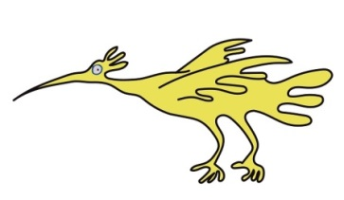

The day of the scan
Your child must not have anything to eat after midnight and should drink plenty of clear fluids on the morning of their appointment.
When you arrive the radiographer will go through the patient metal safety checklist that we sent out with your appointment letter.
.As part of the test your child will need to drink a litre of fluid (over a period of around 45 minutes), we flavour this with blackcurrant or orange. It is essential that your child drinks the liquid quite quickly to ensure that the bowel is full and gives clear pictures. Slowly sipping small amounts of the liquid will not give adequate pictures.

This liquid travels through the small bowel and coats the inside surface so that it shows up better on the scan pictures. If your child has a nasogastric tube we can put the liquid down that. If your child struggles to drink the liquid we may consider inserting a nasogastric tube to enable us to get good clear images of their bowel. If this is necessary we may need to re-schedule for another date.

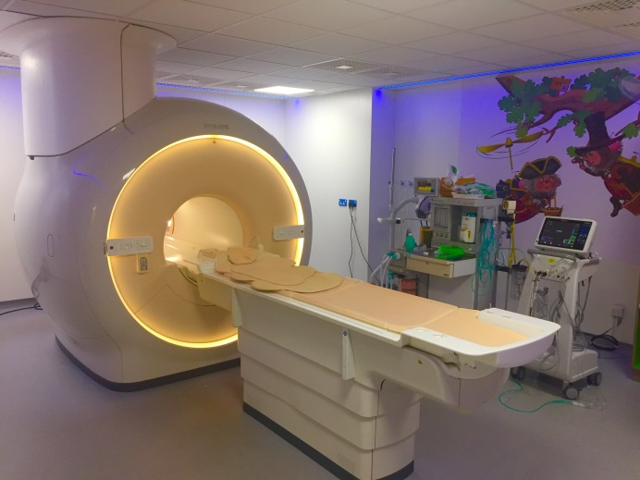

The scan
Your child will be asked to lie on their front and go into the scanner head first so that they can watch the television during the scan. The radiographer will place a coil around your child’s abdomen, this piece of equipment helps to improve the quality of the images that we get.
When your child is comfortable and in the correct position the radiographer will move them into the scanner.
It is essential that your child lies very still for the scan and they will be asked to hold their breath a few times while we take the pictures
The scan usually takes no longer than 20 minutes unless the doctor has asked us to do any extra pictures.

