The last thing we need to do is place our large MRI coil over your chest; this looks and feels a bit like body armour! It is then time to move you into the scanner. The scans will take approximately 45 minutes to 1 hour to complete.

After the scan

We will remove your cannula and ECG stickers and you can go home unless you have any other appointments to attend.

The Radiologist (X-ray Consultant) will report your scans in time for your next clinic appointment. If you do not have a follow up appointment with your Consultant you need your parent/guardian to contact the Cardiac Secretaries 2 weeks after your scan date.

Contact details
If you have any questions or concerns about any of the information on this sheet, please feel free to contact us on 0151 252 5017.

Thank you.

.


This leaflet only gives general information. You must always discuss the individual treatment of your child with the appropriate member of staff. Do not rely on this leaflet alone for information about your child’s treatment.
This information can be made available in other languages and formats if requested.

Alder Hey Children’s NHS Foundation Trust
Alder Hey
Eaton Road
Liverpool
L12 2AP

Tel: 0151 228 4811
www.alderhey.nhs.uk

© Alder Hey
Review Date: January 2028 PIAG: 235





Radiology Department
Your Cardiac MRI Scan




Information for patients
and carers

Your Cardiac MRI Scan

Introduction
MRI (magnetic resonance imaging) uses an extremely strong magnetic field to take pictures of your body.

Cardiac MRI is a specialised scan that assesses heart anatomy and function. You will be with us 1.5 to 2 hours in total, and you are welcome to bring an adult with you.

Please complete the enclosed MRI metal checklist – you may need a Parent / Guardian to help you with this, and they also need to sign it. Anyone who is going into the MRI room with you must also complete a safety checklist once they arrive here at the Radiology Department.

Any questions at all, contact us on the number at the end of this leaflet.

The MRI scanner is very noisy so anyone who stays in the room must wear ear defenders. We have an entertainment system and you can watch a DVD while you have your scans. We have lots of DVDs but feel free to bring your own.


When you receive your appointment
If you cannot attend your appointment or have any concerns that you will not be able to co-operate with this examination please phone us on 0151 252 5017 to cancel/rearrange so that we can offer it to someone else; this helps us to keep our waiting list down.

The day of your appointment

When you arrive an MRI Radiographer will go through metal safety checklists with whoever is going into the scan room. You must leave metal items and electronic devices in our lockers and you may have to change into a hospital gown. We will take height and weight measurements, and then apply some local anaesthetic cream to the front of your elbow and/or the back of your hand to numb the skin. This is so that a cannula (thin plastic tube) can be inserted into a vein once the cream has taken effect (30 mins minimum). This is necessary for most Cardiac MRI cases because one of the scans is taken whilst an injection of contrast (MRI dye) is given via an injector pump.

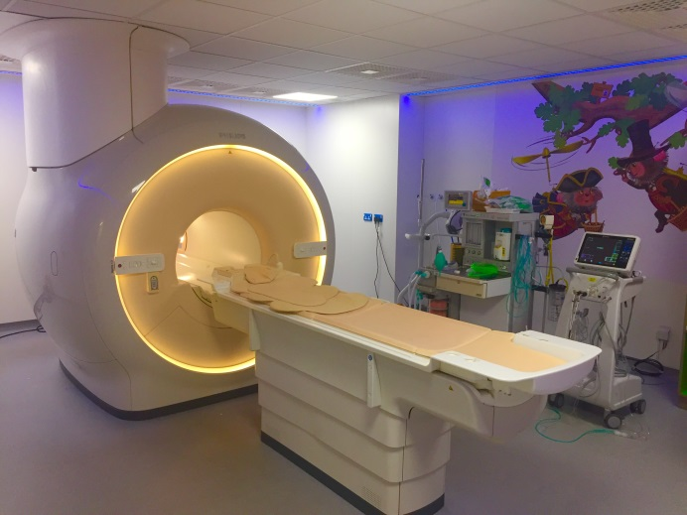

In the MRI scanner room
You will be lying flat on the scanner table and we will make sure you are comfortable. We will attach ECG stickers to the front of your chest so that the scans can be taken in time with your heart beat. If you already have your cannula in at this time, we will connect it to the tubing from the injector and perform a short test injection of saline (a harmless liquid). This should not hurt, you should only feel a cold trickle up your arm.

You will be given earphones to protect your ears and so that you can hear the DVD. We will speak to you via these headphones throughout the scans as we will need you to breathe in and hold your breath over and over again.

