Contact details
If you have any questions or concerns about any of the information on this sheet, please feel free to contact us on 0151 252 5422.
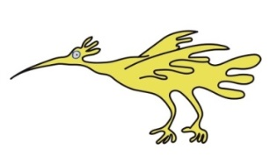
Thank you.

This leaflet only gives general information. You must always discuss the individual treatment of your child with the appropriate member of staff. Do not rely on this leaflet alone for information about your child’s treatment.
This information can be made available in other languages and formats if requested.

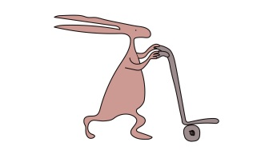
Alder Hey Children’s NHS Foundation Trust
Alder Hey
Eaton Road
Liverpool
L12 2AP

Tel: 0151 228 4811
www.alderhey.nhs.uk

© Alder Hey
Review Date: January 2025 PIAG: 234

Radiology Department
Your Cardiac CT Scan

Information for patients
and carers

Your Cardiac CT Scan

Introduction
Cardiac CT is a specialised scan that assesses heart anatomy. You are welcome to bring an adult with you. Any questions at all, contact us on the number given at the end of this leaflet.

The CT scanner uses radiation to take pictures so anyone who stays in the room must wear a lead apron.

When you receive your appointment:
If you cannot attend your appointment or have any concerns that you will not be able to co-operate with this examination please phone us on 0151 252 5422 to cancel/rearrange so that we can offer it to someone else; this helps us to keep our waiting list down.

The day of your appointment:
When you arrive we will take height and weight measurements, and then apply some local anaesthetic cream to the front of your elbow and/or the back of your hand to numb the skin. This is so that a cannula (thin plastic tube) can be inserted into a vein once the cream has taken effect (30 mins minimum). This is necessary because the scan is taken whilst an injection of contrast is given via an injector pump.

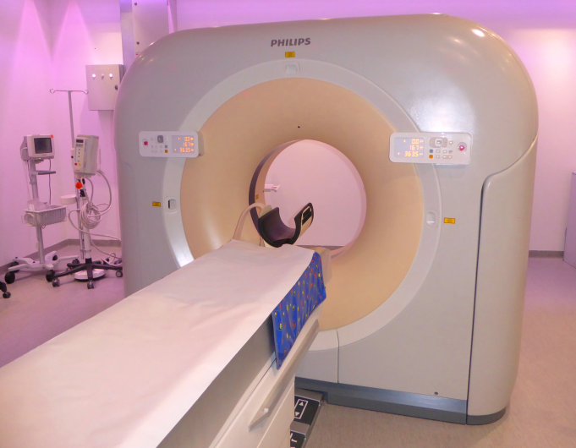

In the CT scanner room
You will be lying flat on the scanner table and we will make sure you are comfortable. We will attach ECG stickers to the front of your chest so that the scans can be taken in time with your heart beat. If you already have your cannula in at this time, we will connect it to the tubing from the injector and perform a short test injection of saline (a harmless liquid). This should not hurt; you should only feel a cold trickle up your arm.

During the CT scan
You will move twice in and out of the scanner and you must hold your breath for a few seconds. On the second movement the dye will go in through your body as the scan is being taken. This will make you feel warm for a few seconds but will pass very quickly. You might also have felt you have gone to the toilet but you will not have.
After the scan
We will remove your cannula and ECG stickers and you can go home unless you have any other appointments to attend. The Radiologist (X-ray Consultant) will report your scans in time for your next clinic appointment. If you do not have a follow up appointment with your Consultant you need your parent/guardian to contact the Cardiac Secretaries 2 weeks after your scan date.

