Endocrine Department
X Linked Hypophosphataemic Rickets (XLH)
Information for patients and carers.

Introduction
X linked hypophosphataemic rickets (XLH) is an inherited lifelong disorder characterised by low levels of phosphate in the blood (hypophosphataemia). Phosphate is a mineral that is essential for the normal formation of bones and teeth in childhood and helps maintain bone strength in adults.
What causes XLH?
XLH is caused by mutations in the phosphate regulating gene PHEX which is located on the X chromosome. Inheritance is X-linked dominant. This is the commonest type of hypophosphataemic rickets. The condition often runs in families through several generations, but in other families a newly diagnosed child may be the first and only affected person.
PHEX regulates fibroblast growth factor 23 (FGF23), a protein produced in bone cells, which is necessary for regulating the phosphate levels within the body. In XLH levels of FGF23 are increased leading to low levels of phosphate in the body.
The body’s phosphate levels are determined by the balance between:
- How much phosphate is taken in from food
- How much is stored in the skeleton
- How much is passed out (excreted) in the urine.
Along with FGF23, a bone hormone called parathyroid hormone (PTH) plays an important role in controlling how much phosphate the kidneys excrete.
Signs and symptoms
In most cases, the signs and symptoms of XLH begin in early childhood. The features of this disorder vary widely, even among affected members of the same family. Many children experience slow growth and are shorter than their peers. They develop bone abnormalities that can interfere with movement and cause bone pain.
The most noticeable of these abnormalities are bowed legs and knocked knees (a condition in which the lower legs are positioned at an outward angle). These abnormalities can become apparent with weight bearing activities such as walking. If untreated, they tend to worsen with time and a number of children will require the input of orthopaedic surgeons.
Fractures tend not to occur but mobility can become limited because of discomfort, deformity or both. Having said all this, if the condition is detected early and compliance with treatment is good, it is possible to have reasonably good growth and little in the way of bony deformities.
How is XLH treated?
Historically patients with XLH were treated with medicines called phosphate and alfacalcidol (a vitamin D preparation) which are taken orally on a daily basis.
A new treatment has now become available for children from the age of 1 year and adolescents who are still growing who have been diagnosed with XLH.
The new treatment is called CRYSVITA (burosumab). It is a human monoclonal antibody which means it is made from human proteins.
How burosumab works
Burosumab attaches to the FGF23 protein in the blood, which stops the FGF23 from working. This keeps more phosphate in the blood so that normal levels of phosphate can be maintained.
How burosumab is given
Burosumab is given as a subcutaneous injection (S/C) on a fortnightly basis.
Initially the injection will be given at the hospital by the Endocrine nurse with a plan to than arrange a homecare nurse to administer the injection at home every fortnight.
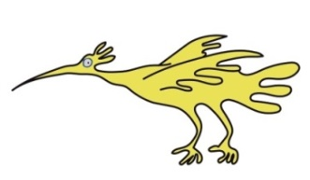
Regular bloods tests will be required throughout treatment with burosumab to monitor its effect. The frequency of the blood test will be discussed at the start of the treatment.
The clinical management of XLH also involves:
- Regular clinic appointments with a paediatric metabolic bone consultant.

- Orthopaedic assessment /input as required which may include the use of orthotics i.e. supportive shoe and insoles or surgical interventions.

- Regular dental checks.
Although there is no cure at present for XLH, the best chance of a good outcome in terms of growth and mobility lies in early diagnosis and good compliance with medication.
For further information please contact:
Lynne Hatchard, Endocrine Nurse on 0151 252 5534 OR Paula O’Leary, Secretary on 0151 252 2281.
This leaflet only gives general information. You must always discuss the individual treatment of your child with the appropriate member of staff. Do not rely on this leaflet alone for information about your child’s treatment. This information can be made available in other languages and formats if requested.
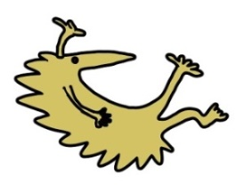
Alder Hey Children’s NHS Foundation Trust
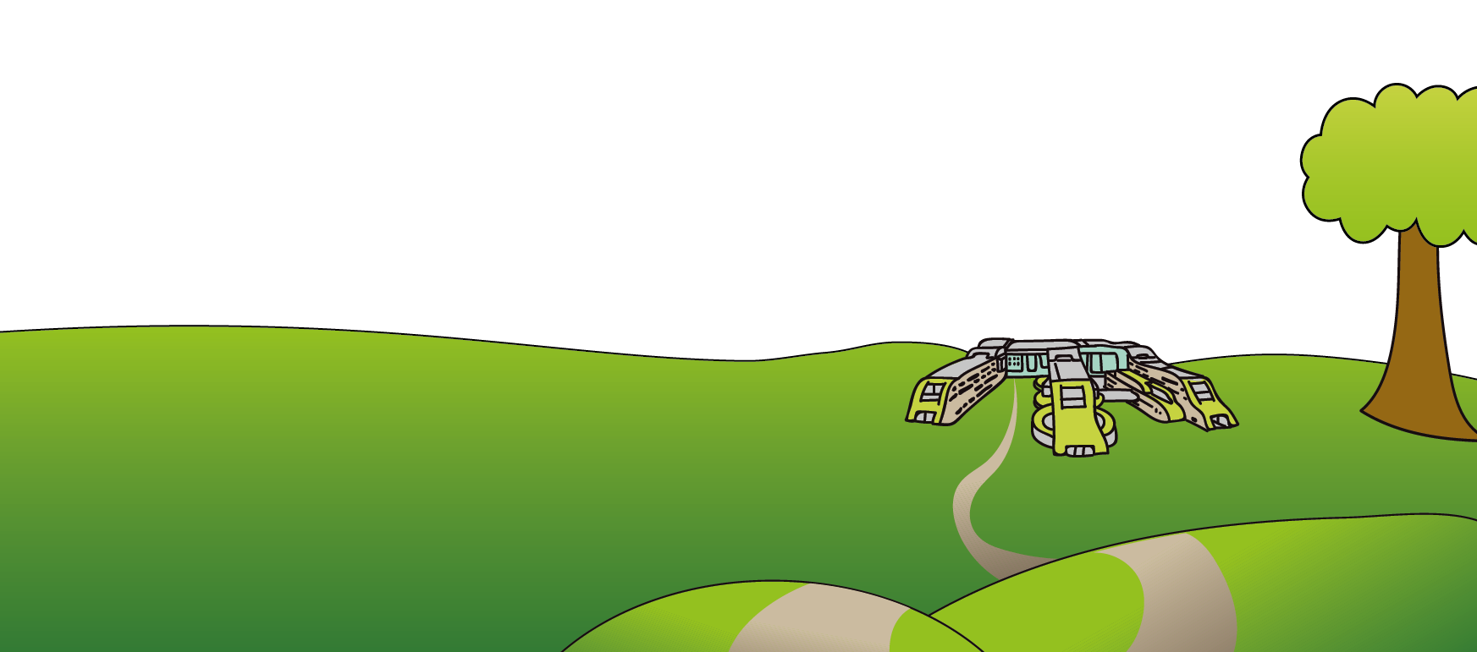
Eaton Road
Liverpool
L12 2AP

Tel: 0151 228 4811
www.alderhey.nhs.uk

© Alder Hey Review Date: May 2025 PIAG: 017

