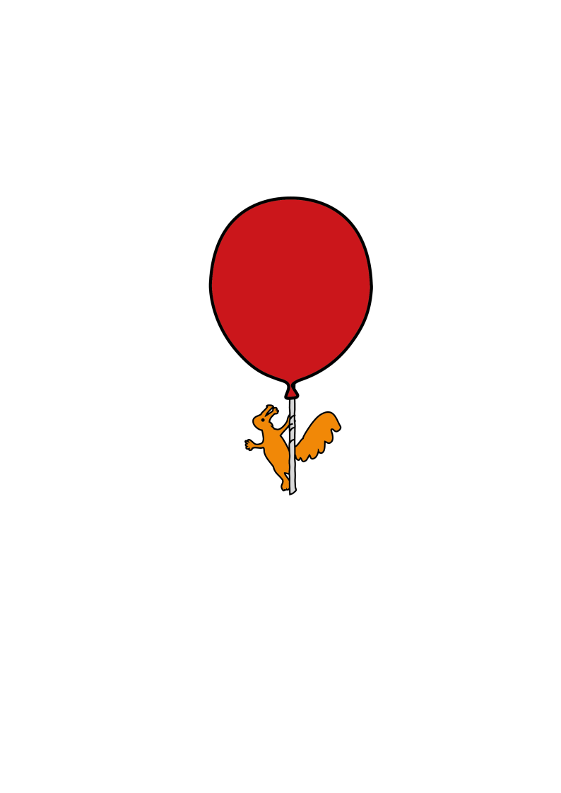

Alder Hey Emergency Department

**Treatment of a Wrist Buckle Fracture and**

**Discharge Information**

For parents and carers

**Introduction**

Your child has sustained an injury of the wrist bone and is diagnosed as a “Buckle Fracture”. This is a less serious type of bone injury due to a small area of the bone being ‘squashed’ rather than ‘cracked.’

This injury is treated like a sprain and should not cause any long term problems.

**Treatment**

We have provided your child with a wrist support (splint) to make them more

Comfortable.. A plaster cast is not needed for this type of injury.

The splint should be worn day and night for three weeks, but can be removed for washing.

.

Most children start to use their wrist and hand again whilst still wearing the splint. Please allow them to use the hand and wrist as much as they want, within the child’s limits of pain and comfort. .

Sporting activities, physical exercise and rough play should be avoided for six weeks after the injury to aid maximum healing and recovery

**Follow up appointments**

This type of injury usually heals very well. We will not need to see your child again.

All X-rays are reviewed by our Radiologists. If there is any concern that there may be a more serious injury, you will be contacted by phone or letter.

**Things to look out for when your child goes home**

Your child may have pain or discomfort in their wrist which should settle over a few

days. Paracetamol and/or ibuprofen can be given to help with the pain. Please make sure you follow the instructions on the packet – and do not exceed the maximum dose or frequency.

If your child remains in pain after a week, or their pain starts to get worse rather than better, please first adjust the splint to make sure it is not on too tight or too loose You can also contact the Emergency department for advice.

Any swelling or bruising from the injury will settle in a few days.

When first removing the splint after three weeks your child may complain of mild stiffness and aching. This is normal and should improve quickly.

**Who to contact for further details**

If your child has problems whilst wearing the splint or during the 3 weeks after the splint has been removed, please contact the Emergency Department for advice.

0151 228 4811 ext 2060.



This leaflet only gives general information. You must always discuss the individual treatment of your child with the appropriate member of staff. Do not rely on this leaflet alone for information about your child’s treatment.

This information can be made available in other languages and formats if requested.

Alder Hey Children’s NHS Foundation Trust

Alder Hey

Eaton Road

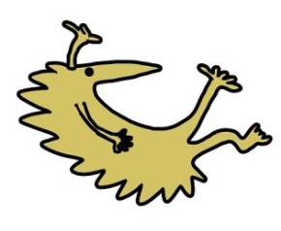Liverpool

L12 2AP

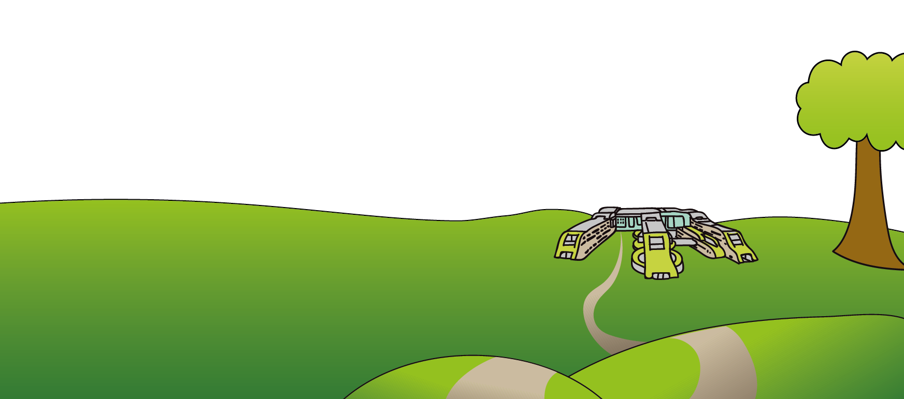

Tel: 0151 228 4811

[www.alderhey.nhs.uk](http://www.alderhey.nhs.uk)

**© Alder Hey Review Date: Feb 2025 PIAG: 044**