Ward 3A & Surgical Decision Unit
What to do after your child has had a General Anaesthetic for a surgical procedure
Discharge information for parents and carers

Your child has been assessed as fit to go home the same day following a general anaesthetic.

This leaflet aims to provide you with information about how to care for your child once you are at home.

Most children appear to be alert and active after they are discharged from hospital. However, do not be surprised if your child complains of feeling dizzy or being tired. Your child may feel dizzy and uncoordinated for the next couple of days.

For the next 24 hours

- You should encourage your child to rest
- You should make sure your child’s activities are supervised by a responsible adult

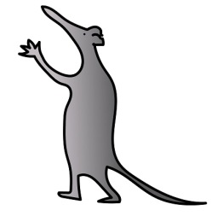
- Do not let your child ride a bike
- Do not let your child take part in any outdoor activities
- Do not give your child any fizzy drinks
- Do not give your child hard to digest foods such as chips, burgers.

Your child may complain of having a sore throat, hoarseness, muscle ache, or pain following an anaesthetic. You can give you child Paracetamol.

Do not exceed the recommended dosage for your child’s age

All advice regarding medicines will be given to you when your child is discharged.

What to do if your child starts to vomit

If your child vomits on the way home or when you get home, do not be alarmed. Do not give your child anything to eat or drink for one hour. After that, you can start giving your child a small amount of water or juice. Then gradually start to increase the amount of fluid you give to your child. Once your child can keep fluids down you can begin to give them a light diet.

If the vomiting continues, please contact your GP out of hour’s telephone number or your nearest Accident & Emergency Department.

If you have been given another advice sheet specific to the surgery your child has had with advice following surgery about vomiting, please follow the advice given.

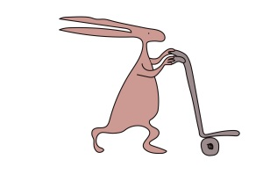
Who to contact if you have any worries

Please contact ward 3A for advice by telephoning:

0151 252 5416 / 0151 252 5447.

Medications

Post-operative instruction:

This leaflet only gives general information. You must always discuss the individual treatment of your child with the appropriate member of staff. Do not rely on this leaflet alone for information about your child’s treatment.

This information can be made available in other languages and formats if requested.

Alder Hey Children’s NHS Foundation Trust
Alder Hey
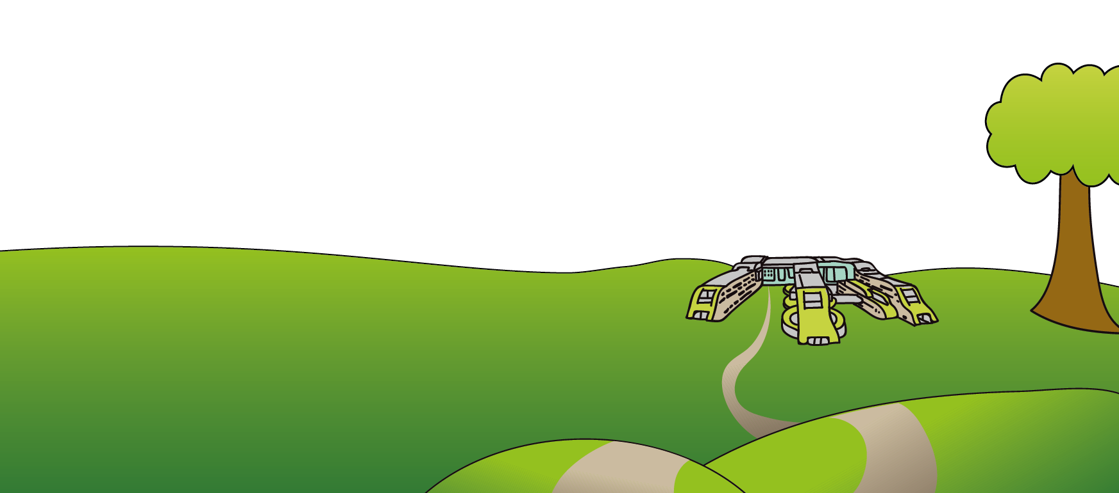
Eaton Road
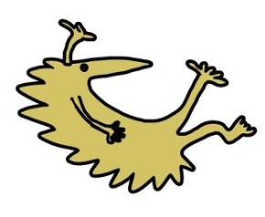
Liverpool
L12 2AP

Tel: 0151 228 4811
www.alderhey.nhs.uk

© Alder Hey Review Date: February 2025 PIAG: 248

