Emergency Decisions Unit
Welcome to the Emergency Decisions Unit (EDU)
Information for parents and carers

Introduction

The Emergency Decisions Unit (EDU) is an eight -bedded short stay unit. Your child had been admitted from the Emergency Department to the EDU for a period of observation. During this time we will observe and treat your child to make sure they are fit to be discharged. If this is not possible your child may be admitted to an in- patient ward. If you have any queries or concerns, please do not hesitate to speak to a member of the nursing staff who will be happy to help.
Visiting the EDU

Parents and relatives can visit any time. During our busy times EDU staff will ask that only two parents/relatives stay with the patient at a time.

Entry to the unit is controlled via a secure door. To gain entry to EDU visitors should ring the bell by the secure door and staff will let visitors into the ward.

Visiting children must be supervised by parents/relatives at all times.

Parents/relatives/visitors should tell a member of EDU staff when leave the ward so that the patient is not left alone.

Ensure that the only medication given to your child is that provided from ward staff. Do not give your child any other medication unless you have spoken with EDU staff beforehand.

Food and facilities

We can provide your child with sandwiches/snacks/drinks, when appropriate, as well as milk feeds for babies. Parents/relatives having hot drinks in EDU must drink them from a secure flask provided by staff. Breast feeding mums can have food and drink provided. Facilities are available to express milk if required.

Patients and relatives should only access the toilets that are clearly signed for their use.
EDU staff can supply books and toys to patients whilst they are in EDU.

Each bed space has a television. Please consider other patients in ED, particularly those in the next bed space, by keeping the TV sound levels low.

Going home

Before your child is discharged you will receive advice about the ongoing care of your child as well as any medicines they may need. If, within 24 hours after discharge you have any concerns or queries, please call the EDU on 0151 2284811 extension 3049.
Please let us know of your experience of the unit before you leave by completing a feedback form and handing it to a member of EDU staff.

This leaflet only gives general information. You must always discuss the individual treatment of your child with the appropriate member of staff. Do not rely on this leaflet alone for information about your child’s treatment.
This information can be made available in other languages and formats if requested.

Alder Hey Children’s NHS Foundation Trust
Alder Hey
Eaton Road
Liverpool
L12 2AP
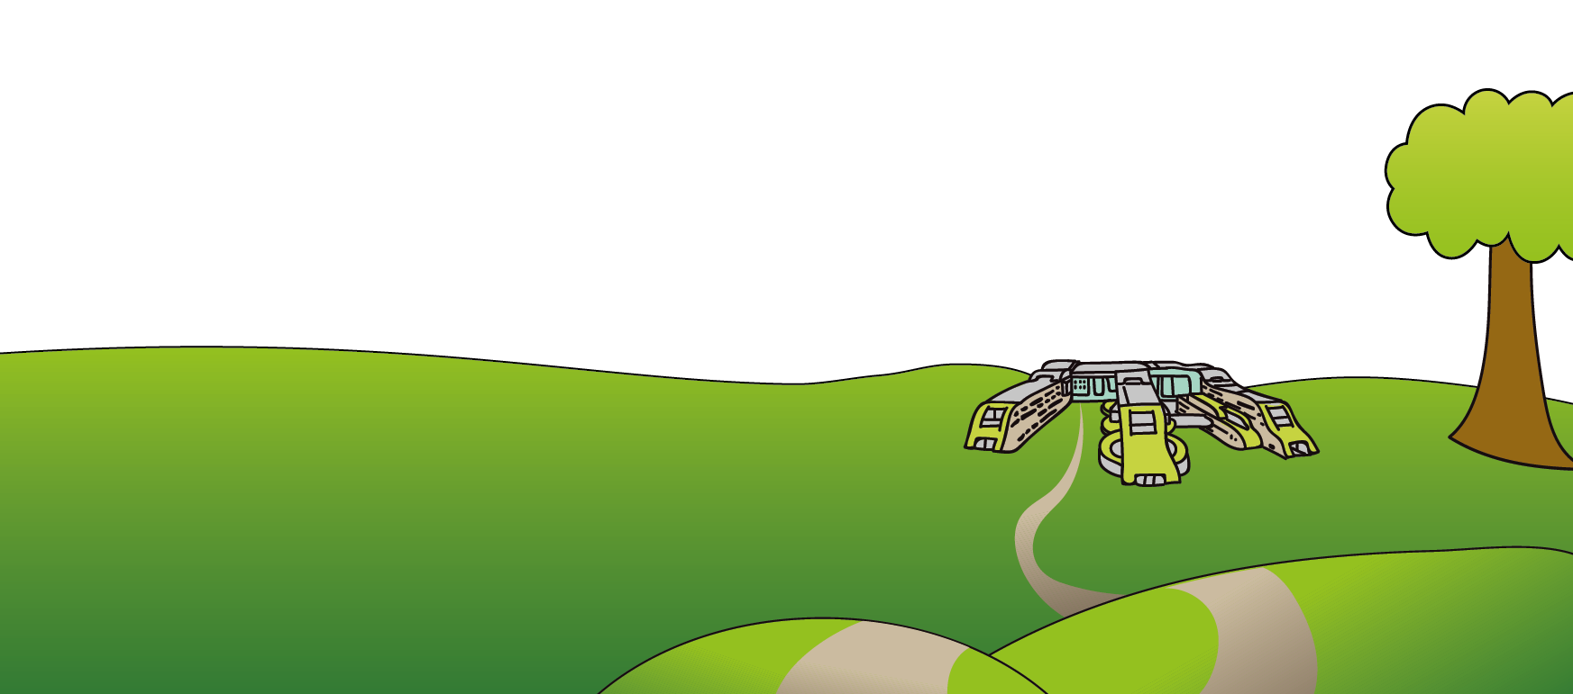
Tel: 0151 228 4811
www.alderhey.nhs.uk

© Alder Hey Review Date: May 2024 PIAG: 054

