Department of Ophthalmology

Watery Eye (Epiphora)

Information for parents and carers

Who is this leaflet for?
This leaflet is for parents / caregivers of children who have watery eye(s), also known as epiphora.
What is Epiphora?
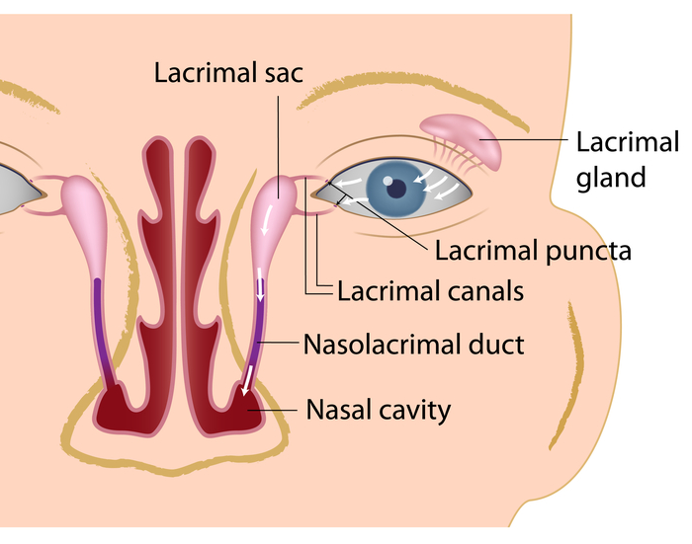
Tears consist of a mixture of water, salt, protein and mucus. They are constantly produced by the lacrimal gland and serve to keep the surface of the eyes moist and healthy.
Tears drain out from the surface of the eye through the lacrimal puncta (small openings in the eyelid) into the tear ducts or canals (canaliculus). There are two tear ducts, one in the upper eyelid and one in the lower eyelid. From here they pass to a small pouch (the lacrimal sac) and then drain down the nasolacrimal duct to the inside of the nose (nasal cavity). Tears eventually empty into the nostrils or the back of the throat, where they are swallowed.
Some people suffer from too many tears or watery eyes, and this is known as epiphora.

What causes Epiphora?
There are many causes of epiphora. These can be broadly divided into:
- Overproduction of tears
- Blocked drainage of tears

Overproduction of tears can be due to:
- Dry eyes
- Irritation of the eyes from eyelashes and eyelids
- Injury or foreign body on the eyes
- Allergy

Blocked drainage of tears can be due to:
- A tear drainage (nasolacrimal duct) system which is not fully developed – this is usually the commonest cause as it is not uncommon for a baby to be born before these channels are completely open.
- Scars from previous injury, infection or surgery anywhere along the tear drainage system
- Deformities of the eyelids and/or the nasal cavity

What are the symptoms of epiphora?
Often your child will be well in him/herself. However you may notice:

- Tears that can roll down the cheek or matt the eyelashes
- Irritation of the delicate skin around the eyes
- Tears may well up inside the eyes making vision blurred, with the child rubbing their eyes
- Sticky discharge on the inner corner of the eyelid
- Painful, red swelling (dacryocystitis) at the inner corner of the eyelid requiring treatment with antibiotics – these can be recurrent

How will the diagnosis be made?
During the consultation, the clinician will ask a number of questions about the problem. In order to confirm the presence of epiphora, they will carry out an examination on your child to look for overflow of tears, irritation of the skin around the eyes and cloudy or yellowish fluid in the tears. They will also be looking for signs which will help identify the cause of epiphora, such as scarring or abnormalities of the eyelids.
Fluorescent yellow drops may be placed into your child’s eyes to observe the length of time it takes for them to clear out of the eyes, and whether any of the drops have reached the nose. Delayed clearance of this dye suggests that there might be a blockage.
Following this careful examination, the clinician will decide on the most likely the cause of the epiphora.

What is the treatment for epiphora?
If any causes of epiphora (other than blockage) are found, such as allergies or infections, these will be treated accordingly with eye drops or other measures.
If epiphora is thought to be due to nasolacrimal duct obstruction, it is common to wait till the age of 12 months to see if the duct will open on its own. More than 90% of obstructions resolve on their own. In the meantime, we would advise to massage the area between your child’s eye and nose with a clean finger. This is especially useful first thing in the morning, to empty the lacrimal sac of tears that have built up overnight, thereby preventing stagnation of tears, and possible infection.
If the epiphora persists then the next step would be surgery. Surgery may be done before the age of 12 months if:
- There are recurrent infections which do not resolve despite antibiotics
- There is a cyst in the lacrimal sac (dacryocele) which is not resolving
What is the surgical treatment for epiphora?
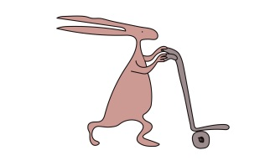
Surgical treatment for epiphora routinely requires a general anaesthetic (where the child is asleep) to carry out the procedure. Your doctor will discuss with you the appropriate surgery for your child.

- Syringing and probing

The first treatment option, this involves passing a blunt probe through the tear ducts to remove any obstructions. This procedure is a delicate one, and can be tricky to perform on young children. It is usually necessary to carry out this test under a general anaesthetic (while the child is asleep). Sometimes, this procedure may overcome a minor blockage, and may even be sufficient to treat the child’s symptoms. This technique is successful in approximately 70% of cases, though this is lower in older children. It is usually recommended for children below the age of 4, who have no other facial abnormalities.

- Intubation
This is similar to syringe and probing, but involves placing a silicone tube through either one (monocanalicular) or both (bicanalicular) punctae. This tube is left for at least four months. It has a success rate of approximately 80%. It is usually recommended where syringing and probing has failed, or in older children. Removal of the tube can take place in clinic; however in some cases a general anaesthetic is required.
- Dacryocystorhinostomy (DCR)
This surgery is usually reserved where the above two procedures have failed, or if there are abnormalities in the facial bones which means the above two procedures cannot be carried out. This procedure involves removing some of the bone between the lacrimal sac and the nasal cavity so that a direct connection could be formed between the two, and bypass the blocked nasolacrimal duct. Intubation is usually performed at the same time to keep the connection open. There are two methods of performing DCR:
- External – this involves making an incision in the side of the nose to get access to the bone. It has a success rate of about 90%
- Endonasal – this involves going up the nose to get to the bone, and therefore avoids a scar on the side of the nose. However this is more difficult to do, and is often not possible in younger children due to the crowding of structures with the nose. This has a slightly lower success rate of 70 to 80% (based upon results seen in adults)
What will happen before surgery?

Before the operation, your child will be seen in the clinic by your consultant or a member of the team. They will ask you about the problem, any other medical problems and any medications that your child takes. They will then examine your child’s eyes prior to making a surgical decision.
If you are to proceed with surgery, the operation will be discussed in detail. This will include any risks or possible complications of the operation.
You will be asked to read and sign a consent form after having the opportunity to ask any questions.
What are the risks and possible complications of surgery?

Common
Bleeding: You may note some small amounts of bleeding from the nose for the 1st 24 hours. This usually resolves on its own without any intervention.
Dislodgement of the tubes: Often these tubes can come out without realising. Occasionally they may require a small procedure to remove the tubes.
Failure: The failure rate of each procedure is described above. Sometimes procedures are repeated which can improve the overall success.
Scar: This is only associated with external DCR, and is usually quite small.
Uncommon
Infection: There may be some redness or swelling along the side of the nose. This will usually settle with some antibiotics but rarely may require surgery.
Rare
Leakage of cerebrospinal fluid: This is the protective fluid around the brain. This is serious and may require antibiotics, or further surgery. It may show as clear fluid running out of the nose, and your child may complain of headaches.
Meningitis: Infection of the layer surrounding the brain. This is serious and requires antibiotics. Your child may complain of headaches, and suddenly appear unwell.
Loss of vision: Rarely blood may collect behind the eye and compress the nerve of vision. This is extremely rare but may show as pain, loss of vision and bulging forwards of the eyeball.
What should I expect after surgery?

After surgery, your child may experience some pain. Simple paracetamol is usually enough to control this. There may be some bleeding from the nose that settles on its own.
The epiphora usually improves a few days after surgery, though sometimes the tubes need to be removed before symptoms are improved. Even after surgery there may be epiphora if your child has a blocked nose.
Four months after intubation, the tube may either be removed in clinic or a date given for removal in theatre. There may still be some watering present up to 3 months after the tubes are removed.
Instructions for after Epiphora Surgery

Your child can return to most normal activities within days of surgery. It is best that your child avoids rubbing their eyes, especially after a tube is inserted. If a tube does become dislodged then please call the clinic. Do not attempt removal of the tube yourself if it dangling from the eye.

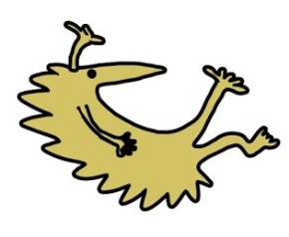
A follow up telephone appointment will be scheduled for a couple of months after surgery. If there are any concerns, please get in touch with the secretary or clinic and we will arrange to see you as appropriate:
Hospital telephone number: 0151 228 4811
Extension for clinic: 2215
Extension for secretary: 2839 / 3595 / 2961

This leaflet only gives general information. You must always discuss the individual treatment of your child with the appropriate member of staff. Do not rely on this leaflet alone for information about your child’s treatment. This information can be made available in other languages and formats if requested.
Alder Hey Children’s NHS Foundation Trust
Alder Hey
Eaton Road
Liverpool
L12 2AP

Tel: 0151 228 4811
www.alderhey.nhs.uk

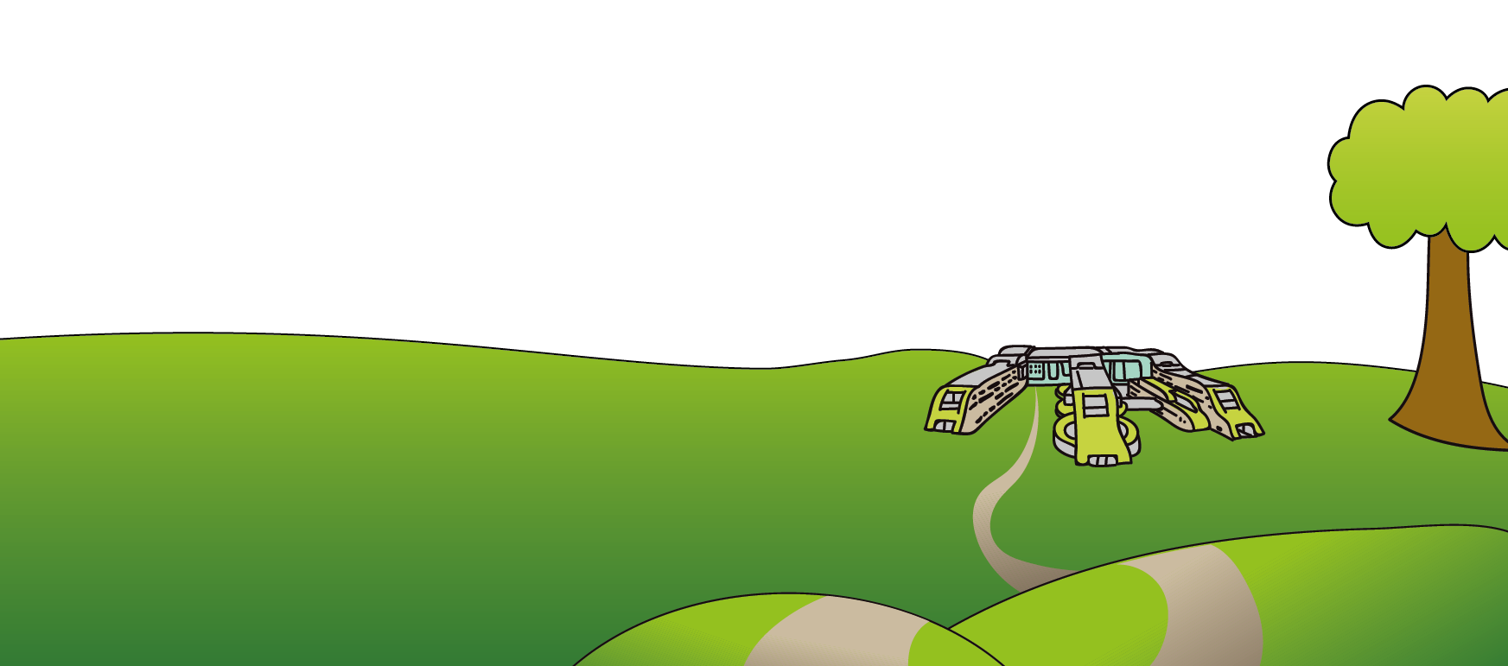

© Alder Hey Review Date: August 2024 PIAG: 355

