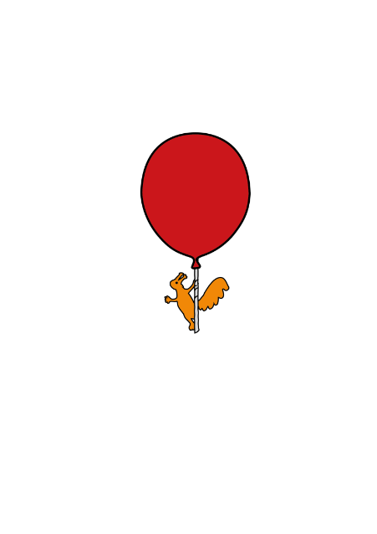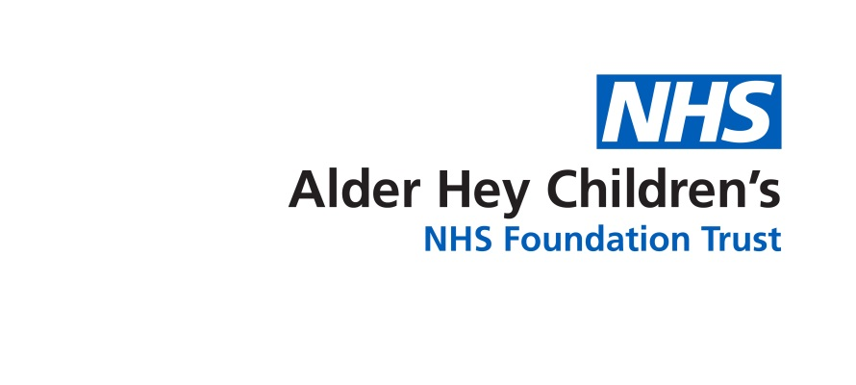

Department of Pharmacy

**Vitamin D Deficiency**

Information for patients, parents, carers



**High Dose Vitamin D**

This leaflet has been included to provide more information about your new high dose Vitamin D (Colecalciferol) prescription.

**Why is Vitamin D Important?**

Vitamin D is an essential nutrient needed to build strong, healthy bones and prevent diseases such as ricketts. All children and young people over 1 year of age require a low daily dose of 10 micrograms (400 international units) of Vitamin D. Unlike other vitamins, the main source of Vitamin D is the sun rather than food. However, in the UK, our exposure to the sun is often not enough to give us all the vitamin D we need. This is why many people also need supplements.

**Taking Your New High Dose Vitamin D Supplement**

You have been prescribed a **HIGH DOSE** of Vitamin D for a **SHORT COURSE ONLY**.

**\*This high dose should only be continued for the time period stated on your discharge or outpatient prescriptions - this will depend on your age\***

**(A review of your Vitamin D levels following the treatment course will be required)**

Once the short treatment course has been completed, you may be advised to take a long term Vitamin D supplement at a lower dose. Over the counter multivitamin supplements may contain some Vitamin D and you should always check the list of ingredients on the packaging and discuss with an appropriate healthcare member of staff.

Please speak to your Pharmacist if you are vegetarian or vegan to make sure the supplement is suitable.

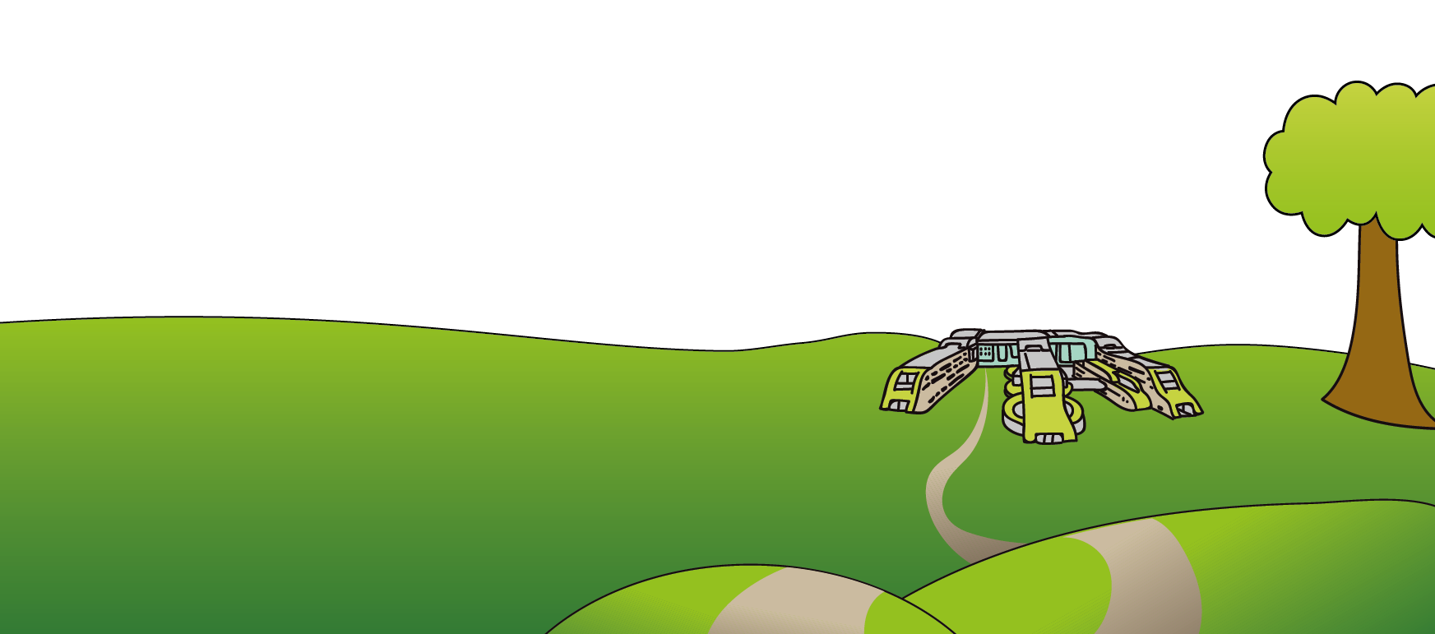This leaflet only gives general information – see manufacturer’s information included in the packaging of your medicine for more details. You must always discuss the individual treatment of your child with the appropriate healthcare member of staff. Do not rely on this leaflet alone for information about your child’s treatment.

This information can be made available in other languages and formats if requested.



****Alder Hey Children’s NHS Foundation Trust

Alder Hey

Eaton Road

Liverpool

L12 2AP

Tel: 0151 228 4811

[www.alderhey.nhs.uk](http://www.alderhey.nhs.uk)

**© Alder Hey Review Date: December 2025 PIAG: 433**