Please remember

We are here to help you. If it would be helpful to have an interpreter available please let us know.

Our telephone number is:

0151 228 4811, Extension 2321

We are open Monday to Friday 8.30am to 5.00pm.

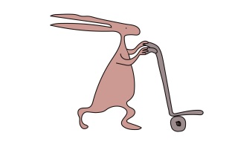

This leaflet only gives general information. You must always discuss the individual treatment of your child with the appropriate member of staff.
This leaflet provides information only about your ultrasound scan.
This information can be made available in other languages and formats if requested.

Alder Hey Children’s NHS Foundation Trust
Alder Hey
Eaton Road
Liverpool
L12 2AP

Tel: 0151 228 4811
www.alderhey.nhs.uk

© Alder Hey
Review Date: May 2024
PIAG: 103

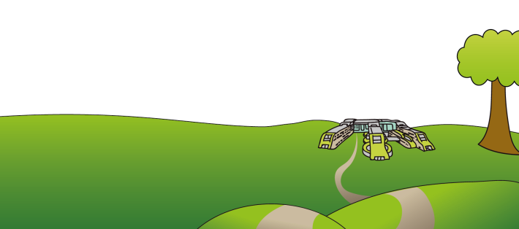

Radiology Department
Visiting
Ultrasound

Information for patients,
parents and carers

Hello
Here is some information about your ultrasound scan.
What is an ultrasound scan?
A scan is a special way of looking inside your body.
The ultrasound scan waves can be used to look at everything inside your body. We can see your liver, kidneys, muscles and even your heart beating.
What is ultrasound?
Ultrasound is a sound wave which humans cannot hear. Animals such as dogs can hear ultrasound waves and bats use ultrasound waves to fly around in the dark without bumping into anything.
Why do you need to have a drink?
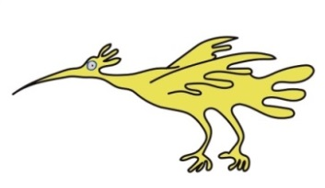
For certain ultrasound scans we may ask you to drink water to fill up your bladder. When the bladder is full it acts like a “window “so we can see inside and look at the lower part of your tummy.

What happens during your ultrasound scan?
A member of staff will explain what your scan will involve and give you the opportunity to ask any questions.
The grown up who has brought you for the scan can stay with you.
We ask you to lie on our bed and loosen your clothes so we can put some special ultrasound jelly on your skin. We tuck some paper towel into your clothes so we don’t get jelly on them. If some jelly does go on your clothes by mistake, it doesn’t matter as it will wash off easily.
We then spread the jelly across your skin using a small piece of equipment called a transducer. This makes the ultrasound waves and a picture appears on the T.V. screen with the help of our computer.
If you require a full bladder for your scan, we have a toilet in the ultrasound room for you when we have scanned your bladder.
During the scan you may be able to watch your favourite programme on a screen on the ceiling.

Does it hurt?
No it does not!
We warm the jelly for your scan, it may feel sticky – it may even tickle!
How long does the ultrasound scan take?
The scan takes between 15- 30 minutes.
However, you will need to be in the department longer than that if your bladder is not full and we need you to have a drink.
Please try to follow the instructions on your appointment letter.
What happens after the ultrasound scan?
When the scan is finished, we help you to wipe the jelly off your skin and tidy your clothes.
When will you know the results of your scan?
We will send a report of your scan to the doctor who requested it.
That’s all there is to it!

