Paediatric Intensive Care Unit
Visiting Guidance
Information for Parents and Carers

Temporary Covid Restrictions
At Alder Hey, our priority remains keeping our children, young people, families, and colleagues safe and well; therefore, the following guidance REMAINS in place.

PICU Visiting guidance

These visiting guidelines have been designed to create a safe environment for all the children within our unit. We particularly wish to minimise the risk of your child having an infection which we could have prevented. We wish to ensure that staff are not hindered in caring for your child.
Please help to keep yours, and other children safe by following these guidelines. Help us by challenging any of our team if they do not wash or gel their hands before entering your child's bed space.
If you have any questions regarding who can visit your child and at what time, please ask the nurse in charge of the unit.

Who can visit?

- Only the 2 nominated visitors (parent/carer) can visit throughout the patient’s PICU admission.
- Any visitors showing signs of fever cough, cold or stomach virus will not be allowed to visit. Please notify the bedside nurse if you or anyone in your family has been exposed to any contagious disease (such as chickenpox) on admission or as soon as you become aware of this.
- Do not visit if you, or someone you live with is showing signs of Covid-19 or have been in contact with somebody who has tested positive for Covid-19. If you or a member of your household does test positive for Covid-19 then you must inform us of this over the phone.

- Visiting is restricted to the 2 nominated visitors to stop the spread of infection.

- Face Masks must be worn by all visitors unless exempt for medical reasons, please don’t be offended when you are asked for the exemption certificate.

When can you visit your child?

- Parents/guardians can visit their child for as long as they wish at any time of the day with the following exceptions:

- The unit or individual Pods may be closed to all visitors when surgical procedures take place. This is to help us reduce the risk of infection.

- You will be asked to leave the bedside twice a day (7am-7:30am and 7pm-7:30pm) for protected handover time; this allows us to protect sensitive and confidential information relating to all our patients and therefore ensuring the safety of our patients.

- Only Parent's /Guardians are permitted to visit before l0 am and after 8PM.

What to do when you are visiting

- On PICU we take infection prevention very seriously and to help us reduce the risk of your child developing an infection we ask that you do the following.
- Please remove outdoor clothing before entering your child's bed space, roll up long sleeves then wash and gel your hands before touching your child and when leaving the bed space.
- If your child is in isolation, please follow the nurse's advice about protective clothing and seek advice about siblings visiting.
- Parents and guardians must remain in their child's bed space/cubicle. Please do not visit any other patient's bed space within the unit. This is not only for infection control reasons but also to maintain
confidentiality for your child and other children on the unit.
- Do not bring food, drink, fresh flowers, or balloons onto the unit.
- Minimal personal items due to keeping the clinical area clean and tidy as per infection control.
- Please respect the needs of others, the parent’s reception area is for parents only.
- Mobile phones should be on silent and phone calls should be taken away from the bed space.
- Photos maybe taken of your own child on your own devices but must not include Staff, medical equipment or clinical documentation.
- Please do not use the main corridor to make phone calls or as a waiting area as this is a clinical area and must always be kept clear.
Medical teams will be using this corridor to take patients to scan/theatre and emergencies from the helipad.
- Please do not use the interview rooms as waiting areas.

This leaflet only gives general information. You must always discuss the individual treatment of your child with the appropriate member of staff. Do not rely on this leaflet alone for information about your child’s treatment.
This information can be made available in other languages and formats if requested.

Alder Hey Children’s NHS Foundation Trust
Alder Hey
Eaton Road
Liverpool
L12 2AP

Tel: 0151 228 4811
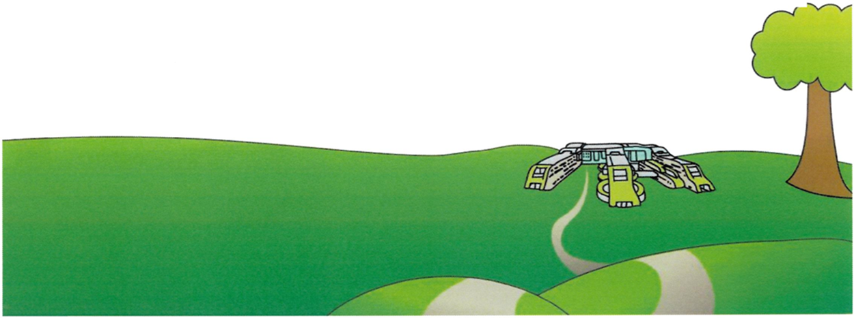
www.alderhey.nhs.uk

© Alder Hey Review Date: February 2025 PIAG 350

