Pregnancy and an x-ray
There is a risk to a developing baby, as each x-ray does involve a small dose of radiation. Children over the age of 12 years may be asked about their menstrual cycle before they have their x-ray. Please do not take offence, as this is Trust policy.
If you are accompanying a child for an x-ray and are pregnant yourself you will be asked to leave the room during the exposure. You may wish to consider bringing a relative or friend to stay with your child during the x-ray.

If you have any queries, please feel free to contact us on: 0151 228 4811 x 4197.

This leaflet only gives general information. You must always discuss the individual examinations of your child with the appropriate member of staff. Do not rely on this leaflet alone for information about your child’s examinations.
This information can be made available in other languages and formats if requested.

Alder Hey Children’s NHS Foundation Trust
Alder Hey
Eaton Road
Liverpool
L12 2AP

Tel: 0151 228 4811
www.alderhey.nhs.uk

© Alder Hey
Review Date: May 2024 PIAG: 117

Radiology Department
Visiting
X-ray

Information for patients,
parents and carers

Welcome to X-ray
Your doctor has referred you to radiology for an x-ray to see how your body works.
We perform lots of different x-rays on
different parts of the body.
When you arrive at X-ray, a member of staff will greet you and explain what your x-ray involves.

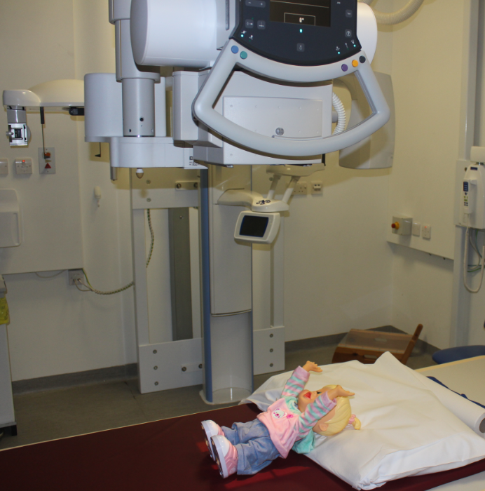

To get the pictures for your test, you will need to stand, sit or lie down for a few minutes while we use an x-ray camera to take the ‘picture’.
You will not feel anything, just like having a normal picture taken. We just shine a light on the part of your body we need to see.
The most important thing is to keep still.

