Pregnancy and a Gamma Scan
There is a risk to a developing baby, as each Gamma Scan does involve a small dose of radiation. Every girl over the age of 12 years will be asked to supply a urine sample for pregnancy testing before they have their scan. Please do not take offence, as this is Trust policy.
If you are accompanying a child for a Gamma Camera Scan and are pregnant yourself, please do not be alarmed, as the risk to your developing baby is negligible. Staff who work in the Gamma Camera can do so with no effect.

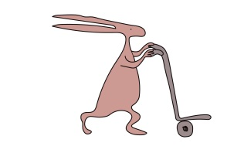

If you have any queries, please feel free to contact us on 0151 252 5332.

This leaflet only gives general information. You must always discuss the individual treatment of your child with the appropriate member of staff. Do not rely on this leaflet alone for information about your child’s treatment.
This information can be made available in other languages and formats if requested.

Alder Hey Children’s NHS Foundation Trust
Alder Hey
Eaton Road
Liverpool
L12 2AP

Tel: 0151 228 4811
www.alderhey.nhs.uk

© Alder Hey

Review Date: Feb 2029 PIAG: 0032

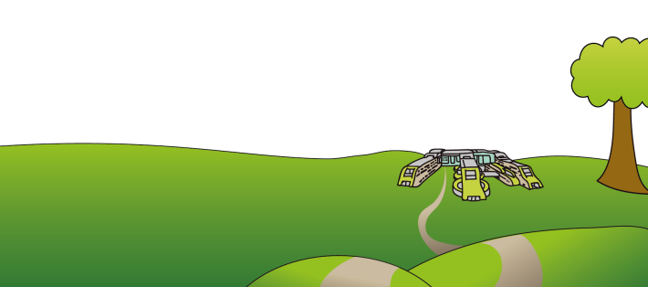

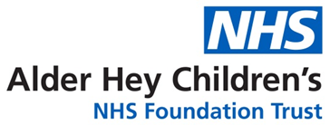

Radiology Department
Visiting
Gamma Camera



Information for patients,
parents and carers

Welcome to Gamma Camera
Your doctor has referred you to us for a test to see how your body works.
We perform lots of different tests on
different parts of the body.
When you arrive at the Gamma Camera, a member of staff will greet you and
explain what your test involves.

As most of our tests do involve having a little butterfly needle, you will be given the option to have ‘magic cream’ to numb your skin so that you shouldn’t feel it.

To get the pictures for your test, we need to give you a special medicine which is a ‘radioactive dye’. The amount of dye you will get is based on your weight.
After you have had your ‘dye’ you may have some pictures taken straight away or you may have to wait a few hours.
A member of staff will inform you of the time for your pictures.
While having your pictures taken you will need to lie still on a bed so that we can get all the information needed for your doctor.
While you are having your pictures taken you will be able to choose what you want to watch on our big projector screen on the ceiling.

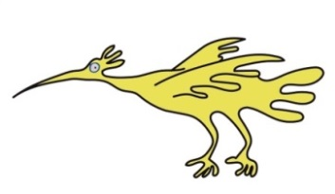

About the radiation involved
We are all exposed to natural radiation every day of our lives. This comes from the air we breathe, the food we eat and even from outer space.
In any one year our exposure will vary
according to where we’ve lived, where we may have flown to and what we may have eaten.
Putting it into perspective

Each medical Gamma Scan therefore gives us a small additional dose on top of the natural background radiation. The level of this dose varies with the type of examination.

