

The Roald Dahl Neurophysiology Department

**Video Telemetry EEG**

Information for parents and carers

**What is Video Telemetry EEG?**

Video Telemetry EEG is the simultaneous recording of the activity of the brain (EEG) and video. It is used to help investigate a number of conditions, most commonly black-outs or seizures which occur during wakefulness or sleep.

**Why does my child need a Video Telemetry EEG?**

****The aim of the test is to record some of your child’s typical episodes which they are experiencing throughout the day or night time. We then look for any possible relationship between your child’s brain activity and these episodes.

Ideally, we would like to record at least three of their episodes before stopping the test.

**Will Video Telemetry EEG hurt my child?**

No, as it is a painless test and there are no side effects

**Where does it take place?**

Your child will be admitted onto ward 4B, **for a period of up to five days**. They will be allocated their own room, with private bathroomfacilities. A parent / carer will need to stay with your child **throughout** the monitoringperiod. A small bed settee is available at night time for the parent / carer to sleep on.

For the test please ensure your child continues with their regular medication unless advised otherwise by your child’s Consultant. Make sure your child has clean hair, which is free from hair gel etc.

**What should we bring?**

Please bring any medications your child will need along with pyjamas, dressing gown, slippers etc.

To keep your child occupied, there is a TV in the room. You are encouraged to bring Ipads / tablets, portable DVDs players to use, along with books and small toys etc.

**What does the test involve?**

Video Telemetry is performed by the Clinical Physiologist who will explain all aspects of the test thoroughly. To monitor your child’s brain patterns, the EEG electrodes are attached to the scalp with a special adhesive or bandage. At the same time, continuous video recording is made. We do not shave or cut their hair.

These electrodes are connected to a small box placed in a bag and worn either around the waist, across the body or placed on the bed.

There will be complete privacy in the bathroom however your child will not be able to shower or wash their hair.

**Your child will not be able to leave their room during the monitoring period**.

This is due to the risk of missing any typical episodes, which would prolong their length of stay.

It helps if your child wears pyjamas, a T-shirt or a button through top during the test.

Please don’t allow them to wear a onesie.

Parents will be allowed to leave the room for comfort breaks.

**Please ring ward 4B on 0151 293 3633 on the morning of your appointment to ensure that the cubicle is available for your child**

**How are the electrodes removed?**

There are **no after effects** following the test and we remove the electrodes with a solution which dissoves the adhesive.On very rare occasions, especially if your child has delicate skin, there may be small tender areas on some of the places where the electrodes have been. These should disappear very quickly and leave no side effects

**When will I get the results?**

You will receive these at your child’s next outpatient clinic.

**What will happen if I decide that my child will not have Video Telemetry EEG?**

It may affect the management of your child’s condition.

**Are there any alternatives to this procedure?**

There are no alternative procedures.

**For further information**

If you have any queries about your appointment please phone the Neurophysiology department on

**0151 252 5375**

This leaflet only gives general information. You must always discuss the individual treatment of your child with the appropriate member of staff. Do not rely on this leaflet alone for information about your child’s treatment.

This information can be made available in other languages and formats if requested.

Alder Hey Children’s NHS Foundation Trust

Alder Hey

Eaton Road

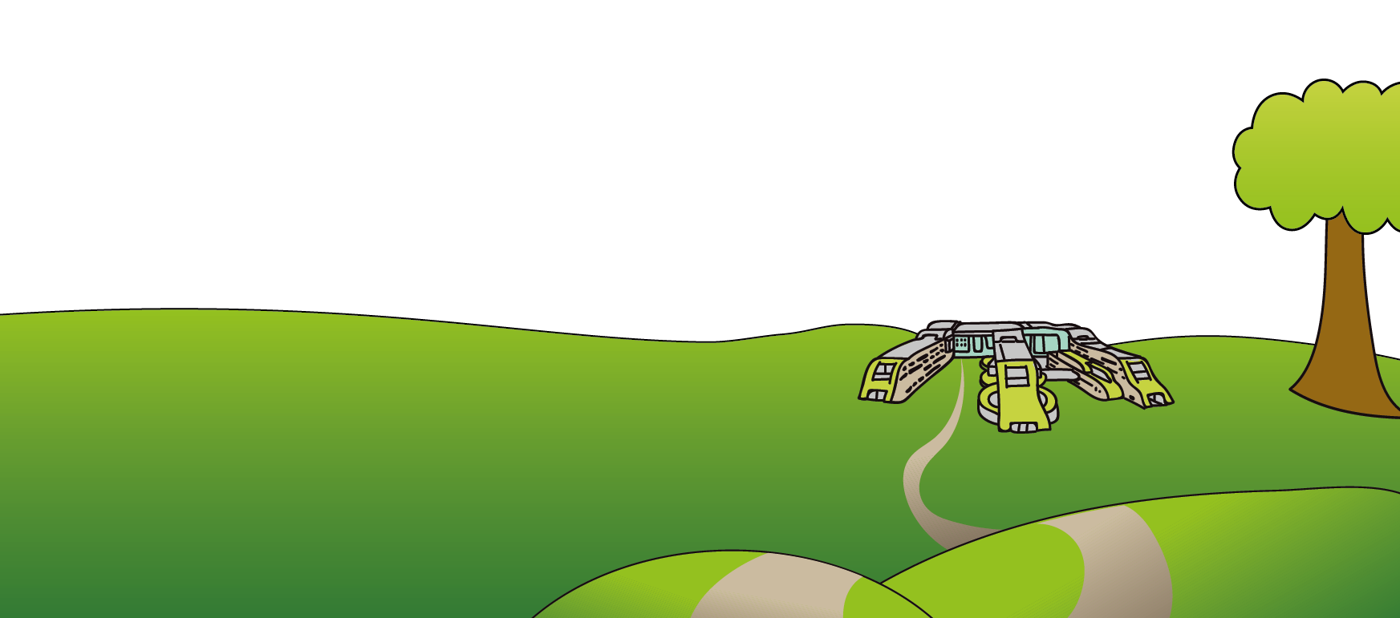Liverpool

L12 2AP

Tel: 0151 228 4811

[www.alderhey.nhs.uk](http://www.alderhey.nhs.uk)

**© Alder Hey Review Date: January 2025 PIAG: 81**