Urology Service

Vesicostomy

Information for insert details

Introduction
Your child’s Doctor has recommended to you that your child has a vesicostomy. This fact sheet aims to support the discussion you had with the Doctor and to enable you to make an informed decision.

What is a vesicostomy?
A vesicostomy is a small opening on the abdomen, just below the belly button, that allows urine to drain from the bladder onto the abdomen. The urine is collected into a nappy. A vesicostomy is usually carried out on babies or children where the kidneys are at risk of damage, as a result of urine being stored in the bladder at high pressure or where there is difficulty emptying the bladder. Your child will remain in nappies whilst they have a vesicostomy. Your Doctor will discuss with you how long your child is likely to have a vesicostomy for and alternative solutions to draining your child’s bladder in the future.

What are the benefits of my child having vesicostomy?
The vesicostomy allows urine to drain constantly. This helps reduce urine going
back up (refluxing) to the kidneys and improves emptying of the bladder.
This will help reduce the risk of urinary tract infections and kidney damage.

What are the risks of my child having a vesicostomy?
The formation of a vesicostomy requires an operation under general anaesthetic. There are risks associated with a general anaesthetic. Complications of the vesicostomy include stenosis or narrowing of the vesicostomy which may lead to poor drainage.
Your Doctor may suggest dilating the vesicostomy. Dilating stretches the opening of the vesicostomy and allows the urine to drain better. Your child’s Urology nurse will show you how to dilate their vesicostomy if it is necessary. You should inform your Doctor or Nurse if the drainage from your child’s vesicostomy is poor. If dilatation does not improve the drainage of urine the vesicostomy may need to be revised, which will require a further operation.

Another risk may be prolapse of bladder tissue through the vesicostomy skin opening. This means that the bladder may protrude out of the vesicostomy, more than usual. This can occur if the child has been straining, for example, during bowel movement or when they are crying.

A small prolapse may come out a couple of centimetres from the opening. When your child is no longer straining it may be gently pushed back. If the prolapse cannot be pushed back or is larger than a few centimetres you should contact your Doctor or Nurse. It is normal for a small amount of pink bladder tissue to be visible at the site. If this becomes discoloured you should also contact your Doctor or Nurse.

Will a vesicostomy hurt my child?
Your child will be under general anaesthetic during the procedure. They may need regular pain relief following surgery until they are fully recovered, usually within 48 hours. There may be a small amount of bleeding from the vesicostomy after the operation. This is normal and will improve. The vesicostomy may also be a little swollen. This usually settles after a week. The opening will then look like a small slit, usually 3 to 4cm across, surrounded by a small amount of pink/reddish bladder tissue. Once healed the vesicostomy is not painful.

Are there any alternatives to this procedure?
A suprapubic catheter may be an alternative. This is a tube inserted into your child’s bladder through the abdomen. This procedure also requires an anaesthetic. There are risks to this procedure which your doctor will explain. The most common is urinary tract infection or the catheter being pulled out. The catheter will also need to be replaced every 3 to 6 months which requires further operations.
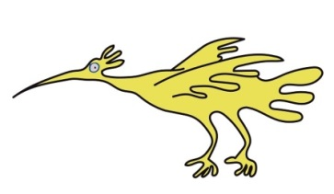
What will happen if I decide my child will not have a vesicostomy?
Your Doctor/Nurse will look at alternative procedures as indicated above.

How long will this procedure take?
The operation usually takes approximately 1 hour. Your child will be in recovery for approximately 1 hour. They should therefore, be back on the ward between 2 and 3 hours.

How long will my child be in hospital?
Usually around 24 to 48 hours. The Doctors may leave a catheter or tube into the vesicostomy. This will be removed before your child is discharged. Your child will be given regular pain relief. The urine draining from the vesicostomy may be blood stained at first. This is normal and will settle after the first few days.

Discharge Information
Your child’s nurse will give you advice before going home as to how to care for your child’s vesicostomy. The urine from a vesicostomy is collected into a nappy. Sometimes it may be necessary to put extra pads, such as gauze or a sanitary towel, into the nappy to absorb the urine. It may also be helpful to put your child’s nappy on back to front. Nappies should be checked regularly and changed when wet to prevent damage to the skin around the vesicostomy. The skin around your child’s vesicostomy should be checked daily for soreness. It may be necessary to apply barrier ointments if you notice your child’s skin is irritated, red or sore. Your child’s Nurse will give you advice with regards to this.
Your child may bathe as normal 2 days after surgery once the vesicostomy has healed. Sometimes it may be possible to fit a bag over a vesicostomy to collect urine but this can be difficult and you should expect your child to remain in nappies.

You should contact your Doctor or Nurse:
- If there are signs of poor urine drainage or urine does not drain from the vesicostomy for 2 hours.

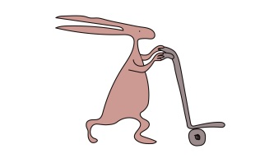
- If your child has signs of urinary tract infection including offensive smelling urine, temperature, irritability, poor appetite or feeling tired and generally unwell.
- Prolapse of the vesicostomy or if the vesicostomy looks different in any way
- Blood in the urine
- Your child complains of pain at the site of the vesicostomy.

You will also be supported at home by your local continence nurse and/or community nurse. Please ask for contact details before your child is discharged.

Further appointment information
Your child will continue to have regular follow up with the Urology Consultant. If there are any problems in the meantime you may contact the Urology Nurses.

For further information.

Please contact the Urology Nurses on 0151 252 5852.

This leaflet only gives general information. You must always discuss the individual treatment of your child with the appropriate member of staff. Do not rely on this leaflet alone for information about your child’s treatment.
This information can be made available in other languages and formats if requested.

Alder Hey Children’s NHS Foundation Trust
Alder Hey
Eaton Road
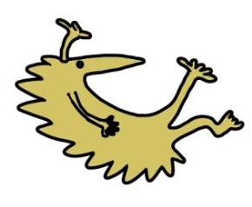
Liverpool
L12 2AP
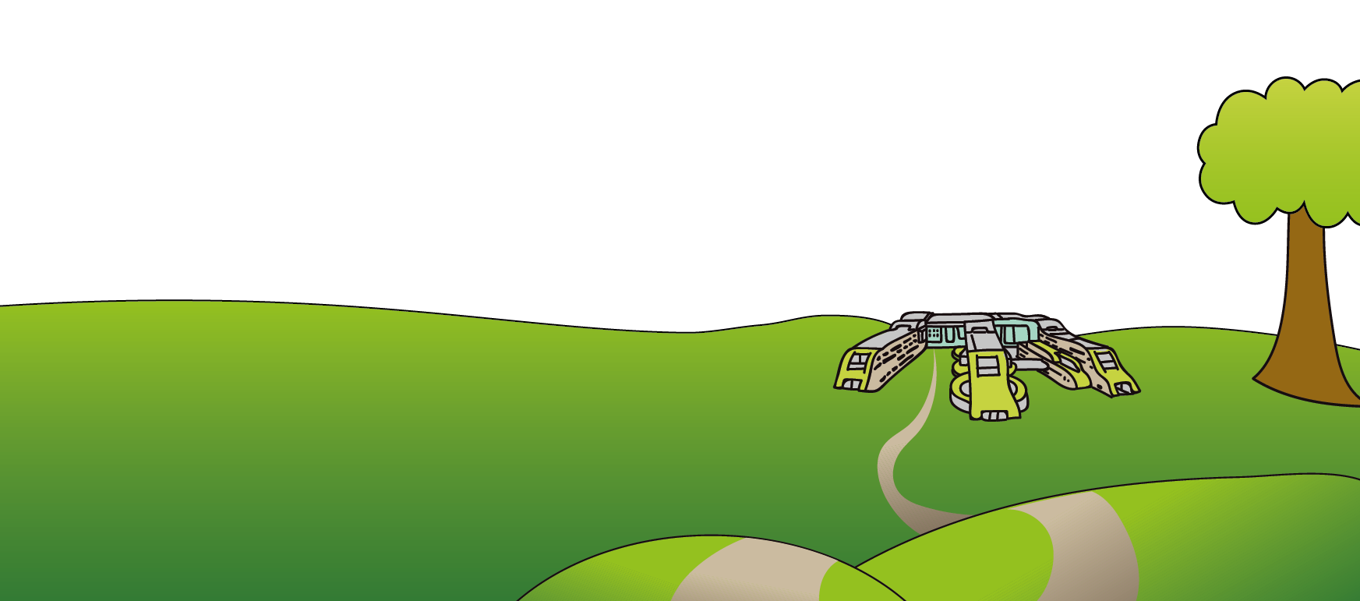
Tel: 0151 228 4811
www.alderhey.nhs.uk

© Alder Hey Review Date: February 2025 PIAG: 0025

