Urology Department

Vaginal Reflux
Information for parents and carers

Introduction

The leaflet is aimed at providing information about Vaginal Reflux.
Vaginal reflux or vesicovaginal reflux is a problem related to toileting, causing wee to be trapped in the vagina, and can be a common cause of wetting in girls. This can be diagnosed by a medical professional taking a history and examination. When urine is seen filing the vagina after passing urine your daughter’s doctor or nurse may advise your daughter has a scan. These scans are not routinely done.
Wetting can occur when retained wee within your daughters’ vagina leaks out, this can happen when she stands up or jumps, coughs or sneezes much later. It is more common in young girls but can rarely be seen in young women. Labial fusion (common occurrence in young girls where the labia are temporarily joined), obesity and poor toileting habits (see below) can make vaginal reflux worse.
What are the symptoms of vaginal reflux?
Vaginal reflux can present with:
- Wetness or dampness after your daughter has used the toilet
- Vulvovaginitis (redness and pain around the vulval region).
- Offensive smell around the vagina.
- Vaginal discharge.
What does vaginal reflux look like?
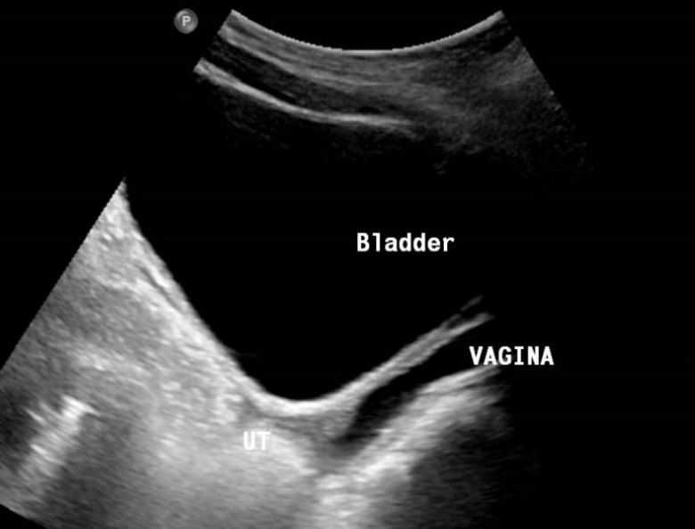
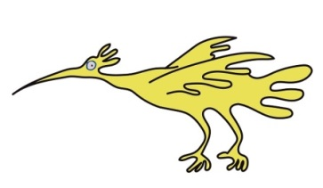
The exterior of your daughter genitalia will often be normal. However, as shown in the image to the left, the vagina contains urine as well as the bladder.
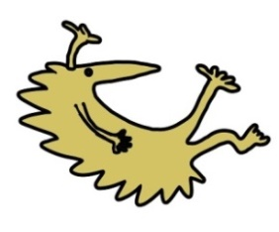
In some girls labial fusion may be seen. When examined your daughter’s labia (inner vaginal lips) will be partially fused together. The external genitalia may be inflamed due to irritation by the wetness.

How is vaginal reflux treated?
There are a few ways your daughter can help with vaginal reflux….
- ‘’KNEES AREN’T FRIENDS’’- Many young girls will sit in the toilet with their knees together as they pass urine. This can cause ineffective bladder emptying and worsen vaginal reflux. Encourage your daughter to sit upright on the toilet with their legs apart from one another. Remember knees aren’t friends!

- PASSING URINE THE OPPISITE WAY ROUND - Encouraging your daughter to sit on the toilet backwards in a straddling positing when having a wee may also help to empty their bladder / vagina more effectively.

- ROCKING - By encouraging your daughter to rock backwards and forwards on the toilet after they have finished their wee or during their wee may help to encourage any collected urine to drain better.

- DOUBLE VOIDING - Asking your daughter to try again to pass more urine after they have finished their wee may also help with better urine drainage.
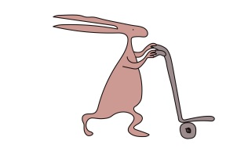
- WIPING - Pressing into the perineum when wiping after your daughter has had a wee may help to absorb urine that may have collected in the vagina.

- COUGHING OR STRAINING - It may be helpful for your daughter to try to cough or strain after she has had a wee to dislodge any wee that may be collected in her vagina.

- WEIGHT LOSS - As vaginal reflux is more common in girls who are overweight, vaginal reflux may reduce as your daughter loses weight.

Will the vaginal reflux get better?
Vaginal reflux is not a life threatening condition, but more of a minor toileting issue that can be well managed at home. By adopting the techniques shown above, this will help to reduce the symptoms of vaginal reflux, and hopefully help to reduce wetting for your daughter. As your daughter grows and their anatomy changes during puberty their symptoms may improve with time also.
If your daughter is under our Urology Nurse Service or the Urology consultants they will monitor her symptoms and be able to advise you with any information you need to help you manage your daughter’s symptoms. Your daughter may also be prescribed different creams to help with their genital irritation, including Dermol 500 cream. If your daughter has labial adhesions she may be prescribed cream that contains oestrogen.
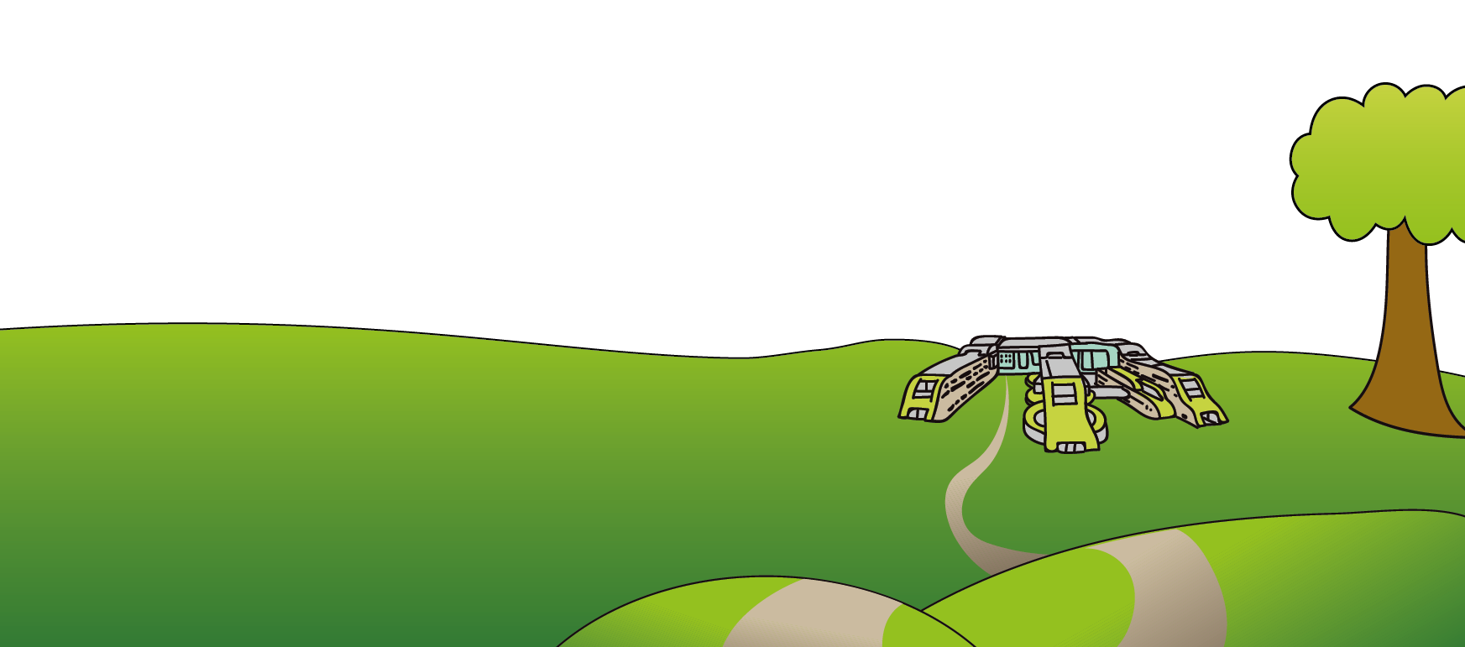
This leaflet only gives general information. You must always discuss the individual treatment of your daughter with the appropriate member of staff. Do not rely on this leaflet alone for information about your daughter’s treatment.
This information can be made available in other languages and formats if requested.
Alder Hey Children’s NHS Foundation Trust
Alder Hey
Eaton Road
Liverpool
L12 2AP

Tel: 0151 228 4811
www.alderhey.nhs.uk

© Alder Hey Review Date: May 2025 PIAG: 173

