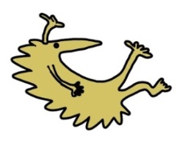
Further information
NHS vaccine information and schedule: https://www.nhs.uk/conditions/vaccinations/

University of Oxford Vaccine Knowledge Project: https://vk.ovg.ox.ac.uk/vk/

Royal College of Paediatrics and Child Health:
https://www.rcpch.ac.uk/resources/vaccination-uk-position-statement

References
- Di Pietrantonj C et al. Vaccines for measles, mumps, rubella, and varicella in children. 2020 https://www.cochranelibrary.com/cdsr/doi/10.1002/14651858.CD004407.pub4/epdf/full

- NHS. Why vaccination is safe and important. 2019 https://www.nhs.uk/conditions/vaccinations/why-vaccination-is-safe-and-important/

- Wilhite et al. Systematic review of potential health risks posed by pharmaceutical, occupational and consumer exposures to metallic and nanoscale aluminum, aluminum oxides, aluminum hydroxide and its soluble salts. 2014. https://www.ncbi.nlm.nih.gov/pmc/articles/PMC4997813/

- Erlewyn-Lajeunesse M et al. Anaphylaxis as an adverse event following immunisation in the UK and Ireland. 2012 https://adc.bmj.com/content/97/6/487

Leaflet produced by Joshua Irvine-Naderali & Deysha Ratnasingham.

This leaflet only gives general information. You must always discuss the individual treatment of your child with the appropriate member of staff. Do not rely on this leaflet alone for information about your child’s treatment. This information can be made available in other languages and formats if requested.
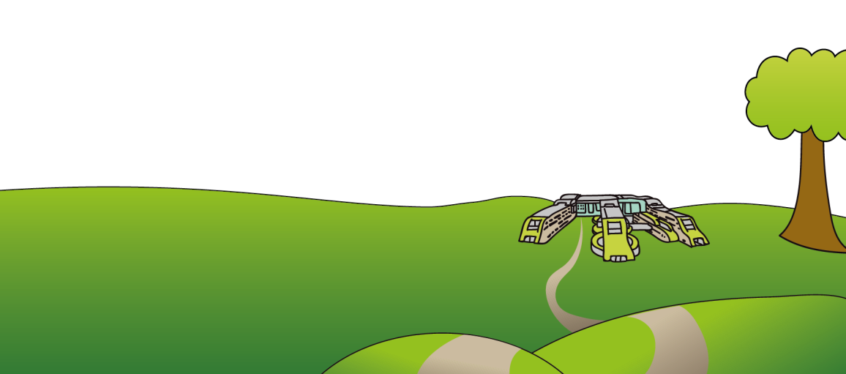
Alder Hey Children’s NHS Foundation Trust
Eaton Road
Liverpool
L12 2AP

Tel: 0151 228 4811
www.alderhey.nhs.uk

© Alder Hey Review Date: August 2025
PIAG: 299

ED Department

Vaccination
Frequently Asked Questions
(FAQs)

Information for patients,
parents and carers

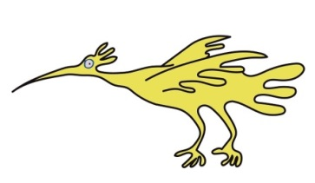
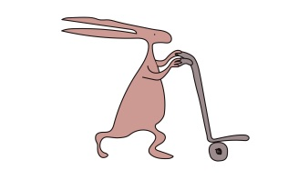

“The two public health interventions that have had the greatest impact on the world’s health are clean water and vaccines.”
(World Health Organisation)
Why have I received this leaflet?
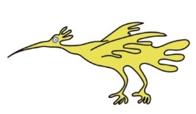
At Alder Hey, we understand that making decisions about your child’s health can be difficult. This leaflet will provide clear information on vaccines and discuss common concerns parents have about vaccinating children.

What are vaccinations?
Vaccinations provide effective protection against many diseases. Before vaccines, many children would become severely ill with infections that are now rare in the UK such as measles, polio and whooping cough. Vaccines contain a weakened part or inactivated form of the germ that causes disease, so the body’s immune system can recognise the actual germ faster and avoid making your child ill.

Will my child become sick if they catch measles?
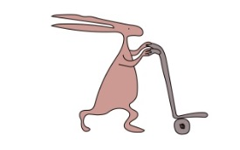
Yes. Children who are not vaccinated that catch measles come to the emergency department because of very unpleasant symptoms such as: high fever, rash, vomiting, conjunctivitis and stomach pain. Some children have severe complications such as pneumonia and encephalitis (infection of the brain).

Will the MMR vaccine cause autism?
No. Many parents are worried about vaccinations causing autism. A recent study involving over 1 million children found no evidence that the MMR vaccine causes autism.¹

Do vaccines really contain harmful substances like mercury?
No. Many parents are understandably worried about other ingredients in vaccines like preservatives, such as thiomersal which is mercury based. However, no routine UK vaccines contain thiomersal.²

Isn’t there lots of aluminium in vaccines?
No. There is roughly as much aluminium in some vaccines as there is in one tub of formula milk.³ If formula fed, your child will have much more aluminium from their milk than they will from vaccines. Aluminium boosts your child’s immune system’s response, meaning your child is more likely to become immune to the germ.

Do some children have difficulty breathing after vaccination?
Less than 1 in 1 million children will have an allergic reaction within seconds or minutes of vaccination, called anaphylaxis.⁴ Healthcare professionals who give vaccines are trained to treat anaphylaxis with adrenaline, which should rapidly resolve the issue. If your child has an allergy, please discuss vaccination with an appropriately trained healthcare professional.

Can my child still be vaccinated if we missed an appointment?
Yes. Unless your child has a temperature, or a trained healthcare professional says otherwise, your child can still have their vaccinations even in these situations:

- Has a mild illness (cough or cold) without fever, even on antibiotics
- Has asthma, eczema or hayfever
- Has epilepsy or a history of febrile convulsions
- Born prematurely
- Family history of reactions to vaccination
- Contact with an infectious disease

Will my child receive the same standard of care if they are not vaccinated?
Yes. Alder Hey will always promote the safe use of vaccines to protect children from harmful illness, but your child will continue to have access to services and outstanding care like any other child. However, unvaccinated children sometimes require different treatments. This will be explained at the time if necessary.

