Opthalmology
Discharge from Hospital Eye Service Uveitis Screening Clinic
Information for Patients
i

What is Uveitis?
Uveitis is an inflammation (swelling) of a layer of the eye. These layers are made up of the iris (coloured part of the eye), ciliary body (muscle behind the iris) and choroid (layer of blood vessels inside the eye). Uveitis can occur in one, several, or all of these layers.

Why did I need screened for uveitis?
Often in young people, there are no signs of uveitis, but if it’s not treated it can damage your eyesight. Fortunately, if we catch it early enough, uveitis is treatable.
What happens when I am discharged from the hospital uveitis screening service?

As you get older, your risk of getting uveitis reduces. Having spoken with you and your parent / guardian we now feel you are able to detect any changes in your vision which may suggest a new onset or flare up of uveitis. It does not mean that the risk of uveitis has gone completely.

Some young people can have no symptoms of uveitis, which is why it is so important for you to continue to monitor your own vision in both eyes.

Signs of uveitis that you and your parents/guardians can look out for include:
- Red eye
- Sensitive to light
- Blurred vision
- Seeing new floaters
- Abnormal-looking pupils
- Clouding of the front surface of the eye (the cornea)
- Unusual blinking
- Excessive eye rubbing
- A squint (one eye does not look straight)
- No interest in tasks requiring visual attention

A tip for family self-monitoring is to remember to check your vision by reading small print one eye at a time, once a week.

You should attend your local Optometrist (Optician) in the community for yearly eye examinations. It is very important to attend these appointments because the risk of uveitis is never completely gone and this is a useful addition to self-monitoring for symptoms.

What should I do if I notice signs of uveitis?

If you notice signs of uveitis between appointments, you or your parent/guardian should contact the eye hospital the same day.

This can be done by telephoning the ophthalmology nurses station on 0151 252 5215 or if out of hours please call Alder Hey Switchboard and ask for the on-call ophthalmologist

Alternatively, you can visit the paediatric emergency department.

For further information:

- Speak to the Ophthalmologist or Optometrist.
- http://oliviasvision.org/ is a website that includes information about childhood uveitis.

Text for checking vision:

Can I see this writing? Please cover your left eye and see if the text is still clear. Then cover your right eye and see if the writing is the same as last time. If you notice either eye has become more blurred you must seek advice from an optometrist or ophthalmologist.

Information for insert details

Introduction

What is Uveitis?
Uveitis is an inflammation (swelling) of a layer of the eye. These layers are made up of the iris (coloured part of the eye), ciliary body (muscle behind the iris) and choroid (layer of blood vessels inside the eye). Uveitis can occur in one, several, or all of these layers.

Why did I need screened for uveitis?
Often in young people, there are no signs of uveitis, but if it’s not treated it can damage your eyesight. Fortunately, if we catch it early enough, uveitis is treatable.
What happens when I am discharged from the hospital uveitis screening service?

As you get older, your risk of getting uveitis reduces. Having spoken with you and your parent / guardian we now feel you are able to detect any changes in your vision which may suggest a new onset or flare up of uveitis. It does not mean that the risk of uveitis has gone completely.

Some young people can have no symptoms of uveitis, which is why it is so important for you to continue to monitor your own vision in both eyes.

Signs of uveitis that you and your parents/guardians can look out for include:
- Red eye
- Sensitive to light
- Blurred vision
- Seeing new floaters
- Abnormal-looking pupils
- Clouding of the front surface of the eye (the cornea)
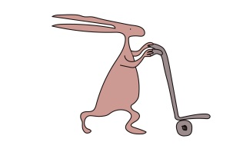
- Unusual blinking
- Excessive eye rubbing
- A squint (one eye does not look straight)
- No interest in tasks requiring visual attention

A tip for family self-monitoring is to remember to check your vision by reading small print one eye at a time, once a week.
You should attend your local Optometrist (Optician) in the community for yearly eye examinations. It is very important to attend these appointments because the risk of uveitis is never completely gone and this is a useful addition to self-monitoring for symptoms.

What should I do if I notice signs of uveitis?

If you notice signs of uveitis between appointments, you or your parent/guardian should contact the eye hospital the same day.

This can be done by telephoning the ophthalmology nurses station on 0151 252 5215 or if out of hours please call Alder Hey Switchboard and ask for the on-call ophthalmologist
Alternatively, you can visit the paediatric emergency department.

For further information:

- Speak to the Ophthalmologist or Optometrist.
- http://oliviasvision.org/ is a website that includes information about childhood uveitis.

Text for checking vision:

Can I see this writing? Please cover your left eye and see if the text is still clear. Then cover your right eye and see if the writing is the same as last time. If you notice either eye has become more blurred you must seek advice from an optometrist or ophthalmologist.

This leaflet only gives general information. You must always discuss the individual treatment of your child with the appropriate member of staff. Do not rely on this leaflet alone for information about your child’s treatment.
This information can be made available in other languages and formats if requested.

Alder Hey Children’s NHS Foundation Trust
Alder Hey
Eaton Road
Liverpool
L12 2AP
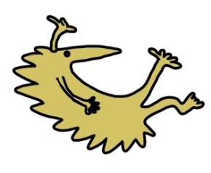
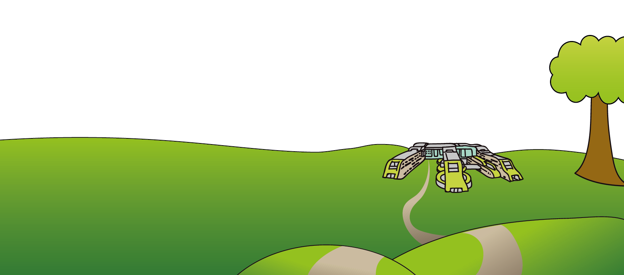
Tel: 0151 228 4811
www.alderhey.nhs.uk

© Alder Hey Review Date: April 2025 PIAG: 401

