Physiotherapy Department
The use of Botulinum Toxin (Dysport) treatment
in children with Cerebral Palsy or Acquired Central Nervous System Injury
Information for Parents and Carers

Introduction
Children who have stiffness in their muscles due to spasticity are seen in the Spasticity Management Clinic. There are several options for treating spasticity. This leaflet is aimed at providing you with an introduction to one of the treatments your child may receive called botulinum toxin (Dysport).
What is Dysport?
Dysport (Botulinum toxin type A) is a toxin that is produced from bacteria under laboratory conditions. It can be used in small doses for treating stiff (spastic) muscles in some children with cerebral palsy, or acquired central nervous system injury
How does Dysport work?
Dysport relaxes stiff muscles by blocking the nerve signals to the muscle fibres around the injection site. This stops the muscle from contracting, and allows the muscle to stretch. It may also help to reduce muscle spasm.
Injections take effect within a few days.
Which children do we treat with Dysport?
Dysport is used to treat children with all types of cerebral palsy and some other neurological conditions. However, it is not suitable for all children and we assess and choose children carefully in our clinic.
Why do we treat children with Dysport?
Every child is different and how Dysport injections could help your child should have been explained both to you and your local physiotherapist. We will ask you and your child about the main problems they are having e.g. putting on their splint, using their standing frame, performing activities like getting washed or dressed.
We look at these problems again after the injections to try to find out if Dysport has helped to make things easier.
In order to assess the effects of treatment we will examine how much your child can move before they have the injection. We may also take a video of their walking. This is called “gait analysis”, and takes place in the Gait Laboratory at Alder Hey.
If your child has Dysport injections we may repeat the examination to assess how much change there has been, or make another video of their walking.
How will Dysport be given to my child?
Dysport is given by injection into the muscles.
How many injections will there be?
This depends on what we are aiming to achieve by giving your child the treatment. Often a few injections are needed but they are done very quickly.

Will my child be asleep when they have their injection?
We give some children a general anaesthetic, but most children just need cold spray, a sedative medicine or Entonox (gas and air) to make the injections more comfortable. Some children may have the injections without any of these. We will discuss with you and your child which will be the best option
How long will my child have to stay at Alder Hey?
This depends on which type of pain relief your child receives.

- If Entonox (gas and air) is given your child can go home immediately after the injections.

- If your child requires sedation medicine, they can go home once they have been assessed by the nurses.

- If a general anaesthetic is required, they will need to have a few hours of observation. On rare occasions your child may have to stay overnight in Alder Hey following the anaesthetic.
How long will the effects of the Dysport last?
The toxin usually starts working a few days after the injections are given and the effect can last for up to six months.
How frequently can my child have the Dysport injections?
We assess each child individually. Based on clinical response and goals we may agree to repeat the injections after a few months.
How will I know where and when to come for the treatment?
We will send you a detailed appointment letter.
Physiotherapy
It is very important that your local physiotherapist knows that your child is having Dysport injections. It is helpful to start a stretching and strengthening programme before the injections, and for at least 6 weeks afterwards
If your child’s muscle(s) have shortened and they are having difficulty wearing splints, we may recommend that the area/ limb that has been injected is put into a plaster cast/splint for a few weeks to provide a prolonged stretch
We will contact your local physiotherapist to arrange this.
Are any problems likely to occur after the Dysport treatment?

- Some children may notice localized pain, bruising or swelling, or a rash, at the injection site.
- In children who are continent, leakage of urine may occur if the injections are given close to the groin area. This is usually temporary
- Sometimes a child’s muscles may become weaker and they may find it harder to walk, or fall more frequently for a short time after the injections.
- Flu-like symptoms and fatigue
All side effects are temporary and the injections are generally well tolerated.
What if I have any more questions after reading this leaflet?
You will get the opportunity to ask questions on the day of the injections.
Alternatively you can contact:
Chris Sneade, Clinical Specialist Physiotherapist or Colm MacEoin, Specialist Physiotherapist on: 0151 252 5660
Or Dr Kumar on 0151 252 5164
If you have any queries or need more information.
We will be available to answer any queries you may have.
We will give you specific advice for your child after the injections.
You will also be given a Frequently Asked Questions information sheet that provides advice on how to deal with the most common problems following the injections.
For further information
You can also read the fact sheet about Dysport on the Scope website: www.scope.org.uk
Please let us know
If your child is taking antibiotics, uses a medicine that relaxes muscles, recently had a medication containing botulinum toxin, or if your child is using anti-platelet (Aspirin-like) or anti-coagulants (blood thinners).
If you think your child is unable to make the appointment made for the injections, please let us know by ringing one of the above numbers.
This leaflet only gives general information. You must always discuss the individual treatment of your child with the appropriate member of staff. Do not rely on this leaflet alone for information about your child’s treatment. This information can be made available in other languages and formats if requested.
Alder Hey Children’s NHS Foundation Trust
Alder Hey
Eaton Road
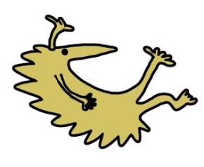
Liverpool
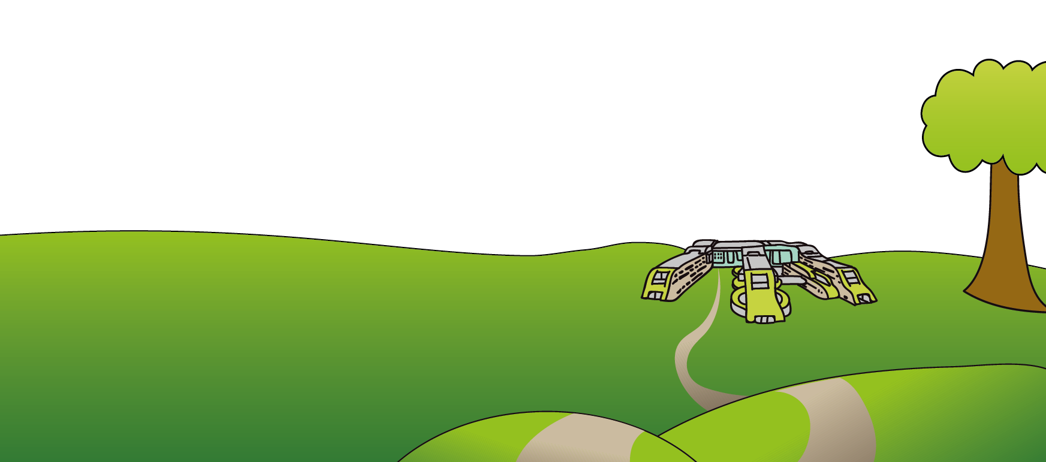
L12 2AP

Tel: 0151 228 4811
www.alderhey.nhs.uk

© Alder Hey Review Date: March 2024 PIAG: 394

