Gastroenterology Department

Upper GI Endoscopy

Information for patients, parents and carers

Introduction
You / your child will have an Upper GI endoscopy (also known as oesophagogastroduodenoscopy ie OGD or gastroscopy). This leaflet explains about this procedure, what it involves and what to expect when you / your child come to Alder Hey Children’s Hospital for treatment.

What is Upper GI endoscopy?
This is a test we use to look at the inner lining of the upper part of digestive tract (oesophagus, stomach, duodenum). We use an endoscope / gastroscope (a flexible tube connected with a camera) that sends images to the monitor screen.

Why do I need it?
Upper GI endoscopy is a very common procedure. It helps us to find out if there is something wrong with the digestive tract and sometimes we use it to check whether your digestive tract is getting better with the treatment. It also helps us to perform certain specific therapeutic procedures, if needed.

Will I be asleep?
Yes, you will be completely asleep. In Alder Hey Hospital we do nearly all endoscopies under general anaesthesia. You will not feel or remember anything about the procedure.

What happens before the test?
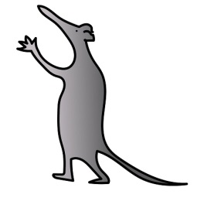
We write or telephone to tell you the date of test and where to come.
- If child is on the morning list
  - Stop food and milk/soft drink/juice at 2.30am
  - Do not drink any water from 6.30am onwards.
- If child is on the afternoon list
  - Stop food and milk/soft drink/ juice at 7.30am
  - Do not drink any water from 11.30am onwards.
(Please contact day case staff or Gastro pathway coordinator if your child has special feeding requirement such as continuous pump feed)
- Some children with specific health requirement may need to be in hospital to prepare for the test.
- Please bring any medicines that you / your child is taking.
- It is important to keep eating food and drinking until the above times to ensure you / your child remains well-hydrated. This may involve waking in the night to have a drink.

When you come to hospital we will ask your parents/guardian to sign a consent form to give us permission to do the test. You can sign it too if you wish to do so.
What happens during endoscopy?

While you are asleep we will pass a gastroscope through the mouth down the oesophagus (food pipe) and into stomach. It is then passed further into first part of small intestine (duodenum).
We often take small tissue samples (biopsies) from the lining of the bowel and send it to our laboratory to give us vital information. The biopsies taken are about the size of a match head and will not cause you any pain.
The test takes only 15 to 30 minutes but you will be in theatre for up to 45 minutes including anaesthetic time.
What happens after the test?
When you wake up from the anaesthetic, sometimes you may have sore throat or sore tummy. The nurse can give you medicines for that.
You can have some light food or drink as soon as you would like it.
Most children will be ready to go home a few hours after the procedure.
When will I get the results?
After the endoscopy we will only be able to tell what the lining looks like. The final results of biopsy will be available in three to four weeks. We will write to you with the results or sometimes we discuss the results in the clinic.
Are the endoscopies safe?
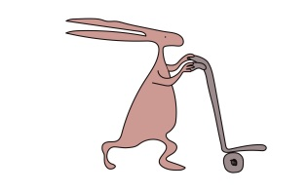
Yes, endoscopies are very safe, however as with any tests there can very occasionally be some problems including:
- Injury to teeth or lips
- Temporary sore throat
- Tummy pain
- Bleeding (blood in vomit)
- Failure to complete the test
- Perforation (hole in the bowel wall) - this is a serious complication but occurs very rarely
Further details about risks with the procedure will be discussed while taking consent for the procedure.
Please contact your family doctor (GP) or local hospital if any of the following symptoms carry on for longer than expected for you / your child:
- vomiting large amounts.
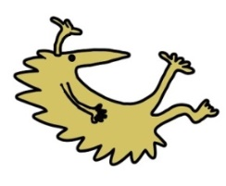
- severe abdominal pain and a swollen tummy.
- becoming generally unwell.
- refusing to eat or drink.
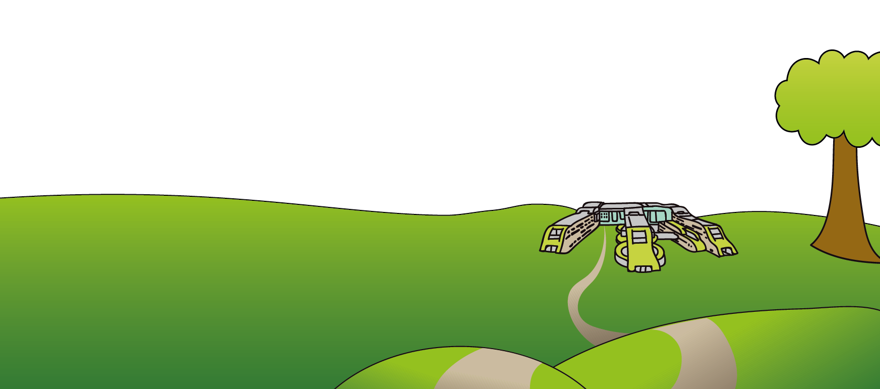
- unusually sleepy or difficult to wake up.
Where can I get more information about having endoscopy?

You can call the Gastroenterology PCO on 0151252 5541/5449/5153

This leaflet only gives general information. You must always discuss the individual treatment of your child with the appropriate member of staff. Do not rely on this leaflet alone for information about your child’s treatment. This information can be made available in other languages and formats if requested.

Alder Hey Children’s NHS Foundation Trust
Eaton Road
Liverpool
L12 2AP
Tel: 0151 228 4811
www.alderhey.nhs.uk
© Alder Hey Review Date: November 2024 PIAG: 93

