This leaflet only gives general information. You must always discuss the individual treatment of your child with the appropriate member of staff. Do not rely on this leaflet alone for information about your child’s treatment.
This information can be made available in other languages and formats if requested

Alder Hey Children’s NHS Foundation Trust
Eaton Road
Liverpool
L12 2AP

Tel: 0151 228 4811
www.alderhey.nhs.uk

© Alder Hey Review Date: August 2025 PIAG: 330

Major Trauma & Rehabilitation Service

Information for patients,
parents and carers

Your Coordinator is:

………………………………………………………………………………

Follow us on Twitter: @AHTraumaRehab

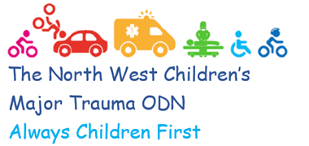 | 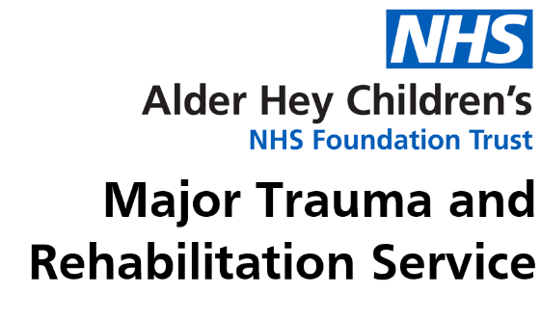

What is a Major Trauma Centre?
A Major Trauma Centre (MTC) is a specialised hospital which has the best available skills and equipment to treat patients who have sustained unplanned traumatic injuries.
Alder Hey is a Children's (Paediatric) Major Trauma Centre within the North West Regional Trauma Network. We receive and care for children from the North West, North Wales and the Isle of Man. Children can be brought to us directly or transferred to us from a local hospital.

What to expect when you first arrive
Upon arrival at Alder Hey, your child’s injuries will be assessed. In order to do this quickly, there may be doctors from different specialties and people performing many tasks at the same time.
This may be very frightening and disorientating for you and your child, but it is necessary to ensure that they are given the best care as quickly as possible. This may include scans, X-Rays or further investigations.
You will meet the Trauma Rehabilitation Coordinator Team and will be allocated a keyworker. The keyworker will be your link throughout your stay and support you to discharge and beyond Alder Hey.

Rehabilitation
Following your child’s injury, you will engage with a range of rehabilitation specialists who will help to optimise your child’s recovery. This may often include physiotherapists, occupational therapists, speech & language therapists and psychologists. We will discuss and keep you up to date with your child’s rehabilitation plan throughout your stay. This will all be documented on your child’s
rehabilitation prescription.

Returning home
When you and your child are ready to return home a supportive and comprehensive discharge plan will be discussed.
On discharge we will complete your child’s rehabilitation prescription and you will receive a copy of this along with timescales for a follow up call. However, the team are available for you to contact should you need to speak to them sooner.
As part of our keyworker role, we will liaise with nursery or school with regards to formulating a plan for their return. This advice will also include returning to activities and/or sport.

Useful numbers

Trauma & Rehabilitation Coordinators

Jo Richardson, Lead Nurse Major Trauma

Mobile: 0797 130 6055

joanne.richardson@alderhey.nhs.uk

Michelle Ireland, Major Trauma Rehabilitation Coordinator

Mobile: 07976 209 603

michelle.ireland@alderhey.nhs.uk

Faye Stanley, Major Trauma Rehabilitation Coordinator

Mobile: 0797 130 8239

faye.stanley@alderhey.nhs.uk

Natalie Vaughan, Major Trauma Rehabilitation Coordinator

Mobile: 0792 906 6894

natalie.vaughan@alderhey.nhs.uk

Aimee Simpson, Major Trauma Rehabilitation Coordinator

Mobile: 0777 365 7391

aimee.simpson@alderhey.nhs.uk

Team Email: majortrauma@alderhey.nhs.uk
Team Phone: 0151 252 5821 / Ext: 2821
Spiritual Care Team – The Sanctuary (Tree House)
The Spiritual Care Team are here for all families, whether or not they profess any sort of religious affiliation or faith, who may feel in need of some support. We are based in the lower floor of the Tree House, accessed via the purple lifts to the second floor.

The Sanctuary is offered as a quiet space for anyone who may feel the need to pray or who may just feel the need to seek some respite away from the stress and pressure of life in the hospital.
There may be times when you feel very much alone, especially when so much is happening to help your child, and you may struggle because you feel that you are unable to be in control of what is happening, as you always have been.
As a team, we offer a 24/7 service to anybody who feels that they may need to unload these feelings, to pray, or to have a chat. You may feel the need for some non-clinical support, or just need a listening ear during your time in the Trust.
If so, then at any time, day or night, ask a staff member to contact an on-call member of the Spiritual Care team via switchboard.
Alternatively, visit the Sanctuary which is always open.

Patient Advice and Liaison Service (PALS Team) concerns and complaints
PALS is a confidential service to support our patients and their families when concerns or complaints cannot be addressed by ward or clinic staff.
PALS Team: 0151 252 5161
Complaints Team: 0151 252 5374

Useful information about our hospital

Parking
The main entrance and car park is on East Prescot Road (L14 5AB on a sat-nav). Enter the hospital site from East Prescot Road. If you are arriving by car, use the drop-off facilities outside the entrance or use the multi-storey car park, which has its own entrance to the hospital. *Please note* the maximum height for vehicles parking in the multi-storey is 2.2 metres.
Car Park Fees
Up to 30mins | Free
Visitors up to 2hrs | £3.00
Visitors up to 2hrs – 6hrs | £4.00
Visitors up to 6hrs – 8hrs | £5.00
Visitors up to 8hrs – 24hrs | £7.00
Disabled Parking | Free

For frequent visitors – you can buy a discounted pass at the concierge desk (look out for the 'Car Park Help Desk' sign in the main hospital atrium). You can purchase passes for ten consecutive days for £10.00, or 30 consecutive days for £30.00, plus a £5.00 cash deposit, which is refunded once the pass has been returned.

Staying overnight
Patient bedrooms have been equipped with special parent beds, funded by Alder Hey Children’s Charity, so one parent or carer can stay overnight.

Self-catering on wards
Each ward has an area near the patient bedrooms for parents to make hot and cold drinks and chat with other parents.

Wi-Fi
Free Wi-Fi is available to our patients and visitors.

Visiting hours
Ward | Parents  (Space for one parent to stay at night) | Other visitors
3a | 24 hour visiting | 1pm – 7pm
3b | 24 hour visiting | 1pm – 7pm
3c | 24 hour visiting | 1pm – 7pm
4a | 24 hour visiting | 2pm – 7pm
4b | 24 hour visiting | 1pm – 7pm
4c | 24 hour visiting | 2pm – 7pm
PICU and HDU | 24 hour visiting (except 7am-7:30am and 7pm-7:30pm)* | 10am – 7:30pm

Cash machine
A free-to-use cash machine is available in the Atrium. If the machine is unavailable, there are machines at the Sainsbury’s supermarket across East Prescot Road.

Cash Office
In the atrium near the car park entrance, our Cash Office can help with queries about travel expenses.

Shops and Restaurants
Treetops Restaurant
Coffee and Deli
 | Monday to Friday | Saturday & Sunday
Breakfast | 7:30am – 10:30am | 8am – 10:30am
Lunch | 11:45am – 2pm | 11:45am – 2pm
Evening | 3:45pm – 6:45pm | Not available
The Deli Bar opens Mon to Fri: 11am to 3pm

Teas and coffees and a range of fresh snacks, salads and sandwiches are served throughout the day.

There are coin-operated vending machines available 24 hours a day. The Atrium also has the following outlets:
The Baguette Co. | Monday to Friday | 8:30am – 4pm
Costa Coffee | Monday to Friday  Saturday  Sunday | 7am – 6pm  9am – 4pm  10am – 3pm
M&S Food to Go  & WH Smith | Monday  Tuesday to Friday  Saturday/Sunday | 7am – 5pm  7am – 8pm  9am – 6pm

Ronald McDonald House
Ronald McDonald House is an independent charity which provides free on-site accommodation for families. This is usually only offered to parents who will have a child staying with us for a prolonged period of time and those that are not local to the hospital. The ward staff will usually approach you about this option.
Tel: 0151 252 5869

