Transition Service
Transition to Adult Services: What does good look like?
Information for young people

What is transition to adult services?

When children become adults it is normal for them to make decisions for themselves and to lead a more independent life. Children’s health and care needs also change as they grow up.
Transition to adult services (Transition) is the name given to the process of moving on from children’s to adult services.

Transition is an important journey. The team at Alder Hey will work with you and your family to ensure that you get the support you need every step of the way. We will ensure that you and your family understand what is happening, feel confident and in control. This leaflet explains what good Transition looks like and what you should expect.

This leaflet is mainly concerned with Transition to Adult Health Services. Some young people with more complex needs also have support from social care and special education. When this happens we will work with these services to co-ordinate the different transitions.

Why do we need transition to adult services?

Transition is important to ensure that services are appropriate for your age and needs. If we didn’t have Transition to Adult Services adults would be nursed on the same wards as babies and children. Services that are needed for babies and children would not be available because adults were using them.

What will happen during transition?

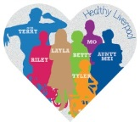
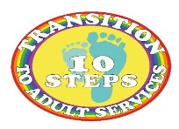
Young people and their families often need guidance and encouragement but shouldn’t feel rushed or unsupported. Transition is a gradual process.

We can think of Transition a series of Ten Key Steps.
Let’s look at these steps together.

- Recognising the need to move on. Professionals will normally start talking to you and your family about your health needs and Transition to Adult Services around the time of your fourteenth birthday. This will allow plenty of time for gradual planned Transition. Sometimes professionals will write a letter summarising your diagnosis and health needs or we may put this information a Health Information Passport or Advance Care Plan. You should be given a copy of this information, have the opportunity to read it and ask questions. This information should be updated as you progress through Transition.
- Taking responsibility for your own health needs. We will work with you, depending on your age and ability, to help you develop the knowledge and skills you need to keep healthy and well. We will give you the opportunity to talk about how your health needs may impact on your future including employment, independent living, sexuality and relationships. You can also discuss risky behaviours like smoking, alcohol and drugs. Some young people with learning disabilities need help to stay healthy and well, and to make decisions about their care, when they are adults. We will ensure that there is someone available who can support and advocate for these young people.

- Starting a Transition Plan. We will work in partnership with you and your family to create your personal Transition Plan. This will be tailored to your health needs and co-ordinated with other aspects of Transition as necessary. You will be given a copy of your Transition Plan, have the opportunity to read it and ask questions. The Transition Plan should be reviewed at each appointment.

- Reviewing your Circle of Support. Your Circle of Support is the group of people, professionals, friends and family, who are there to help you. We will list the professionals in your Circle of Support and identify someone to take over from them when you transition to Adult Services. Your GP will be more important in your Circle of Support when you transition to Adult Services. We will identify a Transition Keyworker, and sometimes a Lead Consultant, to support you and co-ordinate your Transition.

- Referral to adult services. We will refer you to the professionals who will be taking over your care in the adult sector and ask them to tell you more about the services they provide.

- Joint reviews in children’s services. You may be invited to attend a Transition clinic, led by professionals from children services with support from adult services, so that you can get to know the professionals who will be taking over your care. If there is not an appropriate Transition clinic available professional from adult services should be invited to attend your normal clinic appointments.

- Planning emergency care. Once you have moved into adult services, you will need to know what to do and who to call when you are unwell. We will make sure your GP has the necessary information to support you. Once you have moved into adult services, you will not be taken to Alder Hey if an ambulance is called and you need to come into hospital. We will make sure you know which hospital you are likely to be taken to and that they have the necessary information to support you.

- Moving to adult services. Eventually you will be ready to attend the adult clinic or be admitted to the adult hospital ward. We hope that, with our support, you will feel confident and ready to make this decision. Most young people are ready to move into adult services when they are 16 or 17. This means children’s services can provide support to adult services for a while, ensuring that you are properly settled in.

- Joint reviews in adult services. Children’s services will be available to provide advice and support to professionals from the adult services after you move. You may be invited to attend a Transition clinic led by professionals from adult services with support from children’s services. If there is not an appropriate Transition clinic available, professionals from children’s services should be invited to attend your normal adult clinic appointments.

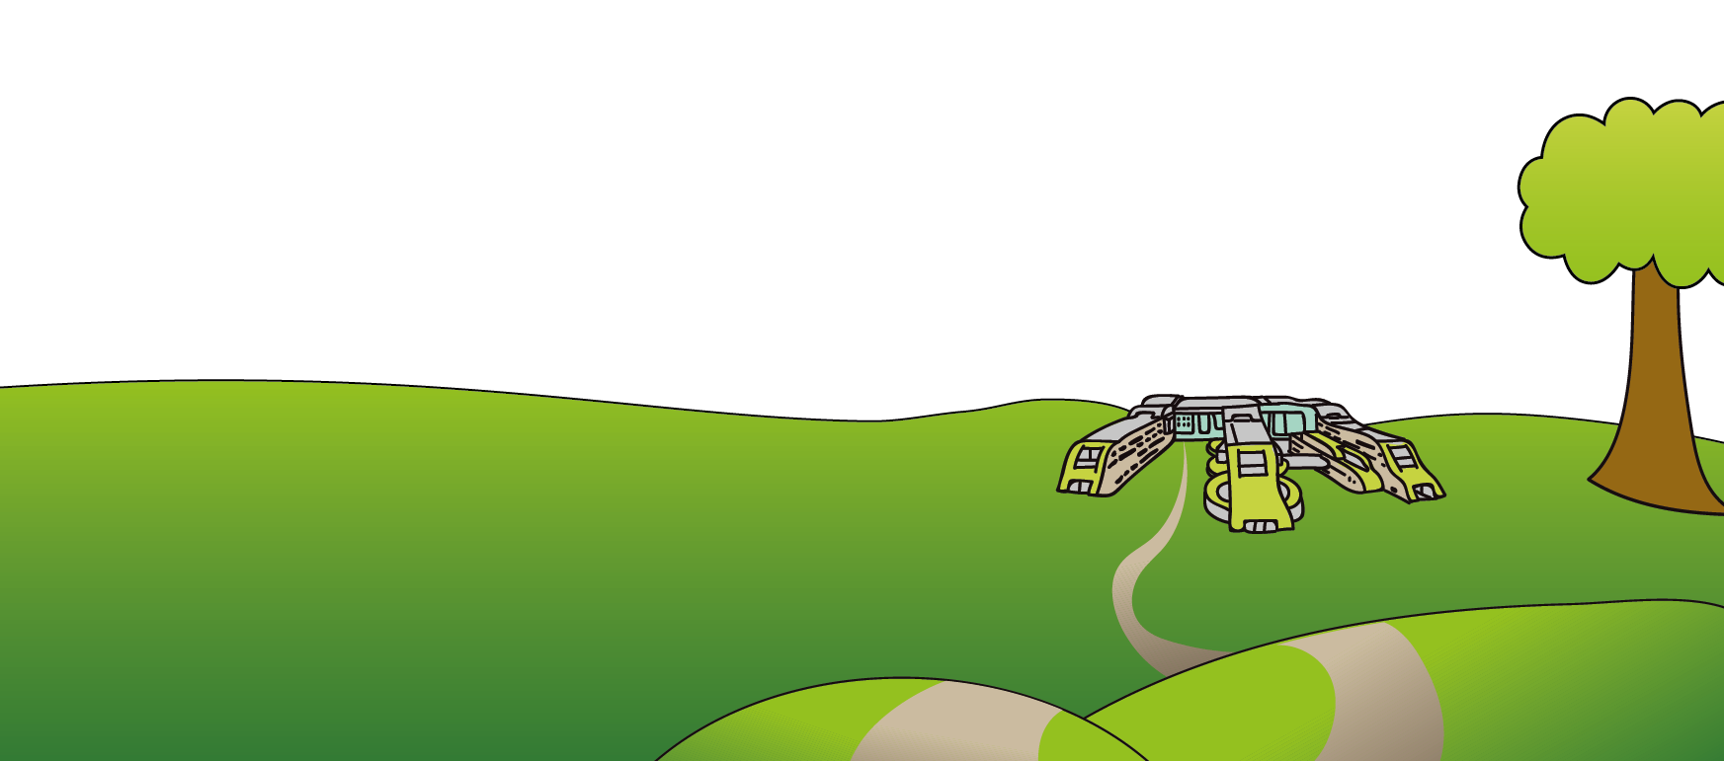
- Completing transition. Finally, when you are between your 16th and 18th birthday (before your 19th birthday), we hope you will feel confident and well supported in adult services and we will be able to discharge you from children’s services.

This leaflet only gives general information. You must always discuss the individual treatment with the appropriate member of staff. Do not rely on this leaflet alone for information about your treatment. This information can be made available in other languages and formats if requested.
Alder Hey Children’s NHS Foundation Trust
Eaton Road
Liverpool
L12 2AP
Tel: 0151 228 4811
www.alderhey.nhs.uk
© Alder Hey Review Date: April 2025 PIAG: 048

