Haematology Department

Transition from Paediatric to Adult Services for Adolescents with Red Cell Disorders

A guide for parents and carers

Introduction

This leaflet is designed to explain about the transition process from Alder Hey Children’s Hospital to the Royal Liverpool University Hospital. If you have any questions about transition after reading it please speak to your nurse specialist or haematology doctor.

What is transition?

Transition is a purposeful, planned movement of adolescents and young adults with chronic physical and medical conditions from child centred to adult-orientated health care systems. It is a process that will enable young people to take responsibility for their own health by making informed choices and decisions about their health and well being, both now and in the future. Transition is one of the greatest challenges for the young person and their family, and we want to aim for it to be a problem free event.

What is the transition process?

You and your child will be introduced to the transition process when they are about 12-13 years old. The transition process takes time and is done over a number of years, with the aim of increasing your child's independence over that time and empowering them to take control of their condition. Firstly, they will be given a self-assessment questionnaire, the aim of which is to identify their needs. This will form the basis of a personal transition action plan. The transition action plan will help them become more knowledgeable, confident and competent in understanding and managing their condition. It will help to clarify current and future health needs and allow for us to have clinical services in place when they move from children’s to adult services. Your child will be involved at all stages of your transition plan. The self-assessment questionnaire will be carried out again when they are between 14-15 years old and when they are over 16 years old. They will also be given a workbook. This will be an educational tool to be worked through with the Nurse specialist and doctor, to help increase their knowledge about their condition.

Transition clinic

From the age of 13, your child will be attending a clinic that the adult consultant haematologist attends. This gives you and them the opportunity to meet the adult team, and for the adult team to meet you and your child. When your child first attends clinic you will be involved, but as your child gets older we will encourage them to do the clinic appointments by themselves. They will be supported in doing this and we will only encourage them to do clinic appointments by themselves when they are ready to do so.

Transfer to adult services

Before your child transfers to adult services we will give them the opportunity to go and visit the adult hospital and meet the adult team. This will be done with your child, the Nurse specialist, you and other teenagers with blood disorders who are part of the transition process. We will also give you a booklet about the services at The Royal Liverpool Hospital, how to access them, and contact numbers.

Between the ages of 16-18 we will transfer their care to The Royal Liverpool University Hospital. The age they go to the adult hospital will depend upon their transition action plan. Everyone is ready to go to adult services at different ages.

When they are ready for transfer, a referral letter will be written by the paediatric doctors to the adult doctors. When they receive this, your child will be sent a clinic appointment. Until you attend your first clinic appointment they will still come to Alder Hey for treatment and clinics.

The first clinic with The Royal Liverpool University Hospital

At the first clinic appointment a full medical history will be taken. They will have to tell the doctor about any problems they have had, what their current medical treatment is and they will be given the opportunity to discuss any fears or concerns that they may have about coming to adult services. They will also have some blood tests done. The doctors will also make sure that they know who to contact for advice and when and where to come if you they worried or unwell, and where where to go for their blood transfusion. They will also check that they have all the relevant contact numbers.

The Nurse specialist from Alder Hey will attend the first clinic appointment.

How you can support your child through the transition process

Helping your child to become independent in managing their condition is a very scary and daunting prospect. For many years you have had a significant role in their management, yet during the period of transition your child becomes increasingly involved in their management and becomes confident in making decisions for themselves, whilst you become less involved. Promoting this independence may be a hard thing for you to do, but it will benefit your child as they will be able to take care of themselves and won't feel out of their depth when they reach adult services, when independence will be expected from them.

There are a number of things that you can do to support them through the transition process:
- Encourage them to participate in clinics by getting them to answer questions from the doctor with you in the room and encourage them to ask the doctor questions. Eventually they will be doing this without you in the room
- Communicate with them. Answer any questions they may have about their condition and involve them in decisions about their management
- Encourage them to manage their own medication at home. Encourage them to take the medication without prompting and get repeat prescriptions when they are running low of medicines
- Support them through the process and talk through your fears together. This will be as daunting for them as it is for you
- Access support for you both from your nurse specialist, the doctors and support groups

Transition is an important step in your child's life and it is best achieved when they have your support and encouragement.

Further information

If you need any further information please contact the Nurse specialist on 0151 252 5070

Useful websites

www.alderhey.co.uk
www.rlbuht.nhs.uk
www.ukts.co.uk
www.teenagehealthfreak.co.uk
www.connexionslive.com

This leaflet only gives general information. You must always discuss the individual treatment of your child with the appropriate member of staff. Do not rely on this leaflet alone for information about your child’s treatment.
This information can be made available in other languages and formats if requested.

Alder Hey Children’s NHS Foundation Trust
Alder Hey
Eaton Road
Liverpool
L12 2AP
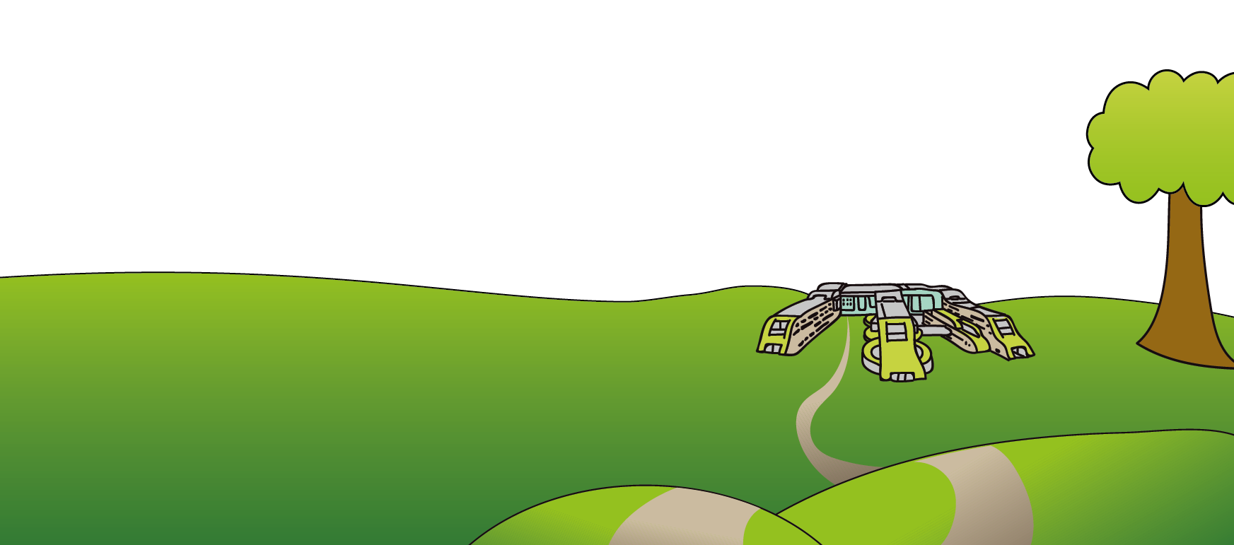
Tel: 0151 228 4811
www.alderhey.nhs.uk

© Alder Hey Review Date: May 2024 PIAG: 0083

