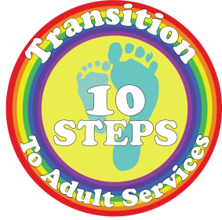

Transition Department
Decisions, Rights and Responsibilities
Information for young people and their parents and carers
.

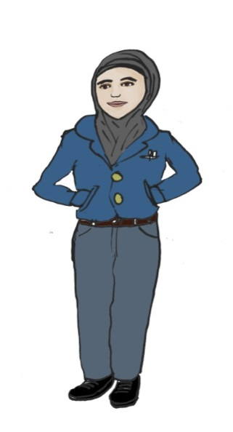
Transition
When a young person begins to move from children’s services to adult services it is known as Transition. This is an important time for a young person as they have a legal right to become more involved in making decisions about their healthcare. This leaflet is aimed at informing young people, their parents and carers of the legal and professional responsibilities that the healthcare professionals have to them.
If you would like this information in another language or format, please contact the Transition Department on 0151 252 5823
Parents and carers
Transition is a time of change for parents too, as the law recognises the rights of young people. Some parents may worry that they may not be involved as much, or their child may not be ready for the changes. It is important that parents and carers remember they can still be involved in their child’s care.

The Team at Alder Hey Children’s Hospital
Not every young person will need the same level of support, and Transition is different for everyone, including parents and carers. Health and healthcare discussions can be a sensitive and personal issue, and we encourage young people to discuss their healthcare decisions with their parents or carers.
We will make sure young people and their families understand any changes and will offer lots of information, advice and guidance.
Consent
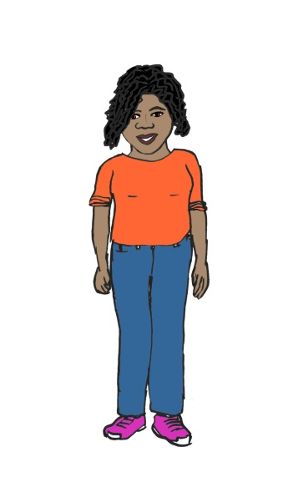
When someone makes a decision about their healthcare this is called consent. Nobody can force another person to give consent. This means that doctors, nurses and other healthcare professions legally have to get permission from you to provide any treatment. There are two types of consent that can be given.

Informed consent

Before informed consent is given for most medical tests and procedures a person
should:

- Receive information about it in a way they can understand.

- Be given time to think.

- Have had an opportunity discuss the choices available to them.

Implied / inferred consent

This is when a person indicates their consent for an examination or treatment.
For example, rolling up their sleeve to have their blood pressure taken. Even in this example, young people can still ask questions and take time to think about the treatment or test.
Who can give consent?
- At 18 a young person is presumed to be able to make decisions about their health.

- A 16 and 17 year old is able to make decisions and consent to their treatment without parental consent.

- For children and young people under the age of 16, their parents, or those with legal parental responsibility can make most decisions for their children.
Competent
Young people under the age of 16 can still be considered to be able to make decisions about their health without their parents. This is known as being Competent.
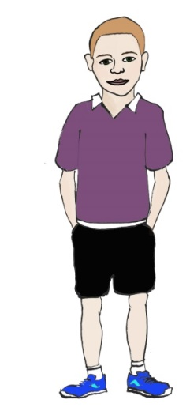
This means that a healthcare professional will assess a young person to see if they are able to make an informed decision about their care.
Parents and carers roles
Parents and carers may feel left out when we offer to see their child without them or to get consent. We will ask permission from the young person if parents or carers can come with them.
Parents still have a very important role in their child’s healthcare. For example, a young person may want to make a decision but need the support of their parents or carers to help them. This is called a shared approach to decision-making.
What would happen if there are concerns about the decision a young person has made?
If a parent or carer has concerns, it is important they talk to the young person to let them know why they are worried.
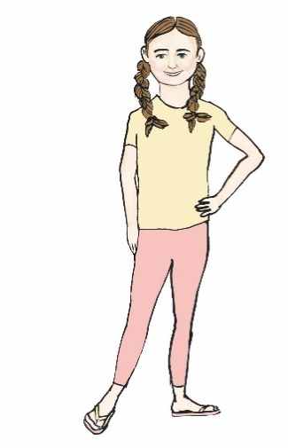
If a healthcare professional is concerned, they will discuss this with the young person. They may also get advice from other professionals.
What happens when parents or carers disagree with a young person’s decision?
The healthcare professional must do what is best for the young person. This is called making a decision in their
Best Interests. The healthcare professional will do this by:
- Listening to what the young person says.
- Listening to what their parents think.
- Considering how all this might affect the young person’s health.
Best Interests is another example of a shared approach to making decisions. Working together can help and support young people in understanding decisions affecting their health and healthcare.

Keeping information private
Keeping information private is often referred to as confidentiality.
All healthcare professionals have to make sure information shared with them remains confidential. When children are young, their parents or carers need to know all the available information to make informed decisions about their child’s health.
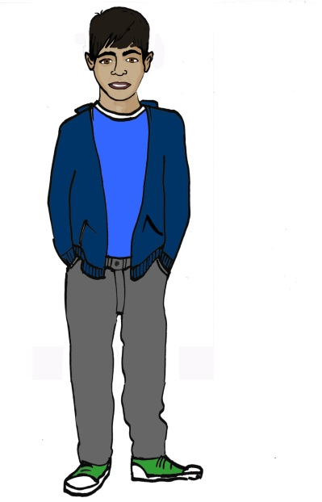
Decisions, rights and responsibilities
When a young person is able to make decisions about their health, they can have the same legal rights as adults about confidentiality.
A young person who is seen alone will be advised by a healthcare professional that the information they share will be treated as private and can only be shared with a young person’s permission or knowledge.
We always encourage young people to involve their parents when making a decision about their care, so they can support them. If a young person chooses not to involve their parents, for example if it is a sensitive issue, it may be appropriate for a health professional to advise parents about a procedure or treatment in general terms.
Exceptional circumstances when information has to be shared
There are times when total confidentiality is not possible and this can happen for children, young people and adults. For example, if a health professional has any concerns about harm or welfare of the young person or another person they may have to tell someone else.

Further information

Please do not hesitate to discuss any of these issues with a healthcare professional involved with your care. You may find these resources helpful for further information.
NHS website http://www.nhs.uk/conditions/consent-to-treatment
(There is a section on consent for children and young people)

NSPCC website https://www.nspcc.org.uk/
(There is a section on children’s rights and decision-making)

This leaflet was produced in collaboration with Edge Hill University.
This leaflet only gives general information. You must always discuss the individual treatment with the appropriate member of staff. Do not rely on this leaflet alone for information about your treatment. This information can be made available in other languages and formats if requested.
Alder Hey Children’s NHS Foundation Trust
Eaton Road
Liverpool
L12 2AP

Tel: 0151 228 4811
www.alderhey.nhs.uk

© Alder Hey Review Date: May 2025 PIAG: 0017

