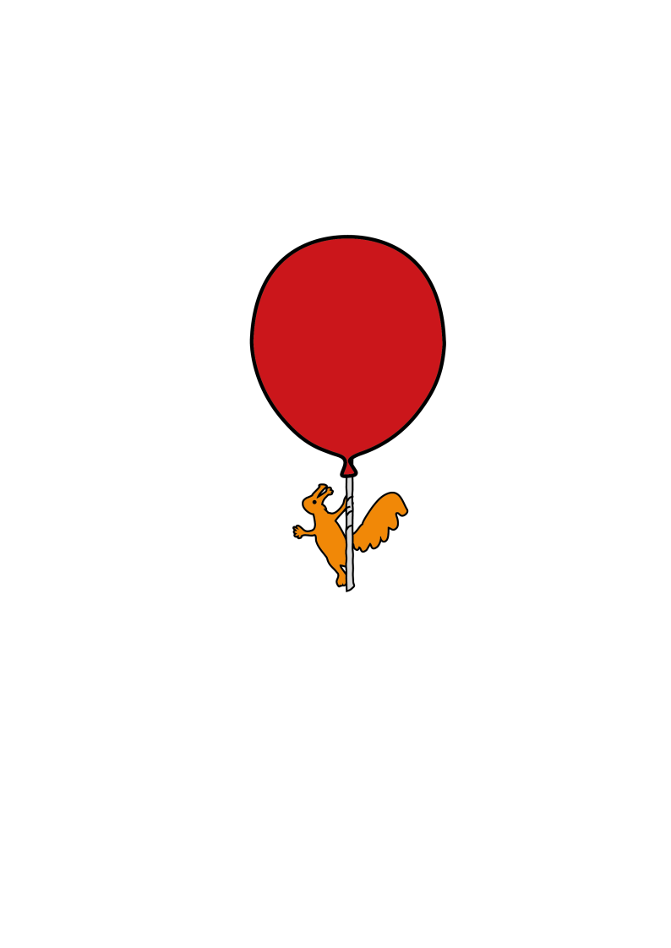

Ear, Nose And Throat Department

**Tracheostomy Information for Parents and Carers**

Information for Parents and Carers



**February 2020**

**Contents**

**Section Page**

Introduction 2

What is a tracheostomy? 4

Advice 5

Meet your care team 6

Teaching programme for the care of your child 7

Support at home 8

Frequently asked questions 9

List of contacts 12

Glossary 14

Notes 16

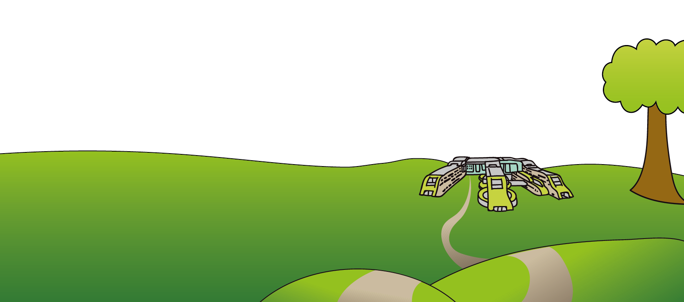

**Introduction**

We understand that this can be a very stressful time for families. We would like to let you know that we are here to support you and your family during this process.

We know that this is a hard time for you and your child and understand that you may have many questions, concerns or fears. We also recognise that you may be afraid. This is understandable as many people worry that they will not be able to learn how to take care of their child’s tracheostomy tube.

We are here to help you learn about your child’s tracheostomy and eliminate any fears or worries you may have. In fact, the whole time you are here, you and everybody involved in your child’s care are planning for the day you can go home.

As you have already discussed with your child’s Doctor, a tracheostomy is required and will be performed to help your child breathe. This booklet aims to help you understand your child’s tracheostomy, prepare you for what to expect and inform you of our discharge process.

Before your child has a tracheostomy, you will be asked to sign a consent form. Your child’s tracheostomy will be inserted under a general anaesthetic. You will see an Anaesthetist before then to discuss any concerns you may have about the operation.

When your child returns you will see your child’s tracheostomy for the first time. Cotton tapes will be placed around their neck and these hold the tracheostomy in place. You will also see temporary stitches; these keep your child’s tracheostomy hole open and will be removed when your child has their first tracheostomy tube change.

To make sure your child gets the safest and best care at all times, at least two caregivers must be taught how to do tracheostomy care. You and a second person will need to learn all parts of your child’s tracheostomy care before they can go home.

****Alder Hey has a teaching programme, which we will start the day of surgery. Over the next few weeks, you and the second person will be shown and required to carry out, all the skills needed so you can care for your child’s tracheostomy. You must be able to safely and comfortably care for your child’s tracheostomy and will be required to show the Nursing Staff how you will do this, on a daily basis.

Once the teaching programme is complete, you will be expected to perform your child’s tracheostomy cares without support. Both you and the second person will be required to care for your child for a 24 hour period before they can go home. This period is part of your teaching programme and is known as transitional care.

For you to read, we have enclosed a teaching programme that you should review before your child has their surgery.

The Ear, Nose and Throat Nurse Specialist and Nursing Staff will make plans for home equipment and supplies to be provided for your child before your discharge. A care package if required will also be put into place.

The estimated length of stay in the hospital will be assessed and based on your child’s recovery, learning needs, home equipment, supplies and local community services.

If you have any questions or concerns please feel free to speak to the Nursing Staff, the Ear, Nose and Throat Nurse Specialist or your child’s Doctor.



**What is a tracheostomy?**

A tracheostomy is a “surgically created opening, into the windpipe at the front of the neck. This opening allows the placement of a tube which sits within the windpipe (trachea) and opens at the front of the neck. The purpose of the tracheostomy tube is to bypass the upper airway (which may be obstructed), to assist ventilation and allow control of the aspiration of secretions. Ultimately, it allows a more secure airway than that particular child has at the period of assessment.”

Mr A J Donne PhD, FRCS(ORL-HNS)

Consultant Paediatric Otolaryngologist

****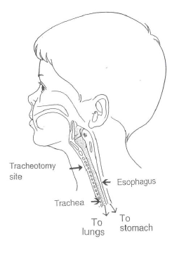

**Advice**

After your child has had their tracheostomy inserted, they will require special care.

Based on our experience with many families who have learned to care for a child with a tracheostomy tube, we offer this advice:-

Spend time taking care of your child during your hospital stay. The more involved you are, the better prepared you are for when you go home.

Choose someone to complete the teaching programme with you. You cannot provide care for your child 24 hours a day. By having another person to help, you can participate in your child’s care together, ask for advice and support.

For your child’s safety, any person caring for them will need to know all of the skills you have learned while in hospital.

When your child is almost ready to go home, you and the other person should spend at least one full day and night caring for your child. This will help you prepare for the transition from hospital to home.

Encourage your child’s siblings and other family members to visit. Your child will want company and your family will begin to feel more at ease with the tracheostomy tube.

After you have learned to care for your child’s tracheostomy, be ready to help others learn to care for your child. Here at Alder Hey we will teach you and a second person how to care for your child’s tracheostomy tube. If you require other family members to be taught your child’s tracheostomy cares that is up to you and most Community Teams can help you with this.

Ask questions. We can do a better job taking care of your child and helping you if we know your questions and concerns.

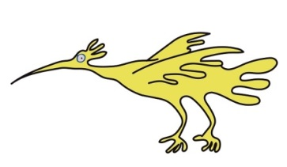****

**Meet your care team**

During your hospital stay, many people will be involved in your child’s care. You may meet and work with:

Doctors

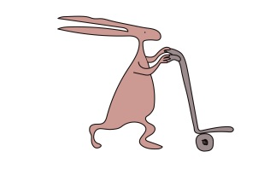Nurses

Nurse specialists

Community Nurses

Physiotherapists

Speech therapists

Dieticians

Play specialists

It is important to remember that once you have been discharged from hospital you are not on your own. You and your child will be able to access help, advice and support from your Community Team, Ear, Nose and Throat Nurse Specialist and General Practitioner (GP).



**Teaching programme for the care of your child**

Before your child goes home, you need to learn the following care. Any person staying with your child will also need to learn all of this information.

1. Why your child needs a tracheostomy tube?

2. Type, size and length of your child’s tracheostomy tube?

3. Why, when and how to suction the tracheostomy tube?

4. Why, when and how to clean the skin around the tracheostomy tube?

5. Why, when and how to change the tracheostomy ties?

6. Why, when and how to change the tracheostomy tube?

7. Humidification.

8. Nebuliser therapy.

9. Supplies to have with your child at all times.

10. Potential emergencies and how to help your child.

11. The signs of respiratory distress and how to help your child.

12. How to give oxygen through the tracheostomy tube.

13. The signs of infection.

14. Activities your child can do and activities to avoid.

15. How to give medications, aerosols if needed.

16. The use of necessary equipment and monitors.

17. Use of home equipment.

18. How to do rescue breathing and cardiopulmonary resuscitation (CPR).

19. Twenty four hour transitional care.

20. Other………………………………………………………………………………………..

…………………………………………………………………………………………………..

You may feel that this is a lot to learn and most parents/carers feel this way, but in time you will become an expert in the care of your child’s tracheostomy.

****When you and the second person have shown the Nursing Staff that each point can be completed successfully on three separate occasions your training will be finalised.

**Support at home**

Before you are ready to be discharged, your Community Team will arrange to supply the items needed to care for your child with their tracheostomy tube. The medical equipment and supplies required will be delivered to your home before discharge. Once you and your child are ready to go home you will have everything you need.

Your child may need a care package depending on their health needs. This can be discussed with the Ear, Nose and Throat Nurse Specialist.



**Frequently Asked Questions**

**How will my child communicate?**

Temporarily the tracheostomy may affect your child’s speech and language development. Alder Hey has Speech and Language Therapists who will assist you and your child with communication options and ways to develop speech and language skills. Your child’s communication options will depend on their airway and the reason for their tracheostomy. These communication options can be discussed further with your Ear, Nose and Throat Nurse Specialist, your child’s Doctor and your child’s Nurse.

**Can my child go swimming?**

We do not recommend that your child goes swimming, because there is a high risk of water getting into the tracheostomy tube.

**Can my child have a bath?**

Yes, as long as you ensure that the water level is below your child’s waist and to avoid splashing.

**Can my child have a shower?**

Older children/teenagers may have a shower, as long as they remember to avoid the spray going into their tracheostomy tube. We do not recommend younger children/babies having a shower.

**Can I get a parking blue badge (disabled person’s badge)?**

Yes. You can get a badge for your car. Remember it should only be used when transporting your child.

**Can my child go to school/nursery?**

Yes, as long as they have a carer with them at all times who is fully tracheostomy trained and competent in carrying out your child’s tracheostomy cares.



**What happens if I have a power cut?**

Your Community Team will supply you with the necessary equipment in case this occurs, so your child will not be in any danger. To make sure you are prepared:-

* Charge your equipment regularly, so that your equipment battery can be used.
* Keep a torch nearby and check its batteries regularly.
* Inform your electricity supplier that you need a continuous supply of electricity for medical equipment.

**Can my child have a pet?**

Yes. Pets that shed a lot of fur or feathers should be avoided.

I do not have a telephone do I need to have one?

We recommend that you get a telephone in your home, in case of an emergency. A mobile phone or landline is essential.

**Will I get any financial support?**

Yes. Financial support is available for you and your child. You will be entitled to Disability Living Allowance (DLA). DLA is awarded at different levels depending on your child’s illness and needs. Carers allowance (CA) is also available if you spend 35 hours a week caring for your child and/or do not earn more than £95 a week. Other support that may be available for you will depend on you and your child’s situation for example income support, child tax credit, a family fund trust grant, direct payments and/or housing/council tax benefit. Check with your Citizens Advice Bureau (CAB).

**Will my child be able to eat and drink?**

Most children with tracheostomy tubes can eat and drink normally. Some do experience problems, such as difficulty in swallowing. If this does happen Speech and Language Therapists will assess them and recommend ways of improving their feeding.



**Can I take my child on holiday?**

This should not be a problem but before organising your trip be sure to check with your child’s Doctor or Ear, Nose and Throat Nurse Specialist that it is safe to do so. Choose your destination wisely and ensure health care provision is easily accessible. Remember to get insurance before travelling abroad and take enough supplies with you. If you are flying contact the airline before travelling in regards to your equipment.

**Will I be able to get help looking after my child?**

We understand that taking care of a child with a tracheostomy is a 24 hour a day job and we do not expect you to be able to do this all of the time. Respite care is an option that you could consider. Respite care involves your child going to a home where they get taken care of for a few days, a week etc. depending on your requirement. Your local authority can provide you with fully trained tracheostomy carers, depending on your circumstances. Certain disabled children’s teams may offer short breaks so that you could go shopping etc. whilst they take care of your child.

**What clothes should my child wear?**

Avoid putting your child into tight clothing that covers the tracheostomy tube. Remember to avoid clothing that sheds a lot of fibres that could get into the tracheostomy.

**My child has their own room, what if something happens in the night and I do not hear them?**

We feel it is safer if your child is a baby or an infant that they sleep in your room, as they may require suction overnight. A baby intercom can be purchased if you require. Some community teams will provide you with monitoring devices, but this does depend on your child’s needs and age.

**What can my child play with?**

****If your child is a baby or an infant do not allow them to play with small toy parts that could be put into their tracheostomy. Dry sand should be avoided also, as this may get into the tube.

**List of Contacts**

|  |  |  |
| --- | --- | --- |
| Contact | Telephone | Website |
| Alder Hey Hospital | 0151 228 4811 | [www.alderhey.nhs.uk](http://www.alderhey.nhs.uk) |
| Ward 3A | 0151 252 5416 |  |
| ENT Nurse Specialist | 0151 228 4811  Ext. 3757 |  |
| ENT Clinic | 0151 252 5206 |  |
| ENT Secretaries | 0151 252 5302 |  |
| **Speech and Language** | | |
| Contact | Telephone | Website |
| Makaton Vocabulary Development Project | 01276 61390 | [www.makaton.org](http://www.makaton.org) |
| The Royal College of Speech and Language Therapists | 020 7838 1200 | [www.rcslt.org](http://www.rcslt.org) |
| **Travel** | | |
| Contact | Telephone | Website |
| Aid for Children with Tracheostomies |  | [www.ACTfortrachykids.com](http://www.ACTfortrachykids.com) |

**Charities**

|  |  |  |
| --- | --- | --- |
| Contact | Telephone | Website |
| Aid for Children with Tracheostomies |  | [www.ACTfortrachykids.com](http://www.ACTfortrachykids.com) |
| Contact a Family | 0808 808 3555 | [www.cafamily.org.uk](http://www.cafamily.org.uk) |
| Family Fund Trust | 0845 130 45 42 | [www.familyfundtrust.org.uk](http://www.familyfundtrust.org.uk) |
| Action for Sick Children | 0800 07 445 19 | [www.actionforsickchildren.org](http://www.actionforsickchildren.org) |

|  |  |  |
| --- | --- | --- |
| **School and Nursery** | | |
| Contact | Telephone | Website |
| Advisory Centre for Education | 0870 770 3306 | [www.ace-ed.org.uk](http://www.ace-ed.org.uk) |
| Network 81 | 0870 770 3306 | [www.network81.org](http://www.network81.org) |
| **Financial Support** | | |
| Contact | Telephone | Website |
| Disability Living Allowance | 0800 882200 | [www.gov.uk](http://www.gov.uk) |
| Carers Allowance | 0800 882200 | [www.gov.uk](http://www.gov.uk) |
| Income Support | 0800 055 6688 | [www.gov.uk](http://www.gov.uk) |
| Child Tax Credit | 0345 300 3900 | [www.gov.uk](http://www.gov.uk) |
| Family Fund Trust Grant | 0845 130 4542 | [www.familyfundtrust.org.uk](http://www.familyfundtrust.org.uk) |
| Direct Payments |  | [www.gov.uk](http://www.gov.uk) |
| Housing Benefit |  | [www.gov.uk](http://www.gov.uk) |
| Council Tax Benefit |  | [www.gov.uk](http://www.gov.uk) |
| Citizens Advice Bureau |  | [www.citizensadvice.org.uk](http://www.citizensadvice.org.uk) |

**Glossary**

|  |  |
| --- | --- |
| Aspiration | Happens when solids, liquids or saliva go into the airway instead of the oesophagus. |
| Bronchoscopy | Is performed under a general anaesthetic and involves a camera being passed into the trachea. It will show the inside of the trachea and the air passages that lead to the lungs. |
| Bronchospasm | Occurs when the muscles in the airway tighten making it hard to breath. |
| Catheter | Is a small, long, soft, clear tube used to remove mucus from the tracheostomy. |
| Cyst | Is a fluid filled swelling. |
| Decannulation | Is when the tracheostomy comes out. |
| Epiglottis | Is a piece of cartilage that covers the opening to the voice box when you eat and drink. |
| Flange | Is the part of the tracheostomy that holds the tapes in place. |
| Granulation | Can often be extra tissue or scar tissue present around the tracheostomy opening in the neck. |
| Haemangioma | Is a blood vessel filled swelling. |
| Humidifier | Is a resource that enables extra moisture to be put into the air. |
| Incision | A cut made during a surgical procedure. |
| Larynx | Voice box or Adams apple. |

|  |  |
| --- | --- |
| Laryngomalacia | Occurs when the larynx is soft and collapses as the child breathes in. |
| Laryngotracheobronchitis | Occurs when the upper respiratory tract becomes infected. |
| Microlarynoscopy | Is performed under a general anaesthetic and involves a microscope being passed into the larynx. It will show the inside of the larynx. |
| MLTB | Is performed under a general anaesthetic and involves a camera being passed into the larynx. It will show the inside of the larynx and trachea. |
| Papilloma | Is a wart. |
| Saline | Sterile salt water. |
| Secreations | Loose and white mucus. |
| Stoma | The opening in the neck where the tracheostomy fits into. |
| Stridor | Noisy breathing. |
| Subglottic stenosis | Occurs when there is a narrowing in between the larynx and the trachea. |
| Swedish nose | Humidification aid. |
| Trachea | Windpipe. |
| Tracheomalacia | Occurs when there is a softening of the trachea which collapses as the child breathes in. |

|  |
| --- |
| Notes |

This leaflet only gives general information. You must always discuss the individual treatment of your child with the appropriate member of staff. Do not rely on this leaflet alone for information about your child’s treatment.

This information can be made available in other languages and formats if requested.

Alder Hey Children’s NHS Foundation Trust

Alder Hey

Eaton Road

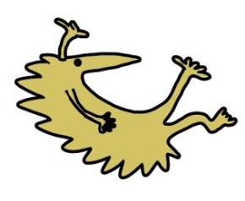Liverpool

L12 2AP



Tel: 0151 228 4811

[www.alderhey.nhs.uk](http://www.alderhey.nhs.uk)

**© Alder Hey Review Date: April 2025 PIAG: 230**