Infection Prevention and Control Department

Toys

Information for parents and carers

Introduction

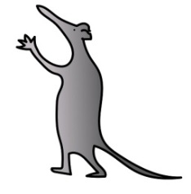
At Alder Hey hospital we know how important toys are to all of our patients. We know they can play a critical role to their recovery and how bringing a favourite toy into hospital can make all the difference.
Unfortunately toys that have not be cleaned properly can become a source of infection.
To help us minimise the risk of cross infection we ask you to:
- Ensure any toys you bring into hospital are clean. All soft toys should be machine
washed before bringing them into hospital. If your child is here for a long stay please wash their toys each week.

- Keep the number of toys brought into hospital to a minimum. This will allow us to effectively clean your child’s bed area.

- Don’t share your child’s toys with other children unless they are group toys such as games.

- If your child has played with any hospital toys in their bed space, please give them back to ward staff to clean rather than putting them back into the general store/playarea.

- Please inform ward staff/Play leader if you are concerned about the cleanliness or condition of any Hospital toys.

Please help us to keep infections to a minimum.
This leaflet only gives general information. You must always discuss the individual treatment of your child with the appropriate member of staff. Do not rely on this leaflet alone for information about your child’s treatment. This information can be made available in other languages and formats if requested.
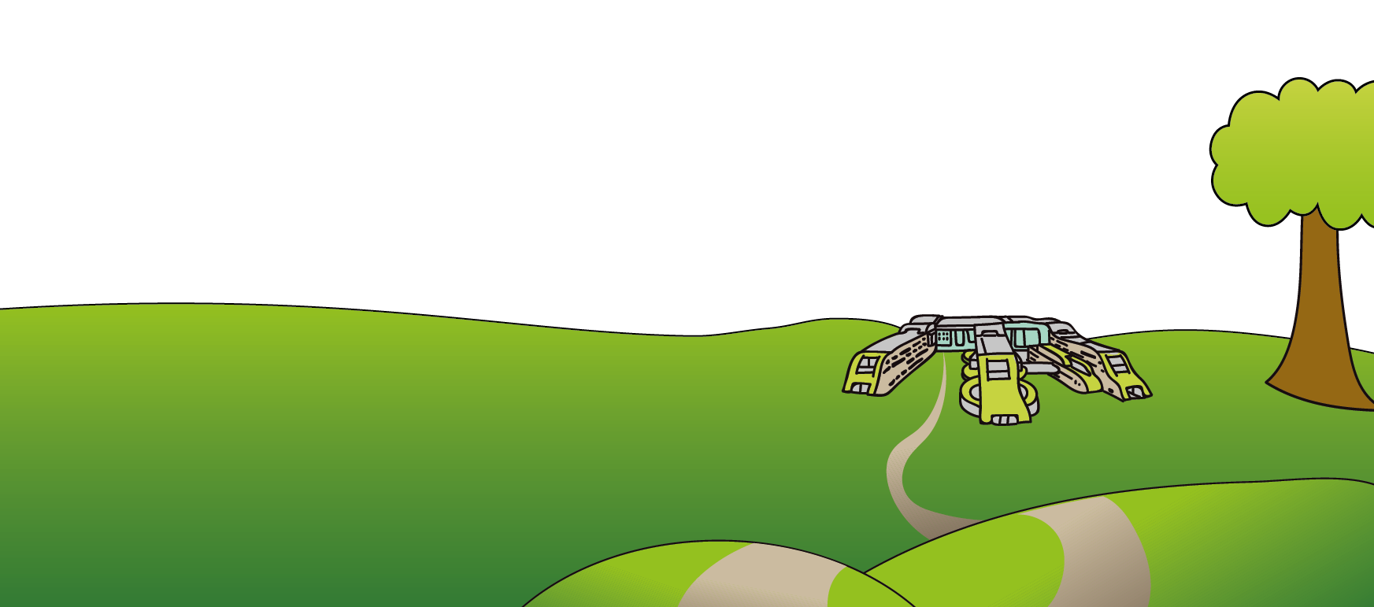
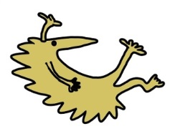
Alder Hey Children’s NHS Foundation Trust
Eaton Road
Liverpool
L12 2AP

Tel: 0151 228 4811
www.alderhey.nhs.uk
© Alder Hey Review Date: May 2024 PIAG 028

