Department of Ophthalmology

Botulinum Toxin Injection for Squint

Information for parents and carers

Who is this leaflet for?
This leaflet is for patients or parents/ caregivers of children planning to have a botulinum toxin injection for squint.
What is a Botulinum toxin injection?
Botulinum toxin (also known as Botox) injections can be used to manage various types of squint and eye movement problems. Botulinum toxin type A is a chemical which stops a muscle from contracting when injected into it. This can help to temporarily realign the eye(s).
Why does my child need a Botulinum toxin injection?
Your doctor will have recommended this treatment as you/ your child has a turn in their eye (known as a squint). The squint may be causing you/ your child symptoms such as double vision, or you/ they may be aware of its appearance.
Squints can be managed in a variety of ways if the patient has double vision, including:
- Prisms
- Injections of Botox
- Squint surgery
Prisms are plastic films that can be added to glasses. These make the brain think that the eyes are aligned by manipulating the image through the glasses. They can, if found helpful, eventually be incorporated into the glasses. They are useful as a short-term measure, or if the other options are not possible. They sometimes can blur vision and the double vision persists when the prisms are taken off.
Squint surgery involves a surgical procedure under general anaesthetic. This is a more definitive method of correcting the squint. However, it can sometimes induce double vision or make it worse. Further, not all patients are suitable for squint surgery, especially if the squint is variable, or if they have had previous surgery.
Botox is usually temporary and generally lasts for 2-3 months. It is used for the following purposes:
- Treat the squint and so avoid squint surgery
- To see if straightening the eyes will help get rid of double vision prior to any definitive squint surgery
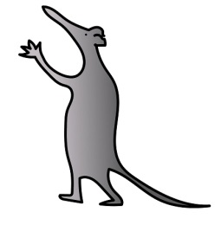
- Help reduce the amount of squint present prior to surgery
- Provide temporary relief from double vision whilst undergoing other treatments or waiting for surgery
- Provide additional benefit to any squint surgery performed
Your doctor will discuss with you the reason(s) for the Botox injection.
What does the procedure involve?
The procedure is performed under general anaesthesia. The surgeon will have planned beforehand the dose of botulinum toxin and the muscle to be injected.
There are different ways of performing the procedure.
- The muscle is held with a special forcep and the Botox injected into the muscle. Sometimes, this will be done using a special needle that detects electrical signals (EMG guidance).
- In some cases, we may make a small cut to the conjunctiva (skin of the eye) to get to the muscle for the injection (direct view).
After the injection is given, a little bit of pressure is applied to the injection site and a drop of antibiotic is given.
What will happen if we decide not to have the treatment?
In cases where the purpose of realignment of the eyes is for cosmetic purposes, there is no rush in making a decision. Your doctor will discuss with the options and any possible alternatives.
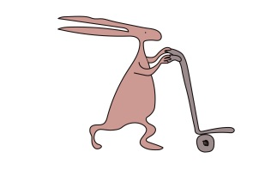
In situations where we feel the realignment of the eyes are necessary to prevent a lazy eye, we will discuss this in clinic to explore the options. This is important because the patient is at risk of developing a lazy eye due to the malalignment. There is a potential that patching treatment (for the condition) has not been effective in the past.

What will happen before surgery?

Before the operation, you/ your child will see an orthoptist (they are specialists in assessing vision and visual function) and an optician. You/ Your child will be seen by your consultant or a member of the surgical team.
The doctor will ask you about the problem, any other medical problems and any medications that you/ your child take.
If you are to proceed with surgery, the procedure will be discussed in detail. This will include any risks or possible complications of the operation. All procedures in children are performed under general anaesthesia.
You will be asked to read and sign a consent form after having the opportunity to ask any questions.
What are the risks and possible complications of surgery?

Common
Overcorrection: The muscle may be weakened too much and the turn in the eye can go in the other direction. As the effect of botulinum toxin is temporary, this should resolve without any intervention in 2-3 months. This occurs in 1 in 4 patients.
Ptosis: The surgeon will take care to inject the toxin into the muscle intended for treatment. Occasionally the toxin may act on the eyelid on the side of the injection and cause drooping of the lid. This should resolve in about 8 weeks. This occurs in about 1 in 10 patients.

Uncommon
Vertical squint: Rarely the toxin may act on the muscles that move the eye up and down, and causes the eyes to look turned up/down. This should resolve in 2-3 months. This occurs in less than 1 in 10 patients.

What should I expect after surgery?

The botulinum toxin takes two to three days to have an effect on the muscle, so you will not notice a change in the position of the eye immediately. The effect may increase over three to five days.

Initially, the position might be too far in the opposite direction (causing double vision), but this will wear off and the eye will gradually come to the straight-ahead position. Towards the end of 3-4 months, the effect of the botulinum toxin wears off and the eye returns to its original position. Sometimes the eyes stay aligned because the brain maintains the new position.

An appointment will be arranged with the orthoptist two weeks after the injection to assess the response. A further appointment to see the ophthalmologist/ member of the surgical team will be arranged in 3-4 months. Further injections might be needed.

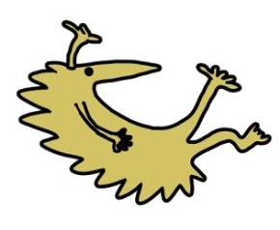

Hospital telephone number: 0151 228 4811
Extension for clinic: 2215
Extension for secretary: 2839 / 3595 / 2961

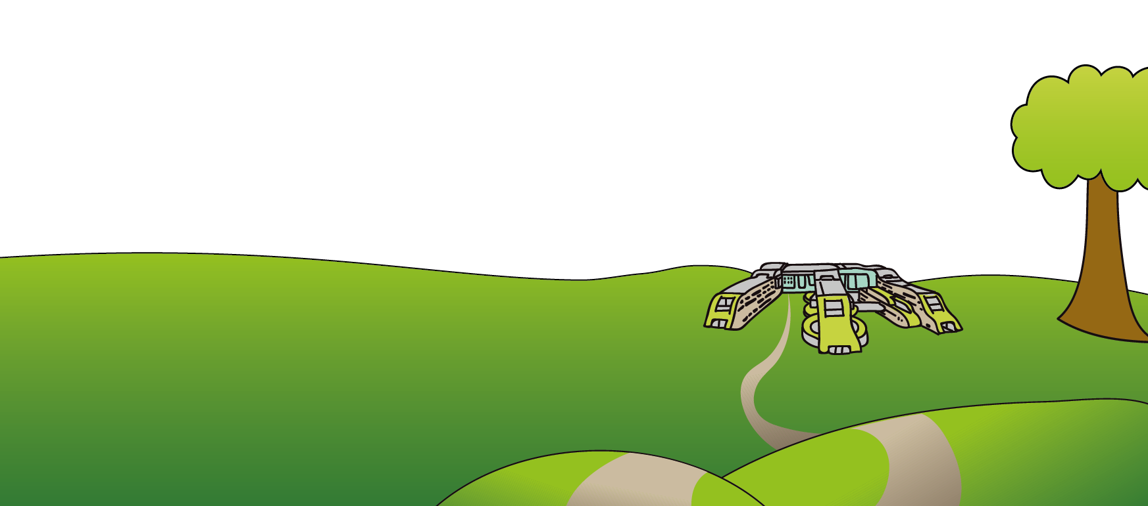
This leaflet only gives general information. You must always discuss the individual treatment of your child with the appropriate member of staff. Do not rely on this leaflet alone for information about your child’s treatment. This information can be made available in other languages and formats if requested.
Alder Hey Children’s NHS Foundation Trust
Alder Hey
Eaton Road
Liverpool
L12 2AP

Tel: 0151 228 4811
www.alderhey.nhs.uk

© Alder Hey Review Date: January 2025 PIAG: 352

