

**Total Hip Replacement (THR)**

Information for patients

**About the procedure**

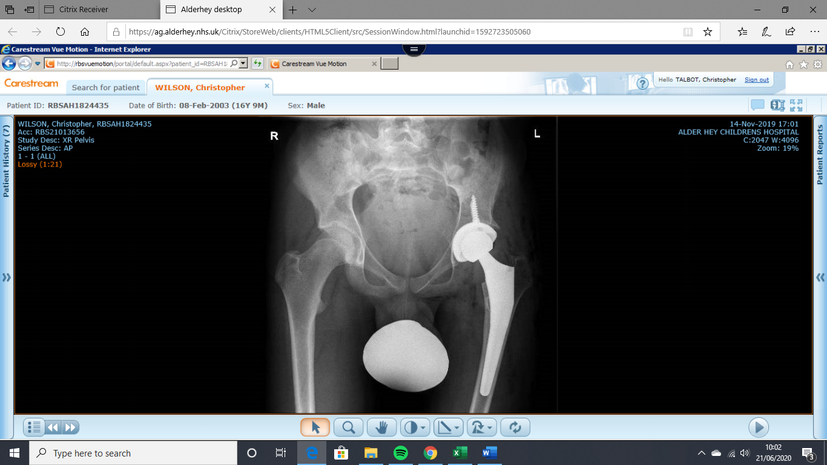**What is a THR?**

A THR involves removing your own damaged ball and socket hip joint and replacing them with an artificial ball and socket. These can be made of metal, plastic or ceramic. The artificial joint is fixed to the bone with a special cement, or has a surface that allows your own bone to grow into. Sometimes screws are needed if no cement is used to hold the socket part of the hip replacement in place until the new bone grows around it.

**Why do I need a THR?**

There are many conditions which require a THR. The damage that occurs in the hip joint as a result of these conditions causes it to be very painful and stops you from doing the things you once were able to do.

**How will a THR help?**

The goal of surgery and the THR is to relieve your pain.

**How long will my hip replacement last?**

The aim is for the THR to last many years, your surgeon will discuss this with you. However, if a problem occurs this may require a further operation sooner than expected to make this better. Please see the National Joint Registry (<http://www.njrcentre.org.uk/>) for further detail on hip replacements.

**What are the risks of a THR?**

A THR is a major operation and places the body under stress. It is important to know that all operations have risks as well as the benefits. Your surgeon will talk to you about these risks, and about the chance of them happening. These risks include:

**Common risks (affecting 2-5 people in every one hundred hip replacements)**

* Persistent Pain
* Altered leg length
* 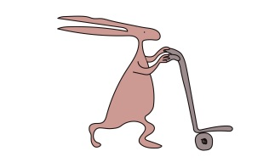Clots in the leg (Deep vein thrombosis)
* Bleeding
* Joint dislocation (where the ball and socket are no longer together)
* Loosening and wearing out of the hip replacement

**Less common risks (affecting less than one in every one hundred hip replacements)**

* Infection

**Rare risks (affecting much less than one in every one hundred hip replacements)**

* ****Fracture
* Major nerve injury
* Blood vessel damage
* Clots in the lungs (Pulmonary embolism)
* Risk to life

Pre-op

Before your surgery you will have a pre-op appointment at Alder Hey where you will meet the team looking after you. This includes the orthopaedic surgeon, orthopaedic nurse specialist, anaesthetist, acute pain team, physiotherapist and occupational therapist.

**Meet the team**

Consultant Orthopaedic Surgeon

The Orthopaedic Surgeon will see you in clinic and talk about the options available to help with your current symptoms. Once the decision has been made to have a THR, the Orthopaedic surgeon will perform your surgery. They will look after you following your surgery.

Orthopaedic Hip Nurse Specialist

The Orthopaedic Hip Nurse Specialist will be your link before, during and after surgery. They will co-ordinate your care. They will ensure all your pre-op investigations are undertaken, reviewed and actioned if required. They will give information about wound care and collect information about you (patient reported outcomes) before and after surgery. They will review you during your inpatient stay and upon discharge.

Consultant Anaesthetist

The anaesthetist looks after you during your operation. They will make sure that you feel safe and comfortable. If you feel anxious in the morning before your operation the anaesthetist can prescribe you some medicines to make you feel better. After surgery they will make sure that you are on all the right medicines to help you to start your recovery and exercise with the physiotherapist.

Physiotherapist (Physio)

The physiotherapist will help you physically prepare for your surgery. They will give you some exercises to practice to help get you fit and strong beforehand. They will also talk to you about what is involved in your recovery and rehabilitation afterwards in order to help you get back to the daily activities and hobbies you enjoy!

Occupational Therapist (OT)

The OT will talk to you about your set up at home and school. They will help you and your guardian make adaptations to your home and school so that it is safe for you after your surgery. They will also give you pieces of equipment to help you with daily activities such as washing and dressing.

Acute Pain Team

The acute pain team visits you on day 1 and day 2 after your operation. They will help to make sure that you are taking all the right medications and feel comfortable whilst you continue your recovery and exercise with the physiotherapist.

Pre-op

You will also attend a pre-operative assessment clinic where blood tests, x-rays, infection screening and a check of your general health will be performed. You will be asked to make an appointment to come back to this clinic within 7 days of your surgery date to have a further blood test and a urine test.

Day of your surgery

On the morning of your surgery you will come to the surgical admissions lounge at Alder Hey where you will meet the anaesthetist. They will ask you some questions in preparation for your surgery. Make sure you don’t eat anything for 6 hours before your operation. You can continue to drink water up until 1 hour before your operation.

After your surgery you will go to the ward. You will be allowed to have something to eat and drink and you can have medication if you are in pain or feel sick. The nursing and therapy staff will show you how you can move in bed in a safe way.

The physio may also start practising some gentle exercises with you and try sitting on the edge of the bed.

Day 1

The doctors and hip nurse specialist will come and see you to make sure you are recovering well from your surgery and you will have an x-ray and a blood test today. The physio will help you start to move, initially transitioning from bed to a chair, progressing to walking short distances with a walking aid. The acute pain team will make sure that you feel comfortable enough to exercise.

It is really important to get moving early not only to help in the recovery of your hip but also for your lungs, your circulation and your digestion.

You should try and be as independent as possible during the day. This includes getting dressed, sitting in a chair for meals and mobilising to and from the toilet. The nursing and therapy staff will help you with this on day 1. You should wear some comfortable and loose clothes during the day. Pyjamas are for night time only!

Days 2-4

Over the course of the next few days the physio will help you progress your mobility. They will also show you how to walk up and down the stairs and get in and out of your car. They will practice your exercise programme so that you feel confident with it before you go home. It is very important that you practice these as your physio advises so you get the best outcome from your surgery.

****The OT will show you how to wash and dress using your aids as well as making sure you are set up at home ready for your discharge. You will be able to have a light shower with a waterproof dressing covering your wound.

Discharge to 6 weeks

**You will need to have a daily injection for 28 days following your surgery. This will help to reduce the chance of developing blood clots forming in your legs and lungs. You will be shown how to administer this to yourself by the nursing team on the ward before discharge.**

You will be sent home with a discharge summary, spare dressing, medication and any equipment provided by physio and OT.

Once you have been discharged from hospital you will come back to see your consultant and the rest of the team at 2 weeks and 6 weeks after your surgery. Your wounds will be checked and they will make sure you are managing okay at home. X-rays will be performed at 6 weeks.

It is important to keep up a level of gentle mobility once you get home as well as practising your exercises.

6-12 weeks

At 12 weeks you will have another appointment and your consultant will tell you if you can stop following your precautions.

You will start some more challenging exercises to help progress your balance, movement and strength around your hip.

3-6 months

Over the next three months you will start return to normal life. Gradually introducing you to activities such as cycling, swimming, uphill walking building up to gentle jogging, P.E and various sporting activities.

After this point you will continue to see your consultant once a year to check how you are managing.

**FAQ’s**

How long does the surgery take?

The time it takes to perform your operation can vary, and your surgeon will discuss this with you during your appointment with them.

How long will I be in hospital for?

Providing that there are no complications with your surgery, post-operative care and rehabilitation the normal length of stay is 2-4 days.

Can someone stay with me?

1 parent is able to stay with you over night. Visiting times for anyone else is 2pm – 7pm.



What do I need to bring?

Here is a list of some of the items that will need whilst you are in hospital:

* Any medication you are taking
* Small aids (long handled shoe horn, long handled bath sponge, grab aid, sock aid)
* Comfortable and supportive shoes – not flip flops, sliders or backless slippers
* Loose fitting, comfortable clothes for day time
* Pyjamas for night time
* Entertainment ie. books, headphones, music, tablets
* Toiletries
* Cups/flasks with a lid to make hot drinks for relatives
* Any pre-prepared food/snacks in a labelled box

When will I be able to go back to school?

Once the team have established that the school environment is safe for you they would aim for you to start returning to school at 3 weeks.

When will I be seen following my surgery?

You will be seen in clinic 2 weeks following your surgery. You will see a doctor and your wound will be checked. You will then be seen at 6 weeks, 3 months, 6 months and 1 year.

The anaesthetists and acute pain team will also arrange a video call with you and your family to see how you are getting on.

What happens if I have a problem with my wound after surgery?

It is important that if there are any problems with wound healing, please contact the hip nurse specialist or Mr Talbot’s secretary on the contact numbers below.

What are hip precautions?

Hip precautions are a set of instructions given to give the best chance of having a good outcome for your new hip. They are given to help prevent a dislocation of the joint. This will be talked about during your clinic appointments and pre-op assessments. Please see the **Hip precautions following THR leaflet** for further information.

Who will look after me when I am too old to come to Alder Hey?

A link between Alder Hey Children’s NHS Foundation Trust and Liverpool University Hospitals NHS Foundation Trust has been established for the adolescent and young adult hip service. This includes yourself undergoing THR. During your appointment with the team, transition to adult services will be talked about to provide you with a long-term plan of ongoing care.

**Contact details (Office Hours):**

Mr Talbot’s Orthopaedic Pathway Co-ordinator (Ann Kershaw): 0151 252 5779

Emma Spink (Orthopaedic Hip Nurse specialist): 0151 252 5282

Physiotherapy (Physio): 01512525405

Occupational Therapy (OT): 01512525660

This leaflet only gives general information. You must always discuss your individual treatment with the appropriate member of staff. Do not rely on this leaflet alone for information about your treatment.

This information can be made available in other languages and formats if requested.

Alder Hey Children’s NHS Foundation Trust

Alder Hey

Eaton Road

Liverpool

L12 2AP

Tel: 0151 228 4811

[www.alderhey.nhs.uk](http://www.alderhey.nhs.uk)



**© Alder Hey Review Date: May 2024 PIAG: 279**