This leaflet only gives general information. You must always discuss the individual treatment of your child with the appropriate member of staff. Do not rely on this leaflet alone for information about your child’s treatment.

This information can be made available in other languages and formats if requested.

Alder Hey Children’s NHS Foundation Trust

**~~~~**East Prescott Road

Liverpool

L14 5AB

****Tel: 0151 228 4811

[www.alderhey.nhs.uk](http://www.alderhey.nhs.uk)

**© Alder Hey Review Date: March 2025 PIAG: 391**



**Department of Respiratory Medicine**

**The genetics of cystic fibrosis and prenatal options**



**Information for patients,**

**parents and carers**



**Introduction**

You have been given this leaflet because you have a child with cystic fibrosis (CF) who is under the care of the CF team. This leaflet aims to answer some of the questions you may have about how CF is inherited as well as options available to you for future pregnancies. Even if you are not planning a pregnancy in the future, there may be information in this leaflet that is relevant to you and your wider family members.

**Genetic basis of cystic fibrosis**

Our DNA (genetic material) contains around 20,000 different genes. Our genes tell our bodies how to grow, develop and function. Most of our genes come in pairs, as we inherit one copy of each gene from our mother and the other from our father.

We all have thousands of changes in our genes, that is what makes us all unique. However, someone may carry a gene change (sometimes referred to as a mutation or pathogenic variant) which affects the way the gene functions, thereby causing disease.

CF is an autosomal recessive condition, which means that a change is required on **both** copies of the gene (called *CFTR*) to cause CF. If one copy of the gene is working normally, and the other copy has a change, then the person is a *carrier* for CF. This is the case for around 1 in 25 people of Caucasian heritage. Individuals of different ethnic origin can also be CF carriers, although this is less common. Being a carrier does not usually cause any health problems.

Image source: <https://www.genomicseducation.hee.nhs.uk/image-library/>

When we have children, we only pass one copy of our *CFTR* genes as the baby inherits its other copy from their other biological parent. If both biological parents are carriers, there is a:

* 1 in 4 (or 25%) chance of both parents passing on their changed copy of the gene and the baby having CF.
* 1 in 4 (or 25%) chance of both parents passing on their working copy of the gene and the baby being healthy (and not a carrier).
* 2 in 4 (or 50% chance) of one parent passing on the changed gene and the other passing on the working copy of the gene, meaning the baby is a healthy carrier.

This is also shown in the diagram below.

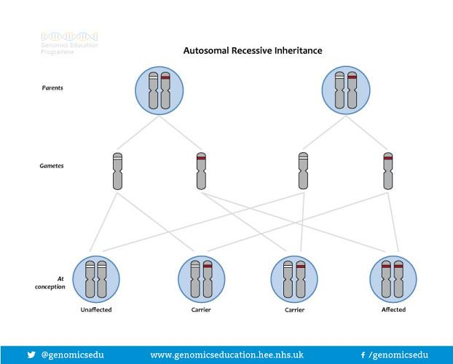Image source: <https://www.genomicseducation.hee.nhs.uk/image-library/>

**What does this mean for our family?**

There may or may not be a history of CF in your family. In most cases, both parents of a child with CF will be a carrier of the condition. However, there are occasions where this is not the case and so it is important to get accurate advice about your own personal circumstances. Carrier testing (to look for a changed copy of the CFTR gene) is available to you and to members of your wider family, who may be planning a family of their own.

**What can the genetics team offer?**

In the genetics clinic, the team will discuss your child’s genetic results, your results (if known), and take details about your wider family. They will then discuss the options available to you and your family members if you are considering any children in the future. They can also provide information to help other members of your family access carrier testing if they would like. The genetics team can also review patients with CF when they are considering starting a family of their own to discuss options available to them.

The role of the genetics team is to provide information and to support you in making the best decisions for you and your family. Attending an appointment does not commit you to having any genetic tests; some families may have a one-off appointment, whereas others choose to re-visit their options by requesting a further appointment at a later date.

**Options for future pregnancies**

The options available to couples who are both carriers for CF and want to have further children can vary depending on their own personal circumstances. However, broadly speaking, the options available include:

* **Testing after pregnancy.** Couples can choose to get pregnant and have the baby tested shortly after birth to find out if he/she has CF. This can be done by testing the cord blood of the baby after birth, or by having the new-born screening test (sometimes known as the heel prick test).
* **Have a genetic test in pregnancy.** Some couples choose to find out during the pregnancy whether or not the baby has CF. Depending on individual circumstances, testing in a pregnancy may be non-invasive (a blood test from the mother) or invasive (a needle through the tummy into the womb).
* **Pre-implantation genetic diagnosis (PGD).** This involves couples going through an IVF-like process to create embryos outside the body. The embryos can then be tested for CF and only embryos without CF would be put into the womb to make a pregnancy. There are strict eligibility criteria for NHS funded PGD such as the mother’s age, health status, body mass index and previous children. Referrals for PGD must be made by the genetics team.

**Next steps**

Please speak to a member of the CF team if you would like a referral to the genetics service. You do not have to be planning on extending your family to ask for a referral and being referred does not mean you have to have any genetic testing if you don’t wish to.

For those patients in the North West, the genetics service is based at Liverpool Women’s Hospital. You can find more information about the service here: <https://www.liverpoolwomens.nhs.uk/our-services/liverpool-centre-for-genomic-medicine-lcgm/>

For those patients in North Wales, patients are referred to the All Wales medical genetics service and will be seen at their local hospital. You can find more information about the service here: <https://bcuhb.nhs.wales/services/health-services1/services1/services/genetics-service/>