COVID-19 Swabbing / Track and Trace Team

Testing for COVID-19

Information for families

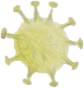
What is Coronavirus?
Coronavirus is a virus. Viruses cause things like runny noses and coughs and colds. Coronavirus is new and can give people something called COVID-19. Because it’s new, we have to be careful so that lots of people don’t get it and become poorly.
How do I know if I have it?
You might have a high temperature – that can make you feel hot on your back or chest, but sometimes you feel cold and have the shivers! You might have a new continuous cough – this means coughing a lot more than you normally would. Sometimes you might not be able to taste or smell – things at home might smell differently to normal or you might not be able to taste your food!
Sometimes we may have it but not know because we don’t have any changes or what we call symptoms. This is why we have to be careful at home, and when we leave the house we must remember to:

Wear a mask - Wash your hands - Keep 2m apart from people you don’t live with
I’m coming to Alder Hey for an operation or procedure – am I still allowed?
Because of Coronavirus, we need to be super careful to make sure you are safe and all of our other patients and families are too. This means that we have to check before you come if you have the virus or not.
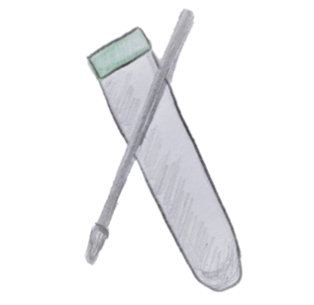
To do that, we need to do something called a swab to test you to see if you have got the virus or not – as we know, sometimes people don’t have any symptoms.
If it’s negative – which means you don’t have the virus, you can come in as planned. If it’s positive – you do have the virus, so you need to stay at home and isolate with your family. That means everybody has to stay at home and not go to school or to work until it’s gone – you may get another swab for that.
You don’t need to worry, your Doctors and Nurses will talk with your grown ups and let you know what you all need to do.
Sometimes, if your operation can’t wait, your Doctor may say it’s OK to come in, but you’ll have to stay in your own room when you’re in hospital.
What is a swab and how do I get one?
A swab looks like a long cotton bud, you may have seen them in your house. The ones that we use are soft and the stick is long and bendy.
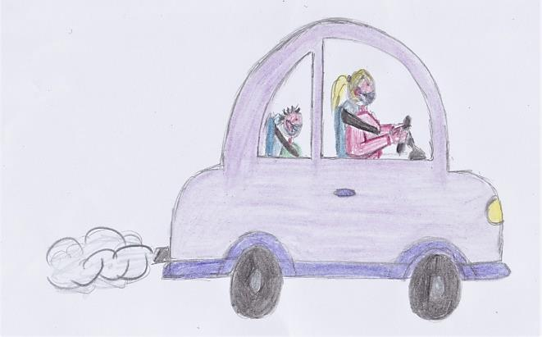
Someone from the hospital will give your grown ups a call and will arrange for you to come to our garage. Your grown ups will need to tell them if they don’t drive because you may have to do something slightly different.
To get to the garage, you will come to Alder Hey using the Eaton Road entrance – look out on your left and you’ll see A&E. Tell your grown up to keep going, there’s a cabin just past A&E, and on the other side of that is the garage!
When you get near, you should see someone with a yellow jacket – they’ll be able to help your grown ups get in to the garage so that you are ready for your swab.
Now we’re at the garage, what happens next?
When you get to the garage, make sure your windows are closed until your grown up has parked and one of our swabbing team asks you to lower it. Our swabbing team will ask you or your grown up what your name is, and they will ask when your birthday is, this is to check that we have got the right person.
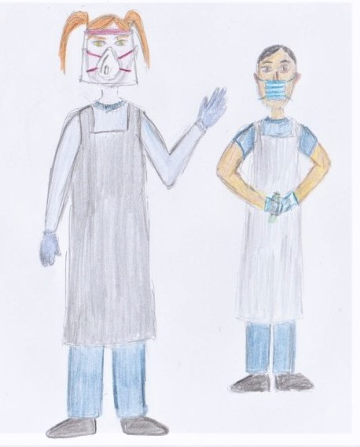
You will see two people when you get there, they may be nurses, physios or healthcare assistants. One will have a mask on, a visor or goggles, a long gown, apron and they will have gloves on. They might look a bit scary because you can’t see all of their face but our team are very friendly and are there to help you.
The second person will also have on a mask but they’ll just have on an apron over their uniform as well as gloves.
This is called Personal Protective Equipment, or PPE.
Now we’re ready to do your swab.
The second person will pass the swab to the first person who is wearing full PPE. They will ask you to open your mouth wide and tilt your head back. It may help to say AAAAAHHHH and stick out your tongue!
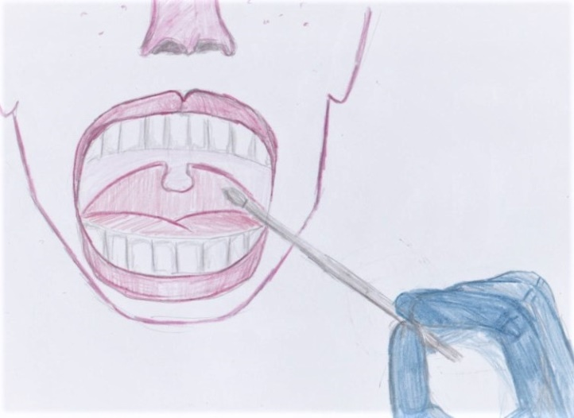
When you open your mouth, right at the back of your throat is where your tonsils sit. They need to swab both sides of your throat – try to stay nice and still. It doesn’t hurt but it will feel strange and it may make you cough a little bit.
You might feel like you are going to be sick but it is only for a couple of seconds – your grown ups need to make sure you don’t eat or drink anything for about half an hour before your swab. You could bring a snack with you and a drink to have when you’re all finished.
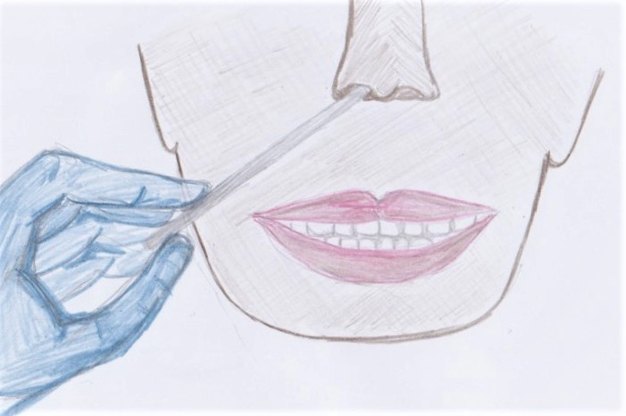
After your throat swab, we need to go up both of your nostrils.
If you put your head back again, they will use the same swab and go inside one of your nostrils like in the picture.
They will hold it in place for a few seconds and then turn it before they take it out and do your other nostril.
It doesn’t hurt but it will tickle and it might make your eyes water a little.
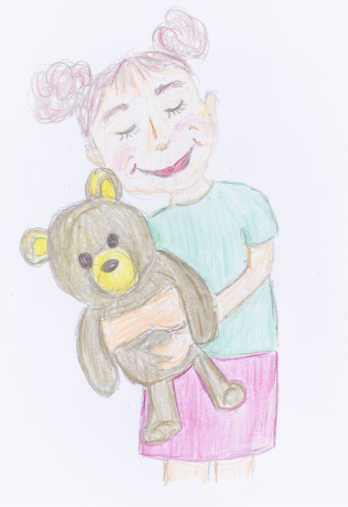
If you bring a tissue with you, you might want to blow your nose afterwards because it may run a little bit!
It might help if you bring your favourite teddy so you can give them a big cuddle when you’re having your swab.
Holding hands works well too, or your grown up can give you a hug, especially if you’re very little and might have a wriggle!
After your swab is done, the second person will put your name on it and it will get sent to be tested. Your grown up can now drive you home.
What happens next?
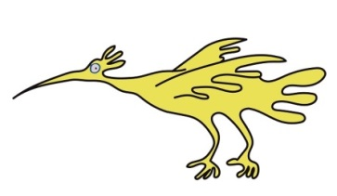
Now you’ve had your swab, you need to go home with your family and carry on as normal. There is no need to isolate, and you can continue going to school until you come in for your operation. Your swab is usually three days before so it’s not for long! Someone will be in touch if the test is positive, otherwise you can come to hospital as planned ready for your operation and we will see you soon.
Frequently Asked Questions:
I’ve got a feeding tube is that ok?
It’s OK if you’ve got a feeding tube in your nose – we won’t swab that nostril, we’ll just do the other one. Your grown ups might have to bring a new tube with them or be prepared to contact your usual team in case the swabbing makes you cough a little bit – they might want to make sure it’s really secure before you come!
I’ve got a tracheostomy, can I still have a swab?
Yes, you can!
If you’re coming to hospital for an operation and you’ve got no symptoms, we’ll swab your nose and throat like everybody else. If you’re not feeling very well, your grown ups should contact your community team and they can come to your house to do a swab, and collect a sample from your trache from your grown ups or carers.
I’ve got a cleft lip and palate, what happens when I go for a swab?
Our swabbers will swab your throat and they may just do one side of your nose – the side where your cleft is, because if you only have a cleft on one side, the other side might be too small for our swab to fit in. If you have a cleft on both sides they will swab both nostrils.
I’ve got a learning disability, will you give me extra time?
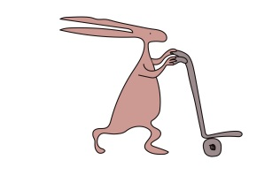
Of course, we will, we know that not all children are the same and that some children need more time to get ready. We will work with you and with your grown ups to make sure that we don’t rush you, that you know why you’re here and what we’d like to do.
I’ve tested positive for COVID 19 before, can I still have a swab?
If you have tested positive before with a PCR or lateral flow swab, please let the team know when they are booking you in for a swab. If you had Covid 19 within 90 days before you’re due to come in, we may not swab you because it may still show up as being positive, but you won’t be infectious. This means that you won’t be able to pass it on to anyone else. If it has been longer than 90 days, we will swab you as normal.
If you have any more questions, you and your grown ups can ask when you book in or when you get to the garage and our team will be more than happy to answer them for you

Leaflet written and illustrated by Helen O’Boyle, COVID Swabbing Team.
This leaflet only gives general information. You must always discuss the individual treatment of your child with the appropriate member of staff. Do not rely on this leaflet alone for information about your child’s treatment.

This information can be made available in other languages and formats if requested.

Alder Hey Children’s NHS Foundation Trust
Alder Hey
Eaton Road
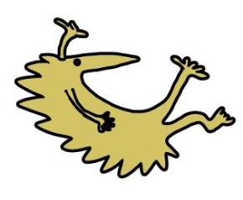
Liverpool
L12 2AP

Tel: 0151 228 4811
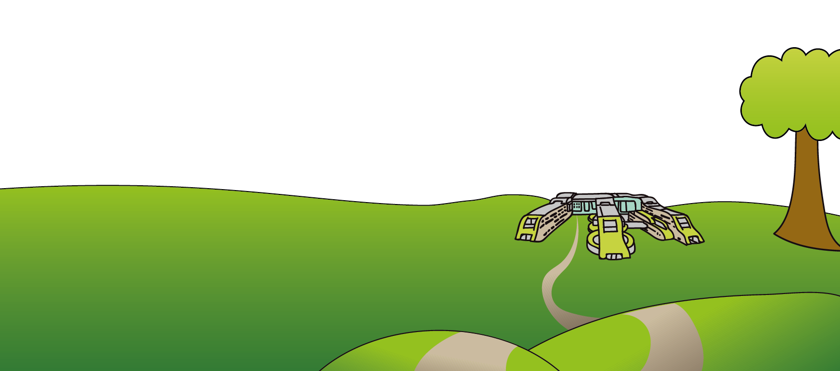
www.alderhey.nhs.uk

© Alder Hey Review Date: March 2025 PIAG: 325

